Our Ref:
Your Ref:
Contact:
Tel:
E-mail:
Date:
Education & Families
Mrs. Maura Oates
Head Teacher
St Brendan’s Primary School and Nursery
45 Barons Road
Motherwell
ML1 2NB
www.northlanarkshire.gov.uk

Dear Parent/Carer,

Parents Portal – Digital Communication

In support of North Lanarkshire Council’s ambition to continue improvement in parental communications and its broader Digital NL plans we have been working with national organisations to develop a “Parents Portal”.
The portal has been and will continue to be developed to provide parents with a clear insight to their child’s education and to support transactional communications between parents and the school, this includes attendance, reports and school information.
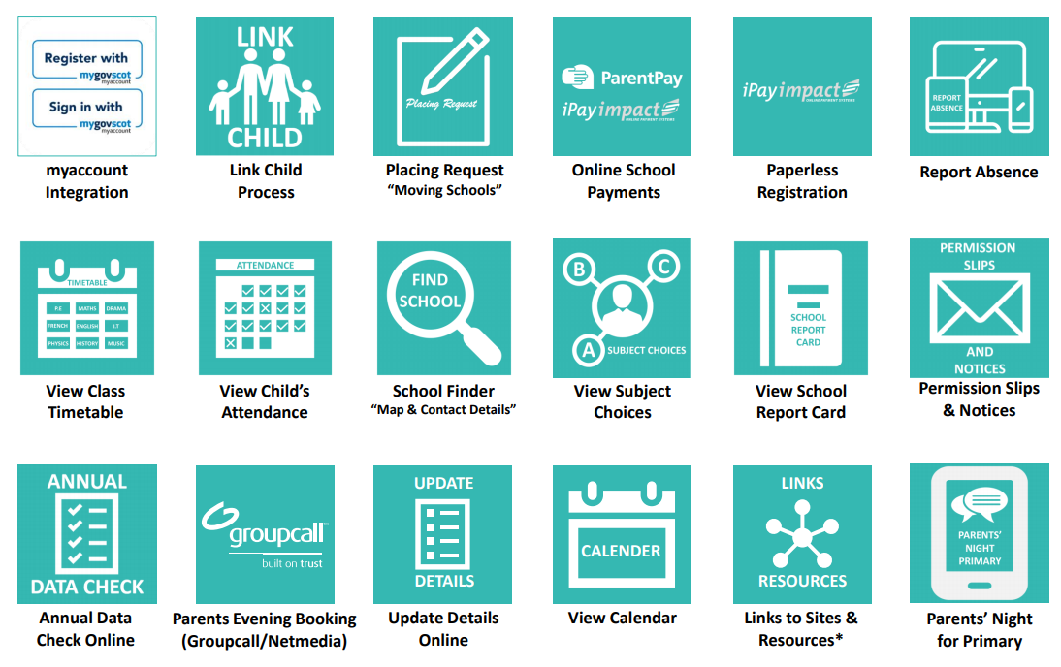Parents Portal has been available in all North Lanarkshire Schools since August 2020. Since then more features have been added and North Lanarkshire has moved forward its own digital communication.
The Portal now gives direct access to iPayimpact, the online payment for school lunches and wider school events, your child’s attendance, and the ability for the main contact parent to update contact details. All information entered will be viewed and then approved by the school. If they had any questions or concerns, they would contact the main carer.
Parent’s Portal now also allows the schools to send home letters and permission forms, which you can return with permission digitally. No longer any need to rely on ‘school bag’ post! As more schools move to using the new pupil report this will also be available to you digitally on Parents Portal.
Instructions for this can be followed in video available via this link:
http://bit.ly/ParentsPortalNLC
This portal will become one of the main communications between schools and parents across North Lanarkshire Council and we encourage you to sign up to this service. It is a one stop shop to many of our current and future communications.

Yours sincerely

Head Teacher

