Literacy
- Read a book from Big Cat Reading or Oxford Owl.
- Complete a ‘Read to Write’ tasks of your choice.
- Challenge: Revise your common words flashcards (on Glow) from term 1&2.
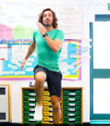
Wednesday 20th May

Arts & Crafts
Follow the link and choose a fun arts and crafts activity. Share your fantastic work with your friends on Glow!
https://www.youtube.com/watch?v=MHxudHu4VK4
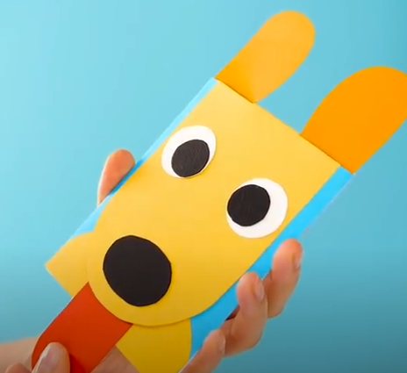

Times Tables
- On Glow (times tables folder), complete the ‘Speedy Tables Wednesday’ activity sheet. How fast can you complete the sheet? Are there any tables you find super easy or tricky?
- Practise writing and saying your 3 times tables.
- Take part in the ‘P3 tables challenge’ on Sumdog. It will be open all week.
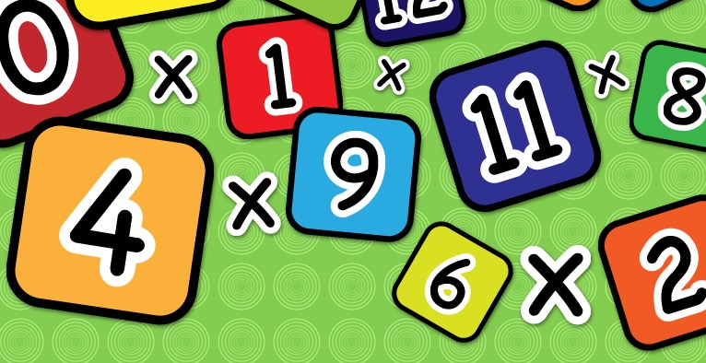

Health & Wellbeing
Scroll down and choose one of the P.E. activities to complete today.

Planet Earth
Watch the link to see what plants need to grow. Can you share your learning with someone at home?
https://www.youtube.com/watch?v=wmFbuI-H9TQ
Science
Click on this link to watch the Science Centre lesson this morning at 10am.

Health & Wellbeing Activities
Joe Wicks
Follow the link and join Joe Wicks with a full body workout. It is live at 9am.
https://www.youtube.com/playlist?list=PLyCLoPd4VxBvPHOpzoEk5onAEbq40g2-k

Jumpstart Jonny
Join Jumpstart Jonny in a themed workout!
www.youtube.com/jumpstartjonny

Cosmic Kids
This a great resource that provides yoga videos for children to follow. I have attached a couple below. YouTube have a large selection available. ‘Just Dance’ also has some fun songs for children to dance along to.
- Pokemon
https://www.youtube.com/watch?v=tbCjkPlsaes
- Frozen
https://www.youtube.com/watch?v=xlg052EKMtk
- The Wizard of Oz
https://www.youtube.com/watch?v=j_3weVPH0-U

Fitness Stations
Log onto Glow and use the fitness activities to set up your own fitness station (Health & Wellbeing> physical education>fitness stations). You could choose different activities each day!

Free Choice
Take part in an active task by yourself or with your family- this could be going for a walk, playing with a ball in the garden or something else!

