Tuesday 19th May
Literacy
- Look at your new ‘common words of the week’ on Glow (under phonemes and common words of the week). Write 3 sentences using your new phoneme.
- Choose a book to read with an adult
Challenge: Revise your phonemes flashcards (on Glow) from term 1&2.
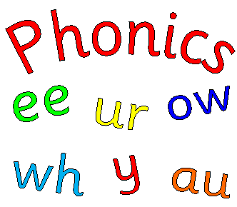
Times Tables
- Follow the link to listen to your 3 times tables. Can you write down your 3 times tables?
https://www.youtube.com/watch?v=t03yW7Oxsoc
- On Glow (times tables folder), complete the second page of ‘Speedy Tables Monday & Tuesday’ sheet. How quickly can you complete each column? Are there any tables you find super easy or tricky?
- Take part in the ‘P3 tables challenge’ on Sumdog. It will be open all week.
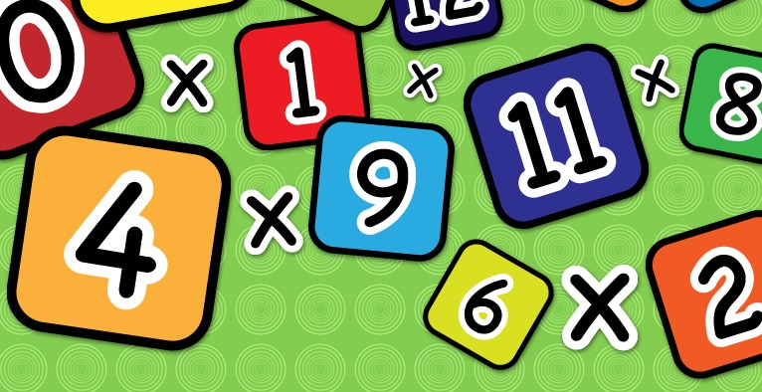

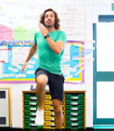
Health & Wellbeing
Scroll down and choose one of the P.E. activities to complete today.

Planet Earth
Yesterday, you listened to Dr. Binocs explaining the different parts of a flower. Watch the video again to refresh your memory.
https://www.youtube.com/watch?v=p3St51F4kE8
Can you write one fact about each of the following: buds, flower, leaves, fruit, stem and the roots.

R.E.
On your daily walk, collect some wild flowers and put these on your May Altar or display them in your house.
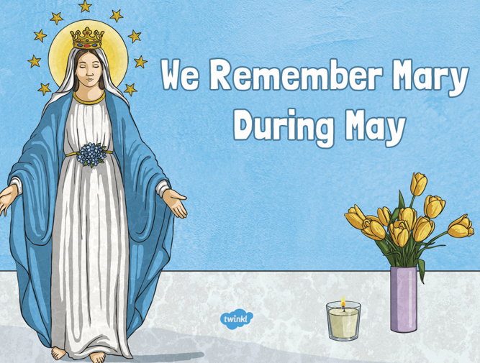

French
Register with the Duo Lingo website and practise your French skills. You can also download this as an app. https://www.duolingo.com/register

Health & Wellbeing Activities
Joe Wicks
Follow the link and join Joe Wicks with a full body workout. It is live at 9am.
https://www.youtube.com/playlist?list=PLyCLoPd4VxBvPHOpzoEk5onAEbq40g2-k

Jumpstart Jonny
Join Jumpstart Jonny in a themed workout!
www.youtube.com/jumpstartjonny

Cosmic Kids
This a great resource that provides yoga videos for children to follow. I have attached a couple below. YouTube have a large selection available. ‘Just Dance’ also has some fun songs for children to dance along to.
- Pokemon
https://www.youtube.com/watch?v=tbCjkPlsaes
- Frozen
https://www.youtube.com/watch?v=xlg052EKMtk
- The Wizard of Oz
https://www.youtube.com/watch?v=j_3weVPH0-U

Fitness Stations
Log onto Glow and use the fitness activities to set up your own fitness station (Health & Wellbeing> physical education>fitness stations). You could choose different activities each day!

Free Choice
Take part in an active task by yourself or with your family- this could be going for a walk, playing with a ball in the garden or something else!

