Monday 18th May
Numeracy
We have been working so hard on our times tables this year. This week, we will practise recalling our tables at a fast pace.
- On Glow (times tables folder), complete the first page of ‘Speedy Tables Monday & Tuesday’ sheet. How fast can you complete each column?
- Follow this link and listen to Jack Hartmann singing the 3 times tables!
https://www.youtube.com/watch?v=t03yW7Oxsoc
- Challenge: Take part in the ‘P3 tables challenge’ on Sumdog. It will be open all week.
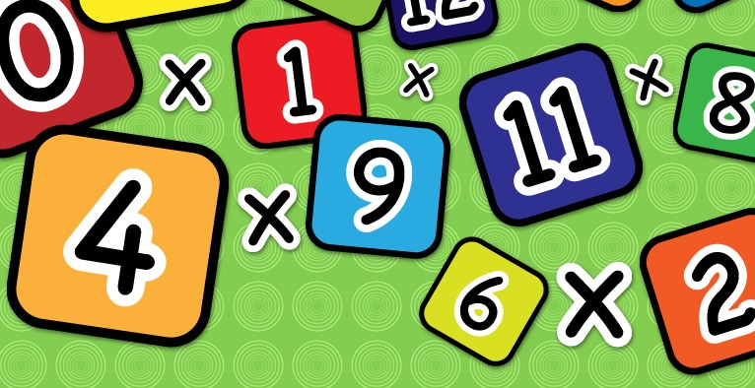

Literacy (Revision Week)
- Revise your phonemes flashcards (on Glow) from term 1&2.
- Look at your new phoneme on Glow (under phonemes and common words of the week). Write 3 sentences using your new phoneme.
- Choose a book to read with an adult.
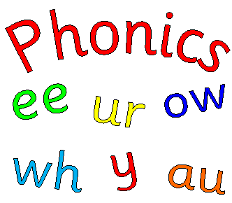

Health & Wellbeing
Scroll down and choose one of the P.E. activities to complete today.
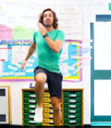

Dancing Time!
Click on the link at 11.30am and enjoy a live dance class with Oti Mabuse!
https://www.facebook.com/OtiMabuse/
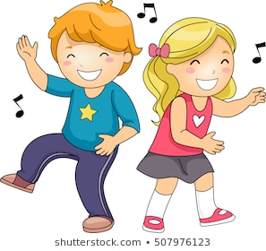
Arts & Crafts
Some pupils have enjoyed painting rocks and leaving them on their daily walk for others to see. Isn’t this a lovely idea? Can you paint a rock and find a nice place for it on your daily walk? I am sure that it will put a big smile on lots of faces!
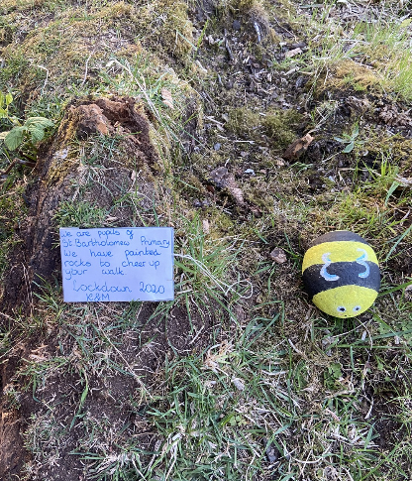

Planet Earth
This week, we will learn all about planets and how they grow. Watch Dr. Binocs explain the parts of a flower. Can you use the video to draw and label the parts of a flower?
https://www.youtube.com/watch?v=p3St51F4kE8

Health & Wellbeing Activities
Joe Wicks
Follow the link and join Joe Wicks with a full body workout. It is live at 9am.
https://www.youtube.com/playlist?list=PLyCLoPd4VxBvPHOpzoEk5onAEbq40g2-k

Jumpstart Jonny
Join Jumpstart Jonny in a themed workout!
www.youtube.com/jumpstartjonny

Cosmic Kids
This a great resource that provides yoga videos for children to follow. I have attached a couple below. YouTube have a large selection available. ‘Just Dance’ also has some fun songs for children to dance along to.
- Pokemon
https://www.youtube.com/watch?v=tbCjkPlsaes
- Frozen
https://www.youtube.com/watch?v=xlg052EKMtk
- The Wizard of Oz
https://www.youtube.com/watch?v=j_3weVPH0-U

Fitness Stations
Log onto Glow and use the fitness activities to set up your own fitness station (Health & Wellbeing> physical education>fitness stations). You could choose different activities each day!

Free Choice
Take part in an active task by yourself or with your family- this could be going for a walk, playing with a ball in the garden or something else!

