FUN FRIDAY!
Literacy
- Read a book from Big Cat Reading or Oxford Owl.
- Complete a ‘Read to Write’ tasks of your choice.

Friday 15th May
Numeracy
- Log into Sumdog and take part in the Sumdog competition. It will be open all day long. Good luck!
- Challenge: Follow the link and use the activities to practise telling the time.
- https://www.doorwayonline.org.uk/timeandmoney/abouttime/
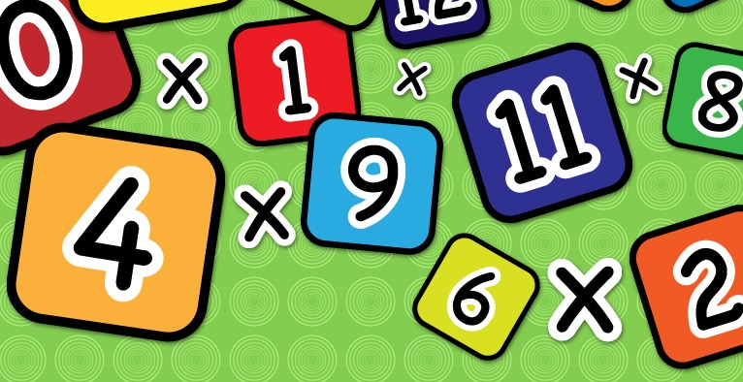

Health & Wellbeing
Scroll down and choose one of the P.E. activities to complete today.

Look back over your activity sheets this week. Are there any activities that you do not get a chance to do that you would love to do now?

Family Fun
Design and make an obstacle course at home or in the garden. How fast can you complete it?
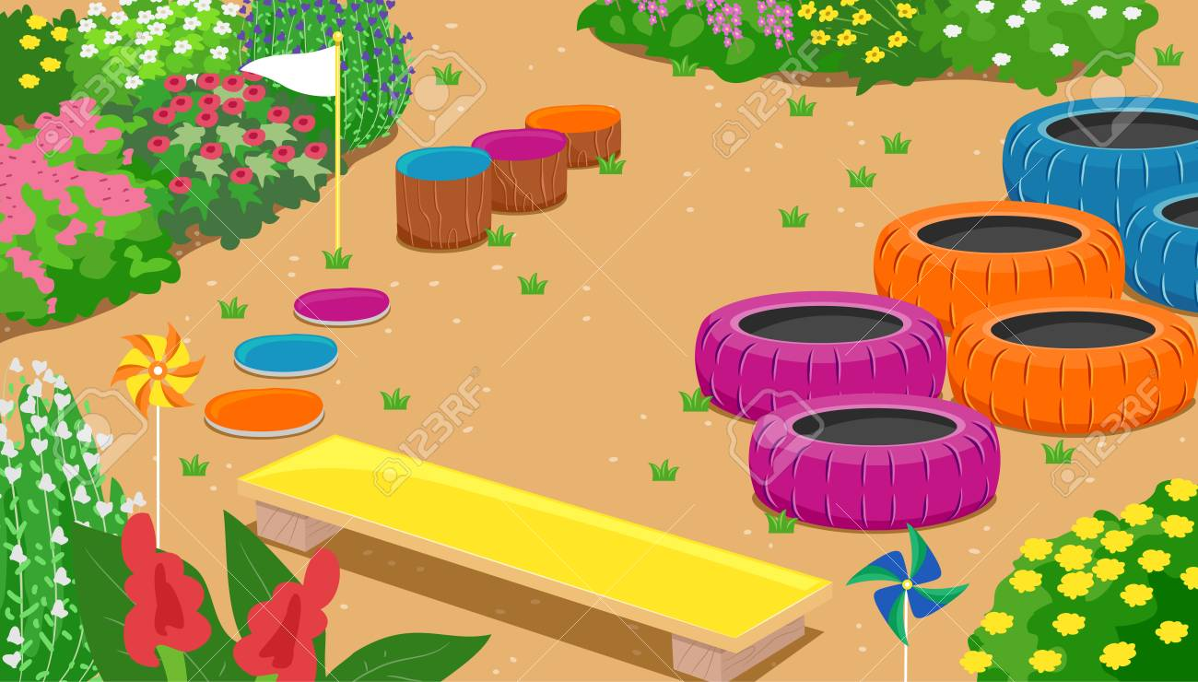

Planet Earth
Watch this video about the sea, rivers and lakes. Can you spot a famous river that we learned all about last term?
https://www.youtube.com/watch?v=bNWuQD7QHBc
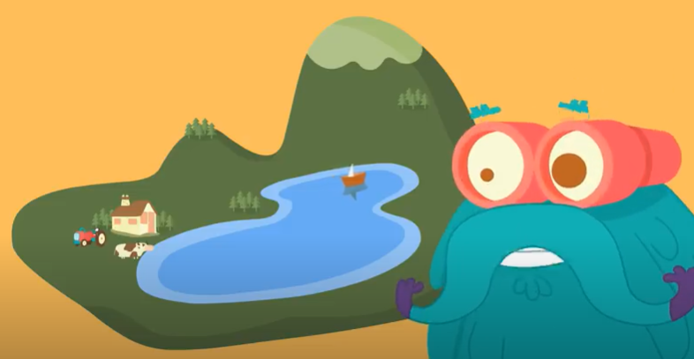

Health & Wellbeing Activities
Joe Wicks
Follow the link and join Joe Wicks with a full body workout. It is live at 9am.
https://www.youtube.com/playlist?list=PLyCLoPd4VxBvPHOpzoEk5onAEbq40g2-k

Jumpstart Jonny
Join Jumpstart Jonny in a themed workout!
www.youtube.com/jumpstartjonny

Cosmic Kids
This a great resource that provides yoga videos for children to follow. I have attached a couple below. YouTube have a large selection available. ‘Just Dance’ also has some fun songs for children to dance along to.
- Pokemon
https://www.youtube.com/watch?v=tbCjkPlsaes
- Frozen
https://www.youtube.com/watch?v=xlg052EKMtk
- The Wizard of Oz
https://www.youtube.com/watch?v=j_3weVPH0-U

Fitness Stations
Log onto Glow and use the fitness activities to set up your own fitness station (Health & Wellbeing> physical education>fitness stations). You could choose different activities each day!

Free Choice
Take part in an active task by yourself or with your family- this could be going for a walk, playing with a ball in the garden or something else!

