Choose one piece of work that you have completed this week that you are most proud of. Share a picture of it on GLOW or even post a message telling me what you have chosen and why you are proud of it. I can’t wait to see what you choose! | It is important to keep in daily contact and let me know how your home learning is going. If you have not yet been in contact this week please send me a message… even just to say hello and let me know how you are : ) |  | As it is the end of the week, take some time to catch up on any activities that you haven’t gotten to.
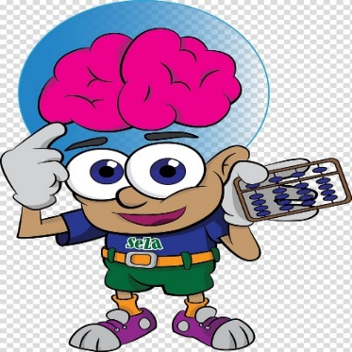  Try out today’s mental maths questions… How many can you answer? : ) | 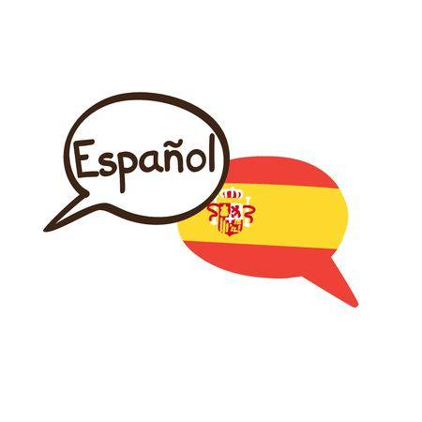  Have a go at the Spanish worksheet below. Try to match up the body parts to their correct Spanish word. Use the body parts song to help you if you get stuck! : )  https://www.youtube.com/watch?v=pOg6y-Q59eM | If it is safe to do so, spend some time outdoors getting some fresh air and exercise : )
There will be a whole school sumdog challenge at 10:00am until 1:00pm. I would love to see lots of P4 boys and girls on the leaderboard. You can do it! : )  Yesterday’s leaders were:  1 – Ciaran  2 – Talia  3 - Lucy |  | For today’s story writing task I would like you to use your imagination! We have been learning all about space. I would like you to create your very own adventure story set in space (it doesn’t have to be set in our solar system… you could even make your own up!) Use the template below to create a super comic book strip. You should have 6 small paragraphs with a picture to match each one. Be as creative as you like! Make sure your short story has:  - A beginning, middle and end  - Capital letters and full stops (and some exclamation marks)  - Ambitious words  - Detailed matching pictures to help tell your story

