Thursday 7th May
Literacy
- Use one of the story prompts from the writing section in Glow to write your own story. The more imagination used the better!
- Practise your common words term 3 & 4 using the PowerPoints on Glow.
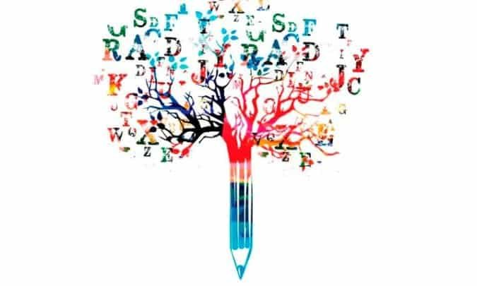
Numeracy
- Practise writing your 4 & 8 times tables.
- Take part in the whole school Sumdog competition today between 10am and 1pm. Let’s see how many children in P3 can log on. Good luck!
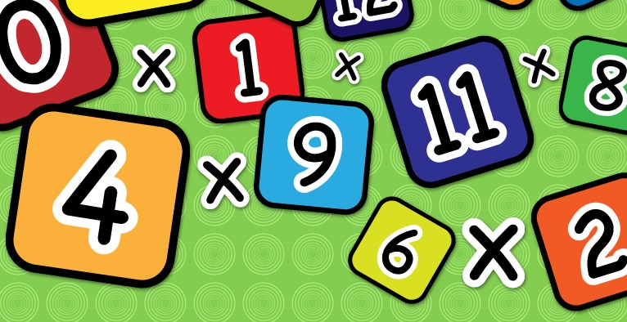

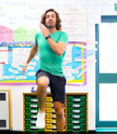
Health & Wellbeing
Scroll down and choose one of the P.E. activities to complete today.

Technology- Junk Modelling!
This week find some recyclable materials in your house such as a yogurt pot, toilet roll or a box. Use your imagination and see what you can create with them. It can be as big or small as you like!
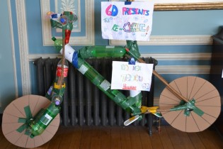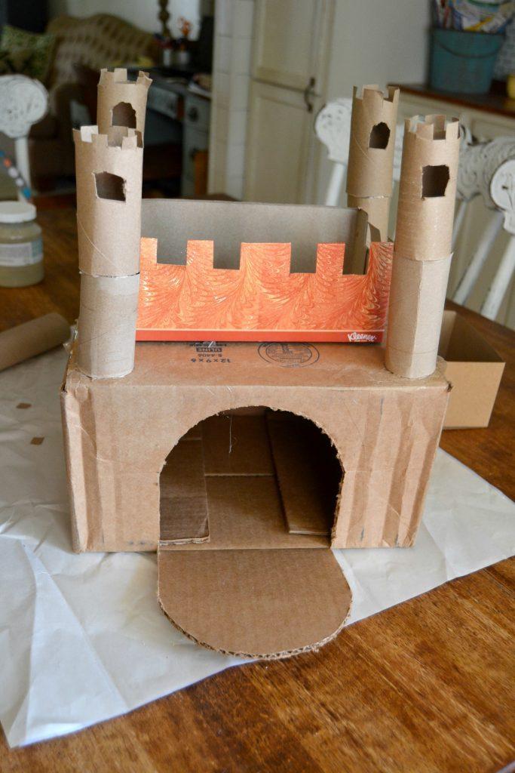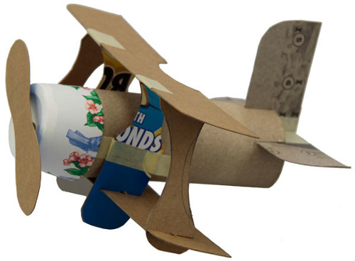

R.E.
Our friends are a very special part of our lives. Can you draw a picture of a friend (or more than one if you prefer) and write some of the things you like about them underneath. I am sure they would love to see your finished picture!
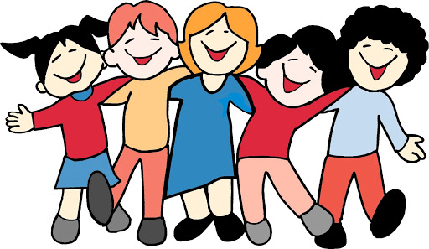

Planet Earth
This week you have learned about the water cycle. Follow the link to draw your very own water cycle!
https://www.youtube.com/watch?v=pg2ALnQq9JQ
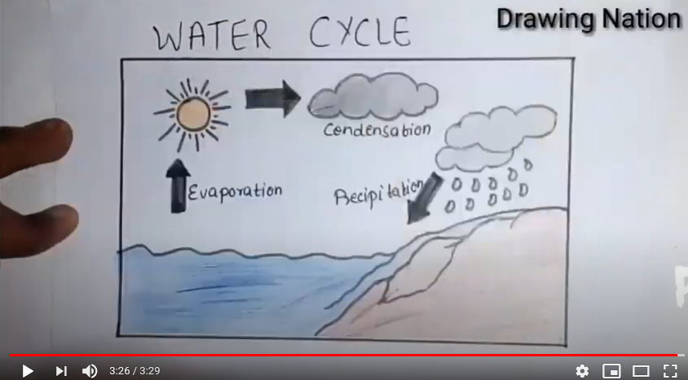

Health & Wellbeing Activities
Joe Wicks
Follow the link and join Joe Wicks with a full body workout. It is live at 9am.
https://www.youtube.com/playlist?list=PLyCLoPd4VxBvPHOpzoEk5onAEbq40g2-k

Jumpstart Jonny
Join Jumpstart Jonny in a themed workout!
www.youtube.com/jumpstartjonny

Cosmic Kids
This a great resource that provides yoga videos for children to follow. I have attached a couple below. YouTube have a large selection available. ‘Just Dance’ also has some fun songs for children to dance along to.
- Pokemon
https://www.youtube.com/watch?v=tbCjkPlsaes
- Frozen
https://www.youtube.com/watch?v=xlg052EKMtk
- The Wizard of Oz
https://www.youtube.com/watch?v=j_3weVPH0-U

Fitness Stations
Log onto Glow and use the fitness activities to set up your own fitness station (Health & Wellbeing> physical education>fitness stations). You could choose different activities each day!

Free Choice
Take part in an active task by yourself or with your family- this could be going for a walk, playing with a ball in the garden or something else!

