|  |  |  |  |
| --- | --- | --- | --- |
| [Education, Mathematics, Arithmetic, Mental Calculation, Abacus ...](https://www.google.co.uk/url?sa=i&url=https%3A%2F%2Fwww.pngguru.com%2Ffree-transparent-background-png-clipart-mueqe&psig=AOvVaw2CNvIhASl1rta1yzEH7h2y&ust=1588633386266000&source=images&cd=vfe&ved=0CAIQjRxqFwoTCMDzztjmmOkCFQAAAAAdAAAAABAD)  How many of today’s mental maths questions can you answer below?  Post your answers onto GLOW : ) | Sumdog (@sumdog) | Twitter  If you haven’t logged onto sumdog yet, please try and complete a few activities today.  I will post our top 3 players later on : ) | | Clipart Of Mother Mary  May is a very special time for Catholic people. It is the month of Mary.  What do you know about Mary? Write a small paragraph or create a mindmap with all of the information you have learned over the years. Try to include a picture of Mary that you have drawn : )  When you have finished, say a special Hail Mary or you could practice your handwriting by writing out her prayer. |
| Geography Clipart Geography Project - Clipart Social Studies ...  GEOGRAPHY  Click on the link to learn all about time zones today  .  Send me 3 facts that you have learned after you have completed the activity : )  <https://www.bbc.co.uk/bitesize/articles/z48fvk7> | Exercise Clipart Cartoon  Spend some time away from your screen and get your body moving!  You could go for a walk, watch Joe wicks or choose a fun exercise video on youtube such as just dance or Zumba.  Let me know what physical activity you choose : ) | [Punctuation Marks Clipart](https://www.google.co.uk/url?sa=i&url=https%3A%2F%2Fwww.clipart.email%2Fclipart%2Fpunctuation-marks-clipart-47157.html&psig=AOvVaw3SD8fBIBlWGSHM6qpy9xu9&ust=1588633781310000&source=images&cd=vfe&ved=0CAIQjRxqFwoTCIDL4JLomOkCFQAAAAAdAAAAABAD)  Daily Punctuation…  Copy down and edit the paragraph below, making sure to add in the correct punctuation. How many errors can you spot in today’s paragraph… Let me know! : ) | |
| Free Fraction Cliparts, Download Free Clip Art, Free Clip Art on ...  Last term we focussed on fractions. Click on the link and choose a few activities and games to refresh your memory.  Look below for some challenger questions to try : )  <https://www.topmarks.co.uk/maths-games/7-11-years/fractions-and-decimals> | | Reading Clip Art For Teachers Free | Clipart Panda - Free Clipart ...  Log in to GLOW and click on the ‘Literacy’ folder, then click on the ‘reading activities’. Choose an activity to complete for today.  Try and spend at least 20 minutes reading for enjoyment today with a book of your choice. | |

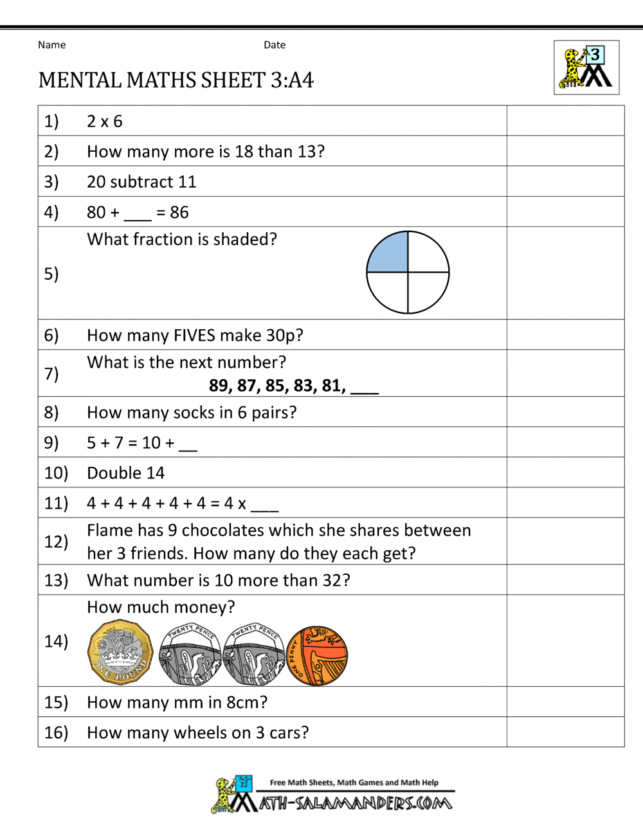

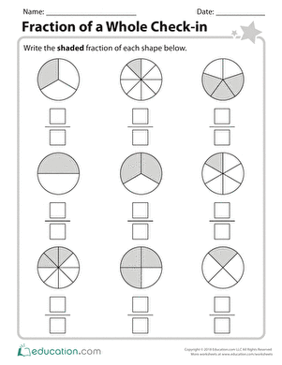

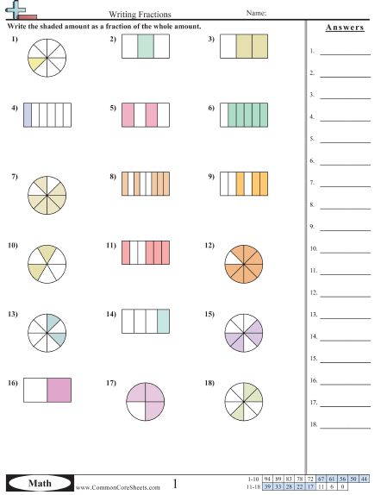

**06.05.20 Punctuation**

**LI: WAL to identify punctuation errors**

it was a cold wet and windy morning curiously, cheyenne looked at talia

do you like superheroes She asked.

I love them! Cried talia who doesnt love superheroes?

Which are your favourite cheyenne questioned Talia

I love Iron Man Batman and Spiderman Talia said, happily.

? / 27