Tuesday 5th May
Times Tables
- Follow the link and practise your 4 & 8 times tables. https://www.timestables.co.uk/
- Subtraction: Complete the second page of the ‘3 digit subtraction 1’ activity on Glow (Glow>numeracy>addition and subtraction>3 digit addition and subtraction> ‘3 digit subtraction 1’)
- Challenge: Practise your skills on Sumdog.
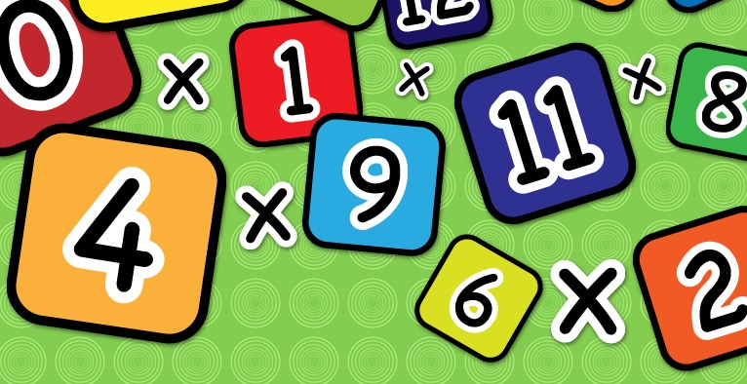

Literacy
- Revise your common words flashcards (on Glow) from term 1&2.
- Choose 3 tricky common words and write a sentence for each one.
- Read an online book with an adult. If you are reading a white or lime band, you can read the same book throughout the week.
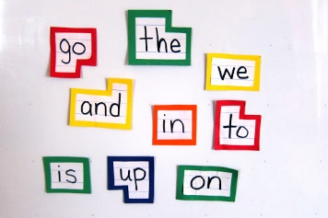

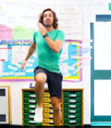
Health & Wellbeing
Scroll down and choose one of the P.E. activities to complete today.

Planet Earth
We now know that our Earth is called the ‘Blue Planet’ because it is made up of 70% water. For the rest of the week, we will learn about the water cycle! Follow these links to watch fun videos about the water cycle.
https://www.youtube.com/watch?v=ncORPosDrjI

https://www.youtube.com/watch?v=y5gFI3pMvoI

Can you talk about what you have learned with someone at home?

Technology- Junk Modelling!
This week find some recyclable materials in your house such as a yogurt pot, toilet roll or a box. Use your imagination and see what you can create with them. It can be as big or small as you like!
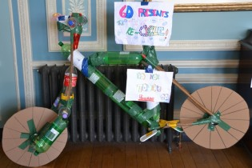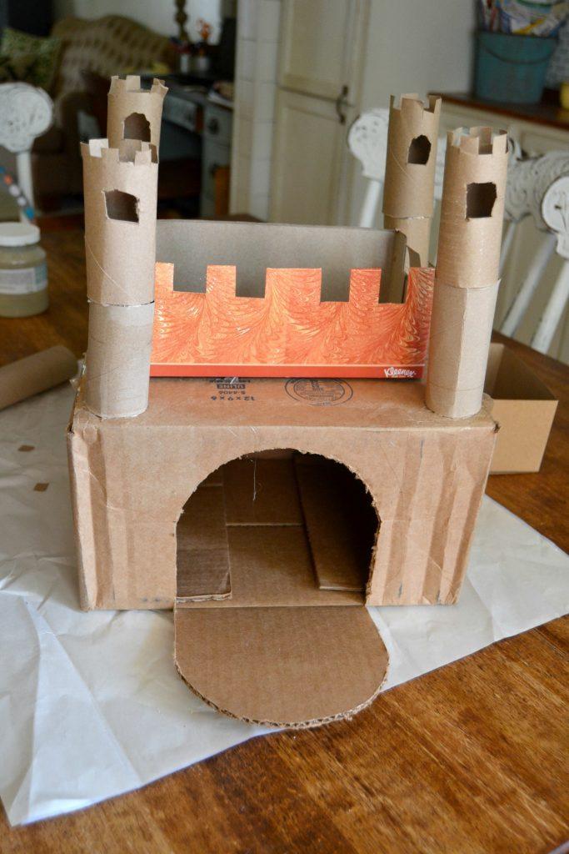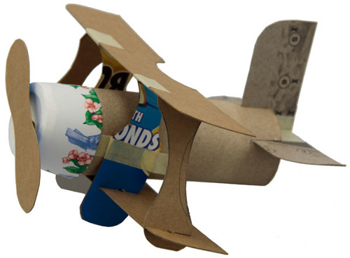

R.E. Relationships
The 4th Commandment is to love your mother, father and adults in your life. We all have adults around us who help us make good decisions. Can you draw a picture of the special people are you who help you to make good decisions? Talk through your picture with an adult at home.

Health & Wellbeing Activities
Joe Wicks
Follow the link and join Joe Wicks with a full body workout. It is live at 9am.
https://www.youtube.com/playlist?list=PLyCLoPd4VxBvPHOpzoEk5onAEbq40g2-k

Jumpstart Jonny
Join Jumpstart Jonny in a themed workout!
www.youtube.com/jumpstartjonny

Cosmic Kids
This a great resource that provides yoga videos for children to follow. I have attached a couple below. YouTube have a large selection available. ‘Just Dance’ also has some fun songs for children to dance along to.
- Pokemon
https://www.youtube.com/watch?v=tbCjkPlsaes
- Frozen
https://www.youtube.com/watch?v=xlg052EKMtk
- The Wizard of Oz
https://www.youtube.com/watch?v=j_3weVPH0-U

Fitness Stations
Log onto Glow and use the fitness activities to set up your own fitness station (Health & Wellbeing> physical education>fitness stations). You could choose different activities each day!

Free Choice
Take part in an active task by yourself or with your family- this could be going for a walk, playing with a ball in the garden or something else!

