Monday 4th May
Literacy (Revision Week)
- Revise your phonemes flashcards (on Glow) from term 1&2.
- Choose a phoneme that you find tricky from the flashcards. Write 3 sentences using the phoneme.
- Choose a book to read with an adult.
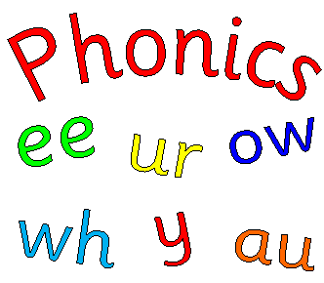
Numeracy
- Follow this website and practise your 2, 5 and 10 times tables.
https://www.timestables.co.uk/
- Subtraction: Complete the first page of the ‘3 digit subtraction 1’ activity on Glow (Glow>numeracy>addition and subtraction>3 digit addition and subtraction> ‘3 digit subtraction 1’)
- Challenge: Sumdog
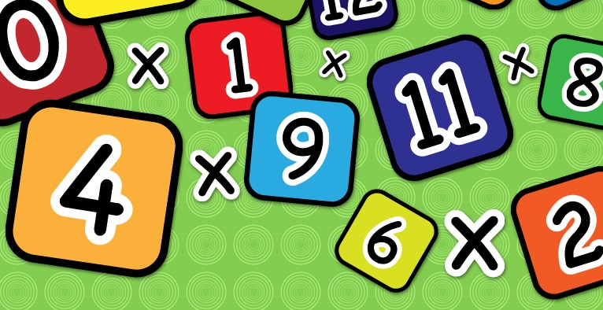

Health & Wellbeing
Scroll down and choose one of the P.E. activities to complete today.

Pupil Design Competition
A company called FSE Design are running a school competition! Show your support to the NHS and other key workers by designing a banner, thanking them for their hard work. The deadline is Friday 8th May. If you would like to take part, you can send a clear photograph of your picture to me and I will enter you in the competition. The lucky winner will have their picture made into a banner and it will be proudly displayed on our school gates.
Technology- Junk Modelling!
This week find some recyclable materials in your house such as yogurt pots, toilet rolls or a box. Use your imagination and see what you can create with them. It can be as big or small as you like!
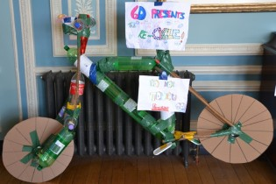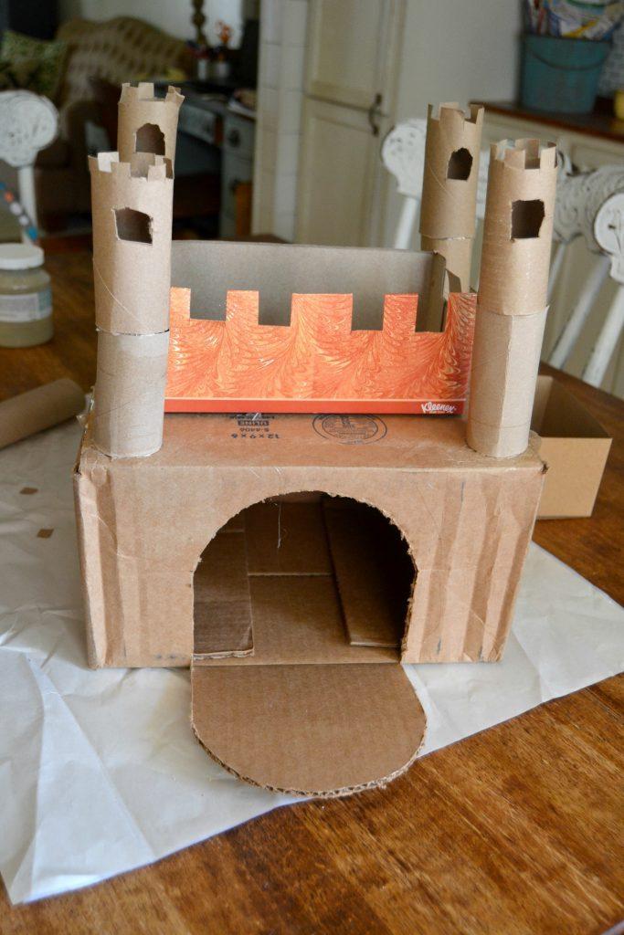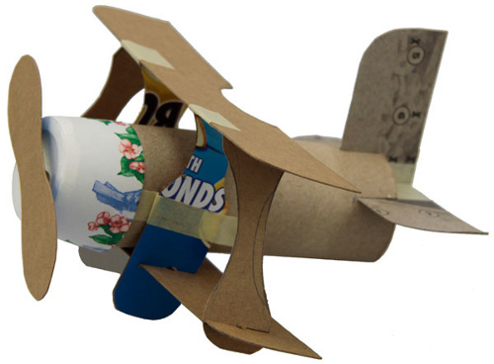

Planet Earth
This week, we are going to focus on WATER. Today we will learn about the oceans of the world!
- On Glow, look through the PowerPoint called ‘Oceans of the World’ in your topic folder.
- Follow this link and listen to the fun song about the oceans. https://www.youtube.com/watch?v=X6BE4VcYngQ
- Can you make a little fact file about the 5 oceans?

Health & Wellbeing Activities
Joe Wicks
Follow the link and join Joe Wicks with a full body workout. It is live at 9am.
https://www.youtube.com/playlist?list=PLyCLoPd4VxBvPHOpzoEk5onAEbq40g2-k

Jumpstart Jonny
Join Jumpstart Jonny in a themed workout!
www.youtube.com/jumpstartjonny

Cosmic Kids
This a great resource that provides yoga videos for children to follow. I have attached a couple below. YouTube have a large selection available. ‘Just Dance’ also has some fun songs for children to dance along to.
- Pokemon
https://www.youtube.com/watch?v=tbCjkPlsaes
- Frozen
https://www.youtube.com/watch?v=xlg052EKMtk
- The Wizard of Oz
https://www.youtube.com/watch?v=j_3weVPH0-U

Fitness Stations
Log onto Glow and use the fitness activities to set up your own fitness station (Health & Wellbeing> physical education>fitness stations). You could choose different activities each day!

Free Choice
Take part in an active task by yourself or with your family- this could be going for a walk, playing with a ball in the garden or something else!

