FUN FRIDAY!

Literacy

* Read ‘The Messy Magpie’ book on Glow (Glow>Topic>Planet Earth> ‘The Messy Magpie Book’)
* **Beginning, Middle and End:** Draw 3 pictures based on the beginning, middle and end of your book. Write 1-2 sentences under each picture to describe what happened in your book.

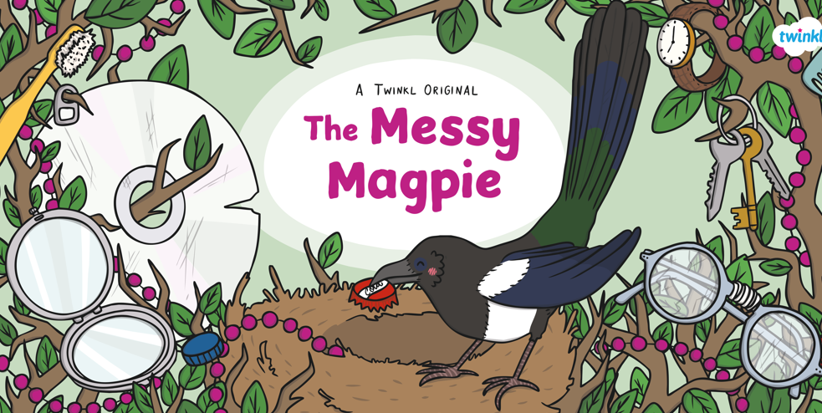

Friday 1st May

Numeracy

* Practise saying your 2, 5 & 10 times tables.
* Practise your numeracy skills on Sumdog today. There is a whole school competition from 10:00-12:30 that you can take part in. The winners will be announced at 2pm. Good luck, everyone!

[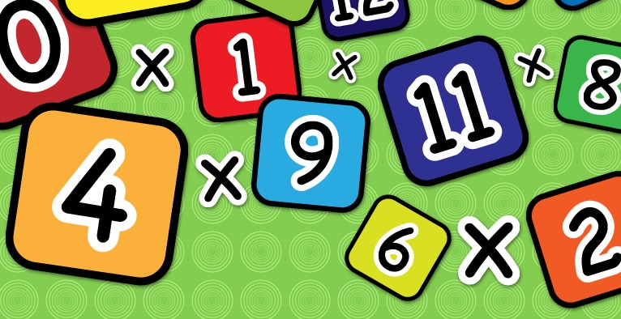](https://www.google.co.uk/url?sa=i&url=https%3A%2F%2Fwww.clipart.email%2Fclipart%2Ftimes-table-clipart-23041.html&psig=AOvVaw2j3dcFS3NOv2ZmTZA7Wc_j&ust=1585230100569000&source=images&cd=vfe&ved=0CAIQjRxqFwoTCIi1obrgtegCFQAAAAAdAAAAABAE)

Health & Wellbeing

Free Choice!

Choose an activity today of your choice. It could be football, running, going for a walk with your family, or another fun activity.

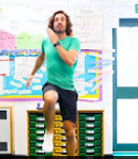

Look back over your activity sheets this week. Are there any activities that you do not get a chance to do that you would love to do now?

[](https://www.google.co.uk/url?sa=i&url=https%3A%2F%2Fwikiclipart.com%2Fchild-thinking-clipart_39115%2F&psig=AOvVaw38zYKWz_eG6obvb9Q1d9LY&ust=1585403215485000&source=images&cd=vfe&ved=0CAIQjRxqFwoTCOC89K3luugCFQAAAAAdAAAAABAE)

Reading

Find a cosy spot and build a reading den. Relax with a book from Big Cat, Oxford Owl or maybe a book that you enjoy from home.

[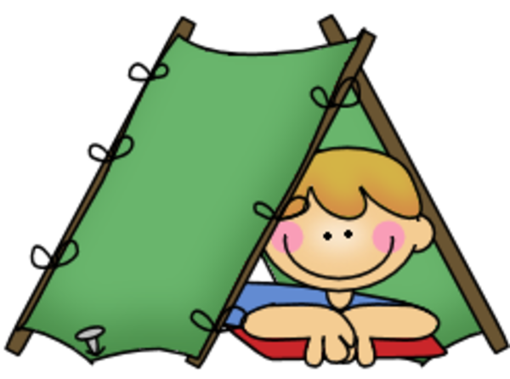](https://www.google.co.uk/url?sa=i&url=https%3A%2F%2Fwww.pinterest.com%2Fpin%2F406027722629011665%2F&psig=AOvVaw3hEC9KYxb_vXaWq5mbsllC&ust=1587726490311000&source=images&cd=vfe&ved=0CAIQjRxqFwoTCODuqZ60_ugCFQAAAAAdAAAAABAD)

Planet Earth

Can you design a poster to encourage others to recycle? It should have a fun heading, some drawings and some information on it.

[](https://www.google.co.uk/url?sa=i&url=http%3A%2F%2Fclipart-library.com%2Fposters-cliparts.html&psig=AOvVaw00LrbiO-JWC5MyjkWcPqCy&ust=1587821590372000&source=images&cd=vfe&ved=0CAIQjRxqFwoTCNDRw8GWgekCFQAAAAAdAAAAABAD)