|  |  |  |  |
| --- | --- | --- | --- |
| Clipart Resolution 980*912 - Online Check In Icon - Png Download ...  As it is almost the end of the week it is important to check in over GLOW or dojo to let me know how you’re getting on this week.  Please make sure to send me a message if you have not already done so. : ) | Story Writing – “The Mysterious Shadow…”  resource image  Today you will be writing an imaginative story with the title “The Mysterious Shadow…”  Visit the bottom of the page for the story starter that you can use to help you get started on your story (You do not have to use this, it’s only if you are feeling a bit stuck). Try to include the following in your story:   * Capital letters and full stops * Correct use of speech marks * Ambitious vocabulary (using you knowledge of adverbs, nouns, adjectives and verbs)   Happy story writing! Please send me a copy of your story when you are done… I can’t wait to read it! : ) | | |
| Visit sumdog and spend some time improving your mental maths.  Who will be our top 3 players today?  Sumdog (@sumdog) | Twitter | Mental Maths Clipart - Clip Art Library Try out today’s mental maths questions below… How many can you get right?(There a few tricky challenges today!)  I will post the answers at 3pm today onto our GLOW page : ) | Free Challenges Cliparts, Download Free Clip Art, Free Clip Art on ...  Art and Design challenge!  The boys and girls of P4 are so creative! Today, I would like you to put your art skills to the test!  I would like you to create a piece of art. It could be absolutely anything at all! You could draw a picture, paint, make a model or an outdoor chalk picture…. Anything at all!  Please send me pictures of all of your artworks over dojo or GLOW and I will post them onto dojo story and our school website to show off P4’s hard work and cheer everyone up : ) | |
| Children Pe Clipart  For today I would like you to use your imagination and PE skills to create your own PE lesson! Make sure to share it on GLOW when you are finished!  Your lesson could be on anything as long as it gets your body moving and lasts for at least 20 minutes! Write out each part of your lesson and then give it a go!  Try to include the following:   1. A five minute warm up 2. Your main activity (10 minutes) 3. A five minute cool down   Have fun! : ) | | Correct Spelling Clipart  Look at the table below and complete your groups spelling task for today | Library of world religion symbols image transparent library png ...  There are many religions all across the globe! It is important that we learn about other cultures and beliefs.  Today we will learn about another religion.  Click on the link to learn all about Hinduism.  <https://www.bbc.co.uk/bitesize/articles/z43v382>  What did you learn today? |

|  |  |
| --- | --- |
| Blue Dolphins  Red Foxes  Green Frogs | Yellow Giraffes |
| 1. Read over your spelling words for today. Choose a fun spelling task to practise spelling your words. 2. Write a sentence for each spelling word. Try to make your sentences interesting by including a connective in each! | 1. Have someone test you on your spelling words – How many can you spell correctly? 2. Try to make your own phoneme story by including as many of your spelling words as possible into a small paragraph. |
| Seven  Seventeen  Clothes  Garden  Yesterday  Swimming  Sure | She  Shape  Washing  Dishes  Wish  Shoe  Fish |

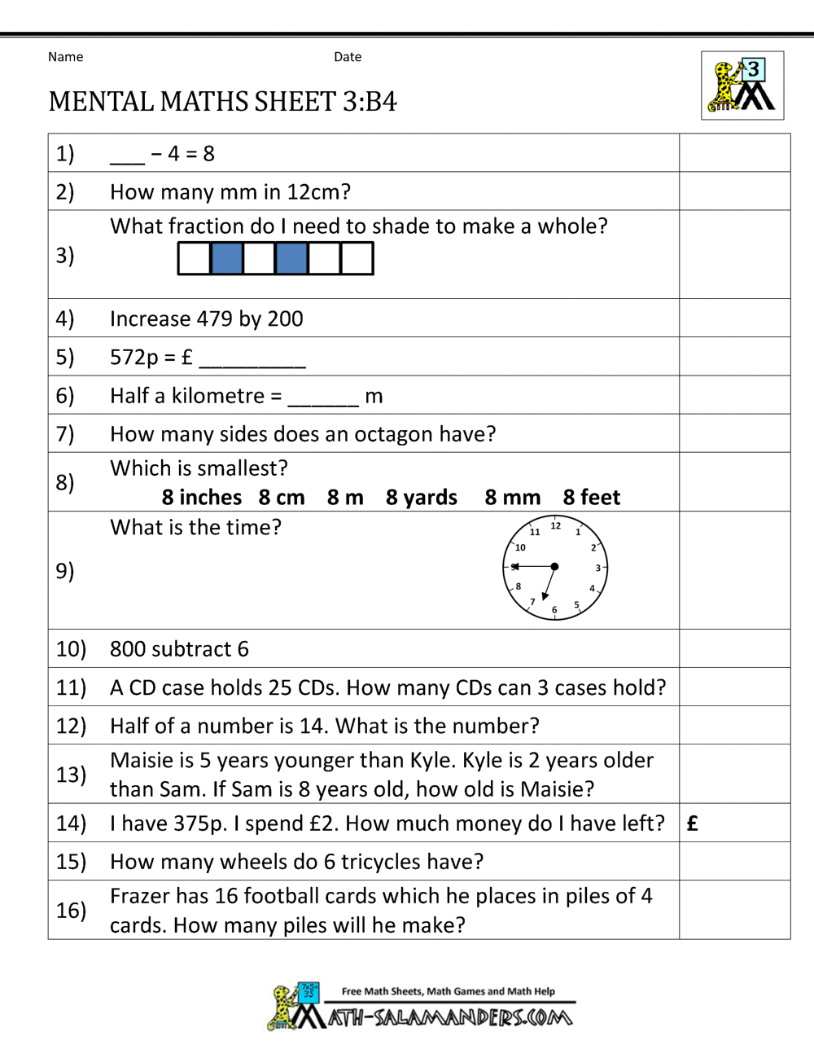

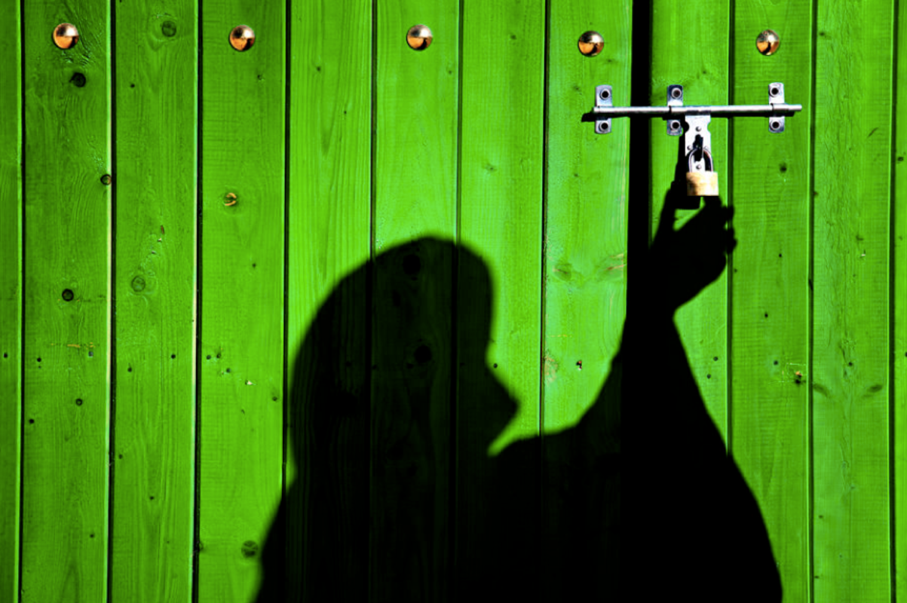

The Mysterious Shadow…

**Story starter!**

It happened in the dead of night. The garden light shone on the person, casting a mysterious shadow…

As silent as a whisper in the night, the figure slowly crept towards the green, wooden doors. Click…The key slipped into the metal lock. Seeing the padlock pop open as expected, the figure slipped the bolt across into its resting position. The doors groaned so slowly, the figure turning to watch the surrounding area, alarmed at the loudness of the sound their actions had made.

The coast seemed clear. Resuming their mission, the shadow slipped inside the room. There it was. This was the sight and moment they had been waiting for…