Please log on to GLOW and post bout how you have gotten on this week. Which activities have you enjoyed most? | It’s Friday! Relax and spend some time with your family. Choose something you like to do. It could be art, a favourite movie or even a board game. Let me know what you pick and enjoy a happy and safe weekend |  | Click on the link for a reading lesson with some questions and challenges.  https://www.bbc.co.uk/bitesize/articles/zb2k8xs
https://blogs.glowscotland.org.uk/nl/stbartholomewsclasses/  Visit our school website and look out for some French and Science challenges from Mrs McLean and Miss Kiernan. Post on GLOW what you choose to do! : ) | 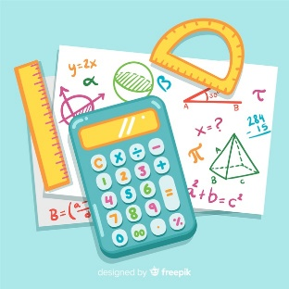 Log on to sumdog and take part in some activities.  I will post the people who have really impressed me this week! | Click the link to start you Friday morning off right with PE with Joe! : )  https://www.youtube.com/channel/UCAxW1XT0iEJo0TYlRfn6rYQ | 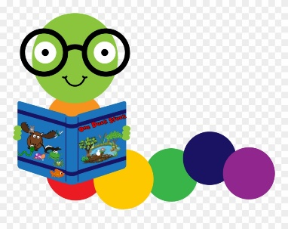  This week we have focussed on nouns, verbs and adjectives. Write me ten super sentences with a noun, adjective and verb in each one! Try writing them in a different colour or circling them to let me know that you know which is which! : )
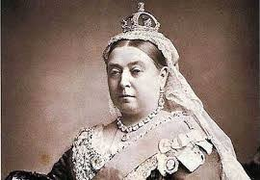  Revisiting the Victorians!  Click on the link to refresh your memory about many Victorian topics! Choose one (such as Queen Victoria. Florence Nightingale or Poor Victorians) and create something to show me what you know… It could be a poster, a report, a fact file or a powerpoint…Anything you like! : )  Please post you work onto our P4 GLOW page or over dojo message. |  | 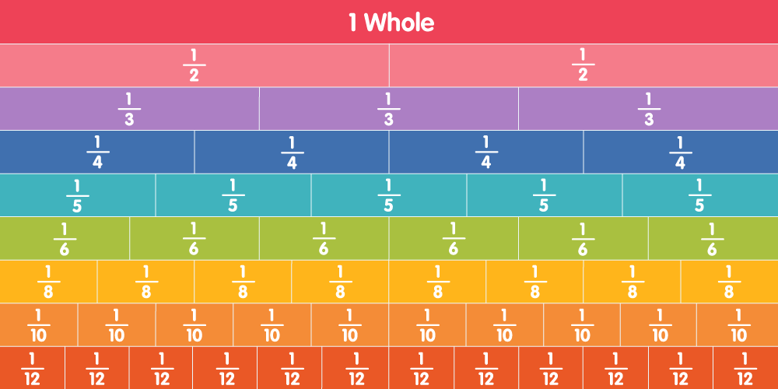 | Click on the link for some fractions activities! Challenge yourself and see what you can remember! I’ll be available all day if you need any help at all! : )  Focus on writing and ordering fractions, you don’t need to complete any equivalent fractions questions  https://wrm-13b48.kxcdn.com/wp-content/uploads/2020/homelearning/year-3/Lesson-4-Y3-Summer-Block-1-WO5-Order-fractions-2020.pdf

