FUN FRIDAY!

Literacy

Writing: Can you write a set of instructions on how to make your Earth Day project?

Remember to include a title, list of materials and set of numbered instructions.

[](https://www.google.co.uk/url?sa=i&url=https%3A%2F%2Fwww.nvidia.com%2Fen-sg%2Fdata-center%2Fgpu-accelerated-applications%2F&psig=AOvVaw1GL06T8ITxNZUwPDrCkYYU&ust=1585922871975000&source=images&cd=vfe&ved=0CAIQjRxqFwoTCMCGy5_1yegCFQAAAAAdAAAAABAD)

Friday 24th April

Numeracy

* Practise saying your 2, 5 & 10 times tables.
* Subtraction Revision: on Thursday and Friday this week, practise your 2-digit subtraction by completing the activity on Glow (Glow>numeracy>addition and subtraction>2 digit addition and subtraction> ‘2 digit subtraction’)

[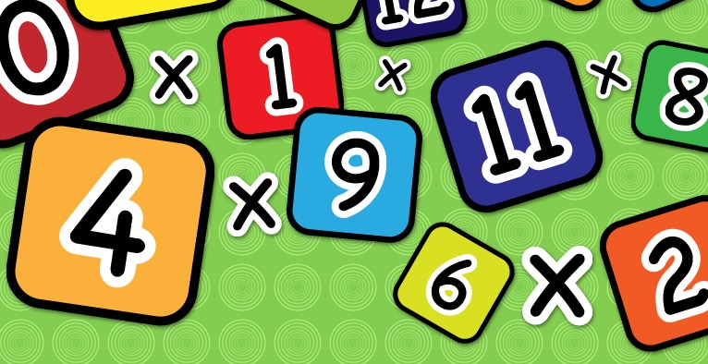](https://www.google.co.uk/url?sa=i&url=https%3A%2F%2Fwww.clipart.email%2Fclipart%2Ftimes-table-clipart-23041.html&psig=AOvVaw2j3dcFS3NOv2ZmTZA7Wc_j&ust=1585230100569000&source=images&cd=vfe&ved=0CAIQjRxqFwoTCIi1obrgtegCFQAAAAAdAAAAABAE)

P.E.

Get your exercise with Joe Wicks this morning.

**OR**

Build an obstacle course in your garden and use it for your P.E. today.

[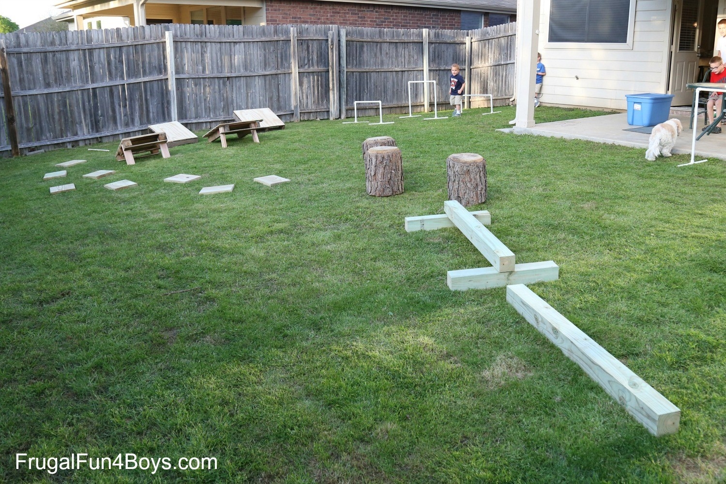](https://www.google.co.uk/url?sa=i&url=https%3A%2F%2Fucanr.edu%2Fblogs%2Fblogcore%2Fpostdetail.cfm%3Fpostnum%3D22474&psig=AOvVaw3CzRoDo4r4O-8N6oKSu-kq&ust=1587800037486000&source=images&cd=vfe&ved=0CAIQjRxqFwoTCIC5lJ7GgOkCFQAAAAAdAAAAABAD)

Look back over your activity sheets this week. Are there any activities that you do not get a chance to do that you would love to do now?

[](https://www.google.co.uk/url?sa=i&url=https%3A%2F%2Fwikiclipart.com%2Fchild-thinking-clipart_39115%2F&psig=AOvVaw38zYKWz_eG6obvb9Q1d9LY&ust=1585403215485000&source=images&cd=vfe&ved=0CAIQjRxqFwoTCOC89K3luugCFQAAAAAdAAAAABAE)

Art & Design

Tune into Steve Harpster on YouTube and choose one of the pictures to draw. Watch the video and follow the instructions.

<https://www.youtube.com/user/tgif38>



Planet Earth

Try to finish your Earth Day project and remember- you can use whatever resources you like! If you can, I would love to see photographs of your finished product!

[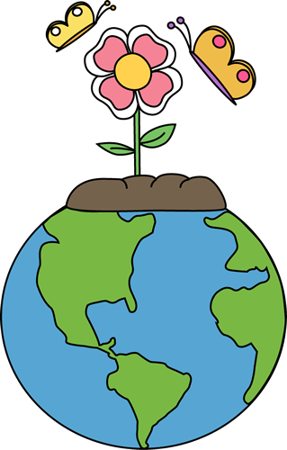](https://www.google.co.uk/url?sa=i&url=http%3A%2F%2Fclipart-library.com%2Fnature-art-pictures.html&psig=AOvVaw1l2Zr1rqQZhlYLRML4ATBu&ust=1585913366442000&source=images&cd=vfe&ved=0CAIQjRxqFwoTCJiG8OnRyegCFQAAAAAdAAAAABAD)