Thursday 23rd April

Literacy

* Make up 3 questions about your topic so far. Research these questions and write down the answers and the name of the source where you found the answer e.g. a science website, YouTube.
* Read a book from Big Cat Reading or Oxford Owl

[](https://www.google.co.uk/url?sa=i&url=https%3A%2F%2Fwww.storyroom.co.uk%2Fevents%2Fwriting-for-fun%2F&psig=AOvVaw3kOLeV2Ulsixb8HovdjLyF&ust=1585402303772000&source=images&cd=vfe&ved=0CAIQjRxqFwoTCIC8jPvhuugCFQAAAAAdAAAAABAE)

Numeracy

* Practise saying your 2, 5 & 10 times tables.
* Subtraction Revision: on Thursday and Friday this week, practise your 2-digit subtraction by completing the activity on Glow (Glow>numeracy>addition and subtraction>2 digit addition and subtraction> ‘2 digit subtraction’)

[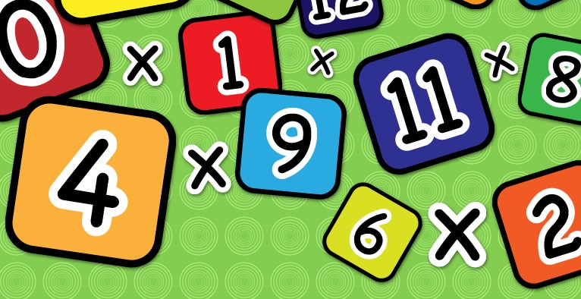](https://www.google.co.uk/url?sa=i&url=https%3A%2F%2Fwww.clipart.email%2Fclipart%2Ftimes-table-clipart-23041.html&psig=AOvVaw2j3dcFS3NOv2ZmTZA7Wc_j&ust=1585230100569000&source=images&cd=vfe&ved=0CAIQjRxqFwoTCIi1obrgtegCFQAAAAAdAAAAABAE)

Click on the link and do some PE. It is live at 9am.

<https://www.youtube.com/playlist?list=PLyCLoPd4VxBvPHOpzoEk5onAEbq40g2-k>

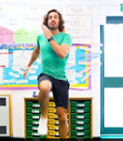

R.E. Relationships

It is good to think about others and do kind things for people who we care about. With an adult, talk about a time when you did something kind for a friend or family member.

[](https://www.google.co.uk/url?sa=i&url=https%3A%2F%2Fwww.clipartkey.com%2Fview%2FimToTw_transparent-people-working-together-clipart-team-high-five%2F&psig=AOvVaw2yVSC3xc1ecPAhz-5S3q5I&ust=1587473362214000&source=images&cd=vfe&ved=0CAIQjRxqFwoTCPCFx6SF9-gCFQAAAAAdAAAAABAD)

Family Time

FaceTime a family member or a family friend to say hello.

[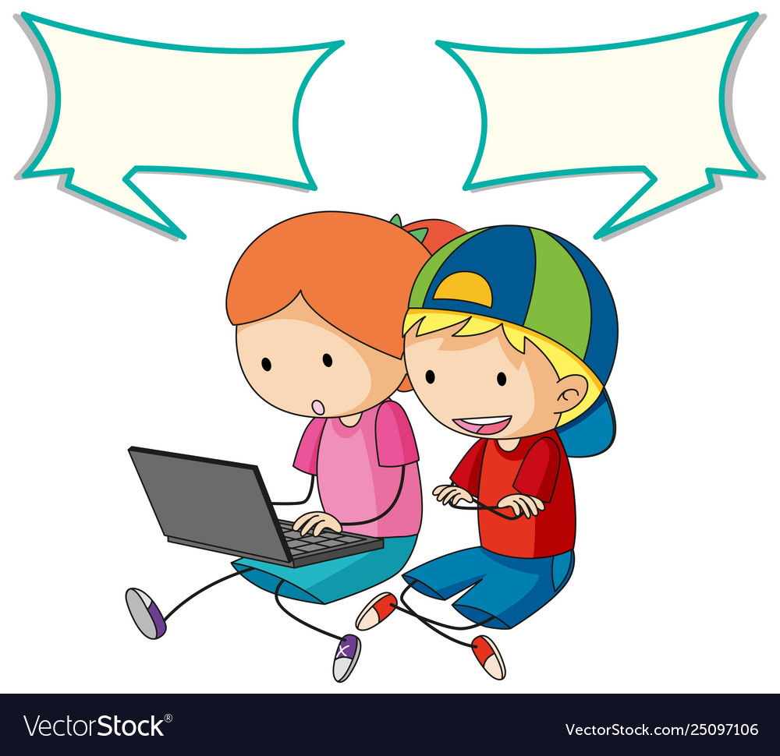](https://www.google.co.uk/url?sa=i&url=https%3A%2F%2Fwww.vectorstock.com%2Froyalty-free-vector%2Fkids-talking-with-computer-and-speech-bubble-vector-25097106&psig=AOvVaw1GeHWt_c7SRQgWAIlCiJ2r&ust=1587557676082000&source=images&cd=vfe&ved=0CAIQjRxqFwoTCKCtmLC_-egCFQAAAAAdAAAAABAK)

Planet Earth

Continue to work on your Earth Day project and remember- you can use whatever resources you like! The more creative, the better.

[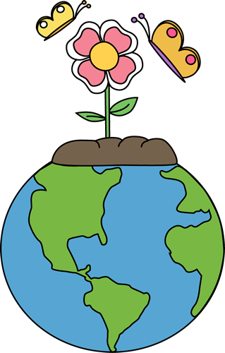](https://www.google.co.uk/url?sa=i&url=http%3A%2F%2Fclipart-library.com%2Fnature-art-pictures.html&psig=AOvVaw1l2Zr1rqQZhlYLRML4ATBu&ust=1585913366442000&source=images&cd=vfe&ved=0CAIQjRxqFwoTCJiG8OnRyegCFQAAAAAdAAAAABAD)