Please check in with me on class dojo or GLOW today, if you have not already done so this week. : ) | Story Writing!  Use your imagination to write your own imaginative story. Take time to plan your story as we do in class. Try to write at least a page of work. Your story can be about any topic you like!  Try to include: Correct punctuation, ambitious vocabulary and interesting sentence openers.  Send me your story when you are done! : ) |  | Log on to sumdog and take part in today’s challenge and play some games.  The house will be open in the afternoon : )
Using your PE skills, create and write your own exercise routine to last more than ten minutes.  Send me it when you are finished… I would love to give it a try! : ) | 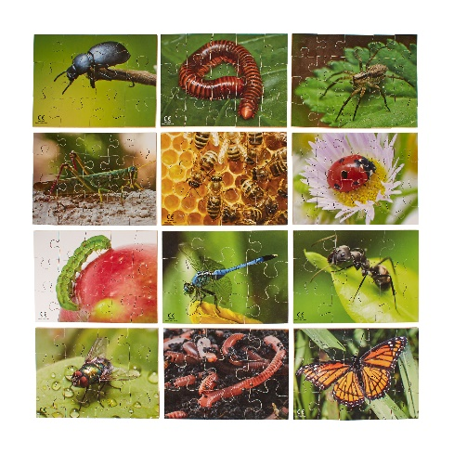Science!  If you can do so safely, go outside for a mini beast hunt! How many little creatures can you find? Write a list or take pictures! | P4’s Great bake Off!  If possible find a recipe online and bake a tasty treat for you and your family to enjoy! Send me a picture to post on the school website! : ) | Click on the link for an online music lesson… Today you will learn all about pitch and melody!  Have fun : )
Click on the link to learn all about adjectives. This will help improve your writing! Send me a list of ten super adjectives! | Here’s a quick daily challenge… How many words can you make using letters from the sentence below?  Write a list and send it to me! : ) | Design Challenge!  Using what you can around the house (like recycling) Use your imagination and create something!  Send me a picture so that I can share it on our school website : ) | Spend some time on your personal topic.  You could watch a video or do some research.  Let me know what you learned today!

