Wednesday 22nd April

Literacy

Log onto the World Books websites and read ‘Earth’s Features’:

<https://worldbook.kitaboo.com/reader/worldbook/#!/bookshelf>

Username: wbsupport

Password: distancelearn

Choose a feature and write 3 things you have learned about this feature.

[](https://www.google.co.uk/url?sa=i&url=https%3A%2F%2Fwww.pinterest.com%2Fpin%2F212443307401248816%2F&psig=AOvVaw1wW2uB8595qvcGlmIUUDOm&ust=1585912251814000&source=images&cd=vfe&ved=0CAIQjRxqFwoTCMCXu9XNyegCFQAAAAAdAAAAABAE)

EARTH DAY

Times Tables

Practise writing tables of your choice.

Challenge: go to your garden or a green area and collect as many loose leaves as you can. Put them into groups of 2, 4, 5, 8 or 10 and practise your times tables.

[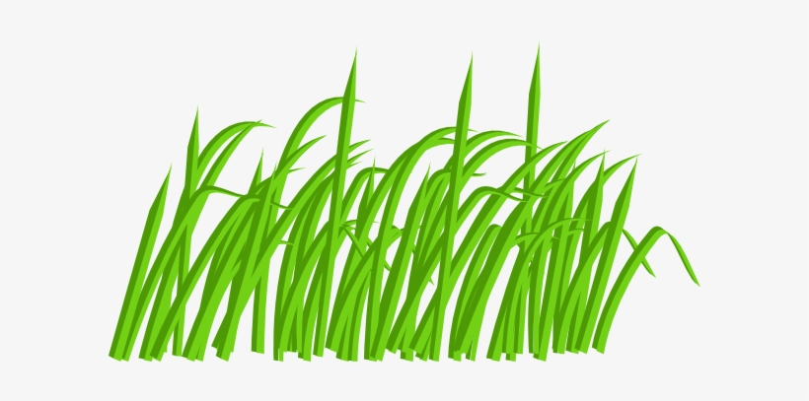](https://www.google.co.uk/url?sa=i&url=https%3A%2F%2Fwww.nicepng.com%2Fourpic%2Fu2q8u2q8u2o0w7u2_green-grass-blade-clip-art-at-clipart-library%2F&psig=AOvVaw2SRzUnHXJ95zowg1nXq7aa&ust=1585913242142000&source=images&cd=vfe&ved=0CAIQjRxqFwoTCOi-xq3RyegCFQAAAAAdAAAAABAE)

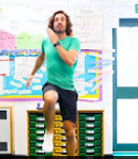

Click on the link and do some PE. It is live at 9am. Take your P.E. to the garden if you can!

<https://www.youtube.com/playlist?list=PLyCLoPd4VxBvPHOpzoEk5onAEbq40g2-k>

Earth Day Project

Over the next few days, try to use what you have learned this week to make a structure of Planet Earth. It can be as big or as small as you like and you can use any resources that you have at home. I have put examples on the next page. Have fun!

[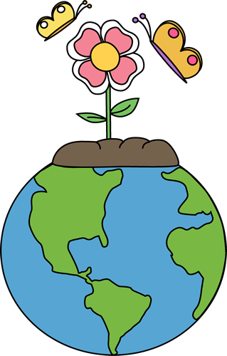](https://www.google.co.uk/url?sa=i&url=http%3A%2F%2Fclipart-library.com%2Fnature-art-pictures.html&psig=AOvVaw1l2Zr1rqQZhlYLRML4ATBu&ust=1585913366442000&source=images&cd=vfe&ved=0CAIQjRxqFwoTCJiG8OnRyegCFQAAAAAdAAAAABAD)

Family Fun

Go for a walk with your family today. Point out as many living things as you can, for example different plants and animals.

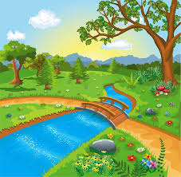

Art & Design

Click on the link to draw a picture of the Earth.

https://www.youtube.com/watch?v=5FhIa6614bE

[](https://www.google.co.uk/url?sa=i&url=https%3A%2F%2Fwww.clipart.email%2Fclipart%2Fcute-earth-clipart-images-236704.html&psig=AOvVaw2DJ_NkbyBCGo4eeocNaUS9&ust=1585912802529000&source=images&cd=vfe&ved=0CAIQjRxqFwoTCKCTi9zPyegCFQAAAAAdAAAAABAE)

