If you haven’t had a chance to complete many tasks from this week’s previous grids that you would like to try, go back and catch up : ) | 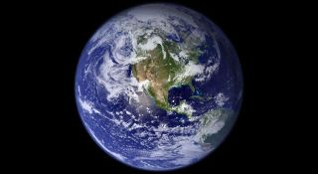  Click on the link to watch a video about the structure of planet earth. Design a poster to show this process  https://www.youtube.com/watch?v=eXiVGEEPQ6c | Daily challenge!  Using what you have around the house try and build your own den! Send me a picture if you can : ) | 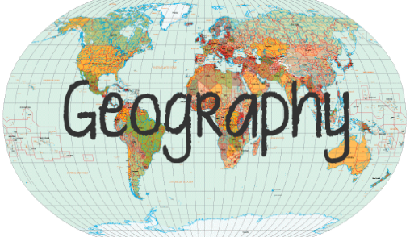  Click here to learn all about maps! There are a couple of activities to help improve your map skills  https://www.bbc.co.uk/bitesize/articles/zhtyvk7
Please check in with me on class dojo or GLOW today, if you have not already done so this week. : ) | If you are able, spend some time in your garden if you have one, or go on a nice long walk and enjoy some fresh air | Click on the link to enjoy a new story from David Walliams  https://www.worldofdavidwalliams.com/ | 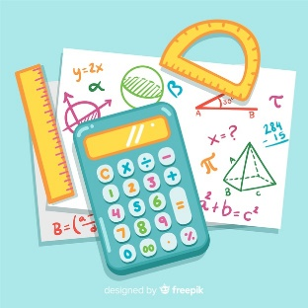  Log on to sumdog and take part in today’s challenge and play some games.  The house will be open in the afternoon : )
Handwriting!  Choose a song or poem that you enjoy. Use the words or lyrics to help you practise your joins! : ) | 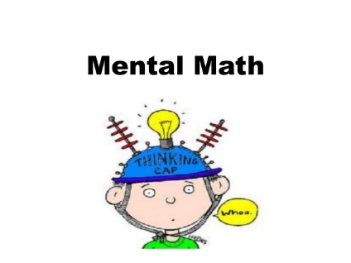  Click on the link and choose a few mental maths activities to complete for today  https://www.topmarks.co.uk/maths-games/7-11-years/mental-maths | Click on the link for a special “How to draw” video about planet earth. Send me a picture when you’re finished : ) | Click on the link to learn all about nouns today. Send me a list of ten nouns when you are done  https://www.bbc.co.uk/bitesize/articles/zjrdwty

