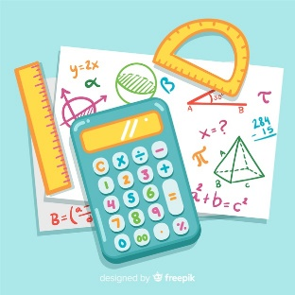  Log on to sumdog and take part in today’s challenge and play some games.  The house will be open in the afternoon : ) | 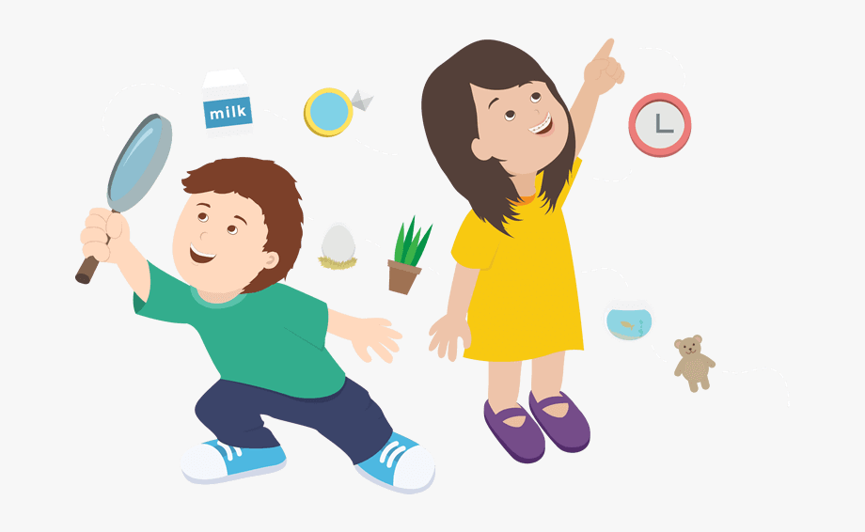  Scavenger Hunt!  Choose one of the three scavenger hunts below and go on a search adventure!  Send me your completed list : ) |   Click this link to watch videos and complete activities all about verbs!  Send me a list of ten super verbs : )  https://www.bbc.co.uk/bitesize/articles/zfc2mfr | 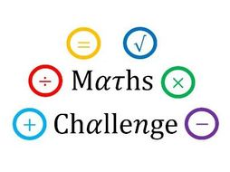  Click on the link and try to solve some maths problems! Let me know how you get on : )  https://www.bbc.co.uk/bitesize/articles/zbqrcqt
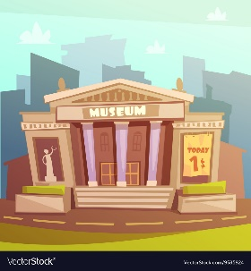  History!  Click on the link for a virtual tour of the British museum using google street view!  https://artsandculture.google.com/streetview/british-museum/AwEp68JO4NECkQ?sv_h=225.53002151215287&sv_p=4.046764584309912&sv_pid=bYHxfKckC7e8oxB7w-r4VA&sv_lid=3582009757710443819&sv_lng=-0.1273686125351787&sv_lat=51.51923665283547&sv_z=2.691129249945927 |   Click on the link to choose a dance class with Oti!  https://www.youtube.com/user/mosetsanagape | Research!  Choose an animal that you are interested in.  Research it as best you can… you could even search educational videos about it on youtube  Create a fact file with your new information and send me a picture |   Show off your food cooking skills by creating a food tutorial video for a recipe of your choice!  Share your recipe with family and friends
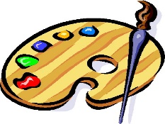  Design challenge!  Research famous logos such as apple, McDonalds and Starbucks…  Now Create a logo that represents you! Your symbol can be made up of words, letters or shapes. | Spend some technology free time with a family member…  You could read together, cook, play a board game or even learn a new card game.  Let me know what you choose : ) | 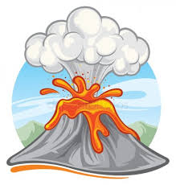  Science!  Click on the link to learn all about our Earth with Maddie Moat : ) Tell me your top 3 favourite facts on GLOW  https://www.youtube.com/watch?v=C36aB6JEGms | 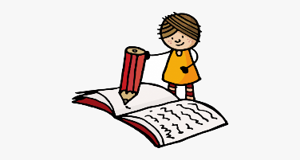  Literacy!  Write an acrostic poem about someone you admire!  It could be a family member, a friend, a celebrity, or even a book character!  Send me a picture when you’re finished : )

