Tuesday 21st April

Literacy

* Look at your new ‘common words of the week’ on Glow (under phonemes and common words of the week). Write 3 sentences using your new common words.
* Read an online book with an adult. If you are reading a white or lime band, you can read the same book throughout the week.

Challenge: Revise your common words flashcards (on Glow) from term 3.

[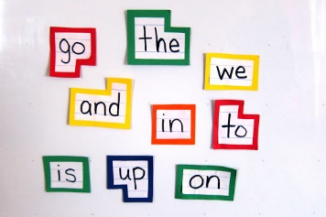](https://www.google.co.uk/url?sa=i&url=http%3A%2F%2Fclipart-library.com%2Freading-words-cliparts.html&psig=AOvVaw0aauAngIQQTDJzYOuR3xzY&ust=1585232996717000&source=images&cd=vfe&ved=0CAIQjRxqFwoTCID1wJ_rtegCFQAAAAAdAAAAABAE)

Times Tables

* Practise saying your 4 & 8 times tables.
* Addition Revision: on Monday and Tuesday this week, practise your 2-digit addition by completing the activity on Glow (Glow>numeracy>addition and subtraction>2 digit addition and subtraction> ‘2 digit addition’)
* Challenge: Practise your skills on Sumdog

[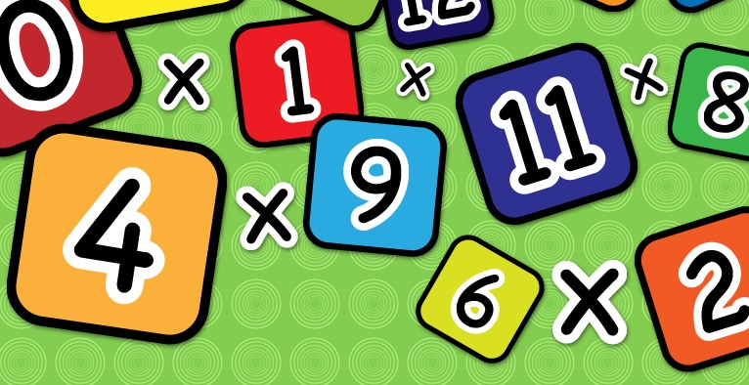](https://www.google.co.uk/url?sa=i&url=https%3A%2F%2Fwww.clipart.email%2Fclipart%2Ftimes-table-clipart-23041.html&psig=AOvVaw2j3dcFS3NOv2ZmTZA7Wc_j&ust=1585230100569000&source=images&cd=vfe&ved=0CAIQjRxqFwoTCIi1obrgtegCFQAAAAAdAAAAABAE)

P.E.

Click on the link and do some PE. It is live at 9am.

<https://www.youtube.com/playlist?list=PLyCLoPd4VxBvPHOpzoEk5onAEbq40g2-k>

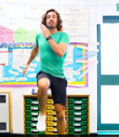

Planet Earth

Watch this video about how the Earth is made up. Write down, or share with someone at home, 4 things that you have learned. You might want to watch the video more than once to listen to all of the new words.

<https://www.youtube.com/watch?v=eXiVGEEPQ6c>

[](https://www.google.co.uk/url?sa=i&url=https%3A%2F%2Fwww.clipart.email%2Fclipart%2Fcute-earth-clipart-images-236704.html&psig=AOvVaw2DJ_NkbyBCGo4eeocNaUS9&ust=1585912802529000&source=images&cd=vfe&ved=0CAIQjRxqFwoTCKCTi9zPyegCFQAAAAAdAAAAABAE)

Reading

Follow this link and listen to David Walliams reading one of his books.

<https://www.worldofdavidwalliams.com/>

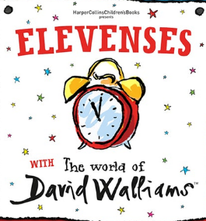

R.E.

For the next few weeks, we will explore relationships. To begin, draw a picture of you with your family or closest friends in a happy place. Label the people in your picture and tell someone at home why the people in the picture are so important to you.

[](https://www.google.co.uk/url?sa=i&url=https%3A%2F%2Fwww.clipartkey.com%2Fview%2FimToTw_transparent-people-working-together-clipart-team-high-five%2F&psig=AOvVaw2yVSC3xc1ecPAhz-5S3q5I&ust=1587473362214000&source=images&cd=vfe&ved=0CAIQjRxqFwoTCPCFx6SF9-gCFQAAAAAdAAAAABAD)