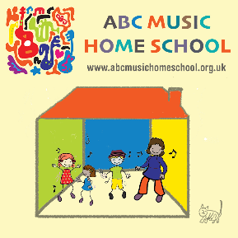

This resource is free to all parents – you just need to register and set up a password to use.
We have adapted our award-winning resources for schools and nurseries so that parents and other adult caregivers can confidently teach their children music at home. Even if you have no musical experience, we promise our resources are easy to use.

ABC Music Home School offers the following: -
age-targeted activity plans for parents and children
online interactive music, games & videos
timetable of video music lessons delivered by trainer on screen
downloadable worksheets
downloadable virtual instruments for phones and tablets
material to learn French and Spanish through music
resources for learning literacy and numeracy with music
We offer a range of easy to use material from Early Years to the end of Primary, focussing initially on Early Years to P3.
We are adding more material every day. We will also have a regular programme of online music lessons parents and children can watch together -
these will introduce parents to activities and resources on the website as well as being fun and engaging for children.

Simply go to the website to register today.

Please share far and wide and remember this resource is free!!

If you have any questions please email me tom@abccreativemusic.com

Best wishes

Tom Bancroft
ABC Creative Music

