
St. Barbara’s Primary School
August 2026

Welcome to St. Barbara’s August Newsletter!


Primary 1
The Primary 1 children have settled very well in school and are enjoying meeting lots of new people! Thanks to the Primary 7 Buddies who have supported them so well so far.

Uniform
Thank you very much for supporting our uniform policy. I would like to thank you for adhering so diligently to this policy. The children are resplendent in their uniforms; they are a credit to you and to the school.

Cafeteria
Children in Primaries 1 – 5 inclusive are entitled to free school lunches. Please ensure that any children in Primaries 6 and 7 have money on their cards for lunch.

Parents of children in Primaries 6 and 7 will shortly receive a code for online payment.
Children in Primaries 6 and 7 who are entitled to free school meals do not require money on their cards.

Breakfast Service (School-based)
The breakfast club is on in school each morning. Breakfast service opens at 8.15am with children going into the playground at 8.45am. Please do not drop your children off before the appointed time as we cannot guarantee to have staff available. Children should be here and seated for 8.30am at the latest.
Please note: Children attending breakfast club must have breakfast.

Allergy Awareness
Please let us know if your child has an allergy.
If your child has a food allergy, you must complete a specialist form in conjunction with your child’s dietician before your child can use the cafeteria service. Please contact the school for further information.

Under normal circumstances, children are encouraged to share toys etc. However, many children have a range of food allergies across the school including nuts, eggs etc. Consequently, we ask children NOT to share snacks etc. in order to keep all of our children safe.

Please note: St. Barbara’s is a NUT-FREE ZONE and a LATEX-FREE ZONE.
We have pupils with severe nut allergies. Please do not send nuts into school.


Photographer

The photographer will visit the school on Tuesday 8th September.

Bus Travel/ After-School-Care
Many parents of children who use the school bus will know that we take a bus register each day. If there is any change to your child’s normal arrangements, please contact the school office to let us know.
If there is any change to after-care arrangements, please ensure that you inform the service provider as well as the school. Thank you.

Bus Bay
The Parent Council was instrumental in getting the bus bay created on Drumcavel Road. A significant number of children travel to/from school by bus each day – please do not compromise their safety by parking in the bus bay. Thank you.

Drop-off
When dropping off your child please drop off at the top/bottom gate where there are members of staff supervising. We would like to take this opportunity to thank all parents/carers who drop and leave their children at these points as it can be very overwhelming for some of our children when there are large numbers of adults at the gates.
Collection
All young children should be collected by a parent/carer and should not be allowed to run around the playground. Any younger siblings should be supervised by a parent/carer as the playground is very busy at this time.

Staff Car Park
Please do not park in the staff car park at any point during the day including prior to the start of the school day.

I would like to ask all parents/guardians to refrain from parking in the school car park and on the yellow lines on Elmira Road. I do realize that it can be very difficult to park in the vicinity of the school and I appreciate the great efforts made by many to park and stride.

However, Fr. O’Brien has given permission for parents to use the church car park to drop off/pick up.
Many thanks to him for helping us to keep all of the children safe.




Sacramental Preparation

Confirmation (Primary 7)
Bishop Toal will confer the Sacrament of Confirmation on the Primary 7 children on Monday 26th October.

Each child will require a Sponsor. Ideally this should be one of your child’s Godparents; however it can be any practising Catholic over the age of sixteen – with the exception of parents.
More information will be sent to you in due course.

Bishop Toal will visit the school on Wednesday 2nd September and attend Assembly. He will then meet with the Primary 7 children.


Reconciliation (Primary 3)
The Sacrament of Reconciliation will take place on Tuesday 23rd February at 11am in St. Barbara’s Church. More information will be sent to you in due course.


First Holy Communion (Primary 4)
The date for First Holy Communion will be issued next week.

Parents/Carers of children in Sacramental classes will receive a brief form to complete shortly.
Further information in respect of all of the sacraments will be sent in due course.

----------------------------------------------------------------------

Parent Council A.G.M.

The annual Parent Council A.G.M. will take place on Monday 7th September at 7pm in the school.
Please come along to the A.G.M. to find out more about the work of the Parent Council.

The first meeting of the P.T.A. will follow this meeting – please come along and support them too!


Primary 1 Welcome Mass

The annual Primary 1 welcome Mass will take place on Tuesday 22nd September at 10am in St. Barbara’s Church. Everyone is welcome to attend.

God’s Loving Plan

The annual meeting for God’s Loving Plan, the relationships and moral education programme for Catholic Schools, will take place on Wednesday 23rd September at 7pm in the school.
It is imperative that parents of the current Primary 6 attend.
Parents of children in Primary 7 who attended last year are very welcome but do not need to attend again.

This meeting is aimed at parents/carers of children in Primaries 6 and 7 however everyone is welcome.


Meet the Teacher!

There will be an opportunity for you to come and meet your child’s teacher at a ‘Meet the Teacher’ event on Wednesday 2nd September.

You are very welcome to come into the school between 3.10pm and 3.40pm to see your child’s classroom and to meet his/her teacher. (These times are necessary in order to give the cleaning staff time to clean the buildings).

NOTE: The church car park will be available for you to use. Please take advantage of this to help our neighbours!

To ease congestion, please adhere to the following guidelines:

- A maximum of TWO ADULTS PER FAMILY are welcome to attend this event - and the children are welcome to accompany you.

- Please enter the main building through reception and exit the building through one of the playground doors

Please note: This is a very informal occasion and not an opportunity to ask individual questions about your child’s progress/curriculum.

We look forward to seeing you then!

---------------------------------------------------------------------------

GLOW/NL’s Digital School/Virtual Classroom
All children will be reminded of their GLOW login details or provided with new login information this/next week.

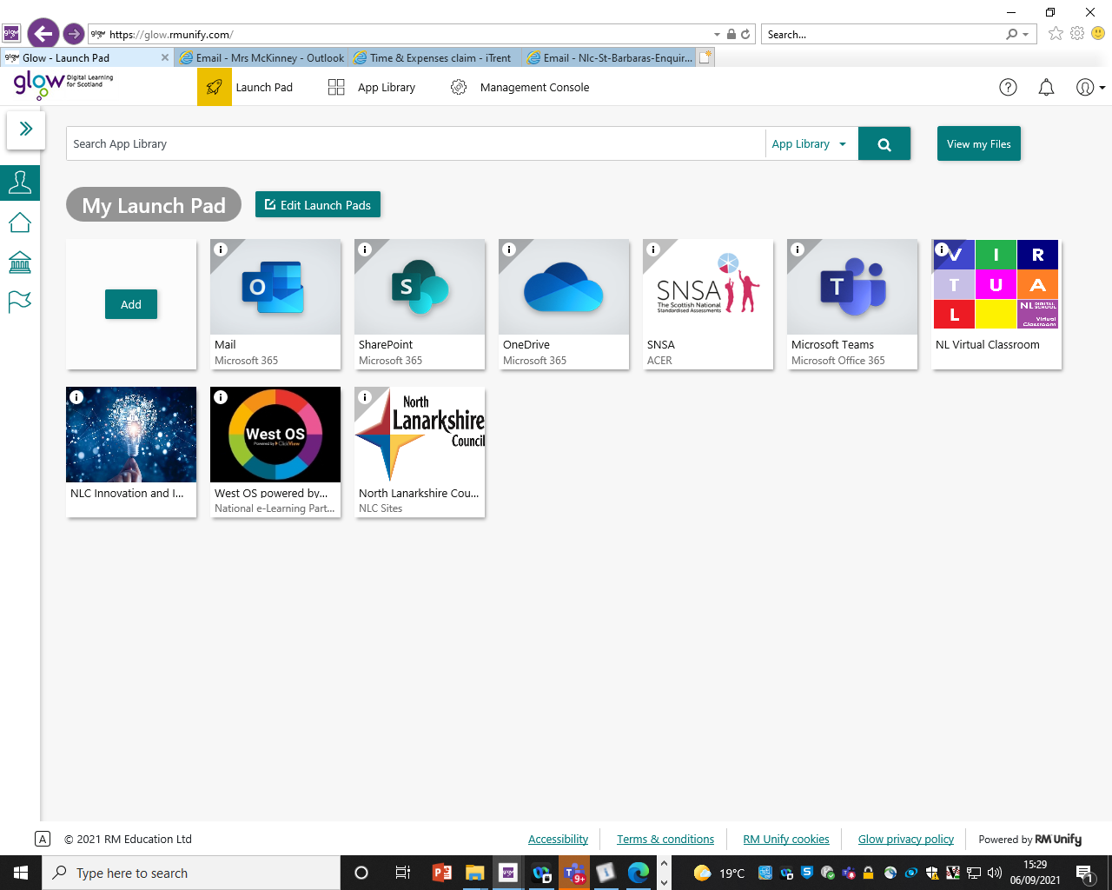
Guides to GLOW and the Virtual Classroom can be found in the Digital Learning section of the website.



---------------------------------------------------------------------------
Mass

The first school Mass of the session will take place on Friday 28th August at 10am in St. Barbara’s Church. Everyone is welcome.

September Holiday Weekend

School closes at 3pm on Thursday 24th September and will re-open on Tuesday 29th September at 9am.

October Holiday

School will close on Friday 9th October at 3pm and will re-open on Monday 19th October at 9am.

Parent Appointments

Parent appointments will take place in the school on Thursday 26th November.
The first session will begin at approximately 3.15pm and the second at approximately 6.15pm.
Further information including how to book your slots will be made available nearer the time.

P.E. Days
Please see days for P.E. below.

P.E. uniform should be worn each P.E. day.

Class | Staff | Days
P.1 | Miss Carrick | Tuesday & Thursday
P.2/1 | Mrs Armour/Mrs McEleney | Thursday & Friday
P.2 | Mrs Hone | Monday & Friday
P.3 | Mrs Boyce | Tuesday & Thursday
P.4/3 | Miss Donnelly/Mrs MacLeod | Monday & Thursdayf
P.5/4 | Miss McCormack/Mrs Grant | Monday & Friday
P.6/5 | Mrs Haughey/Miss Donnelly | Wednesday & Thursday
P.6 | Mrs Butler | Wednesday & Friday
P.7 | Mrs King | Tuesday and Friday



New Term Reminders

Water Bottles
The children are encouraged to sip water throughout the day.
Please make sure that your child has a water bottle daily. Please fill the water bottle for your child coming to school; these can be topped up during the day.

Snacks
Please ensure that your child has a small snack for morning interval; if your child is younger, please separate this from their packed lunch as this can be very confusing for them to choose what to eat before lunch. Small, healthy snacks are encouraged; some of the younger children have come in with party-sized bags of sweets!
Fizzy drinks and nuts are not permitted.


Birthdays
Birthdays are important occasions for all of our children and we have a special Birthday Wall in the school hall to celebrate with the children.
Treats cannot be brought into school to share with the class due to allergies.

Birthday Invitations
We all know how special and exciting birthdays are for all of our children. However, there are a few important points I would like to draw to your attention:

- As a school we are NOT allowed to issue class lists due to data protection legislation. We will be happy to give you numbers of children in your child’s class to help with your planning.
- In recent years there were parties to which class groups of boys or girls or indeed practically whole classes were invited. However, in one or two instances one child or two children were left out. This caused tremendous upset in school and beyond. Therefore, I would ask you to consider this when planning for the special event.
- Where you intend to invite all of the children in the class to a birthday party, you can choose to send an email invitation into the school and we will send it out via our Groupcall system.

- Birthday cakes: we are not permitted to accept birthday cakes/other treats for classes to celebrate birthdays in school.

Mobile Phones/Electronic Devices/Consoles
Many of our children have smart watches/mobile phones to enable parents to make contact outwith school hours.
I would like to remind everyone that phones must be switched off upon entering the school grounds and may be turned on only once the children have left the school grounds.
If you need to contact your child during the school day, please phone the office and we will be happy to help.
In addition, some children have brought expensive phones and fitbits, smart watches etc. to school. Please note that we are not insured for these items and any loss/damage will be at the owner’s risk.



Additionally, we do not allow the children to bring Nintendo Switch, iPads, iPods etc. to school as we are not insured should something happen to them.

Internet Safety

Throughout the year we maintain a focus on internet safety. We use material from the CEOP (Child Exploitation and Online Protection) website to support our work (details for parental access can be seen below).
Throughout the year the children will access the internet in school and at home to help with their work.
You will be aware the internet hosts many exciting opportunities for education. The online world is a wonderful place for young people to explore, with unprecedented opportunities for learning and creativity; however just like the real world there are risks and dangers they should be aware of and which we should all act to protect them from. As a school we encourage the use of technology as an important part of the children’s development but always want them to spend their time online safely. I am sure that you will support this aim.
Just a few simple steps by you can help keep them safe and help the children to know what to do if they feel uncomfortable about anything they encounter while on the internet.
If you do not wish your child to be able to access any inappropriate content online, please ensure that their computers, laptops and other devices with internet access are all fitted with parental controls.
You can find free downloadable versions online or you can contact your internet service provider (such as BT, Talk Talk, Sky) for more information.
As a minimum, please set parental controls on your search engines, youtube account and the mobile phone your child uses.
One of the most popular search engines in the world is Google. You can visit Google’s information safety centre for simple step by step guides - www.google.com/familysafety/tools

Below are a few options available to you; they truly are simple to set, promise.
Visit the Google home page – www.google.co.uk and click on the ‘search setting’ tab in the top right hand corner.
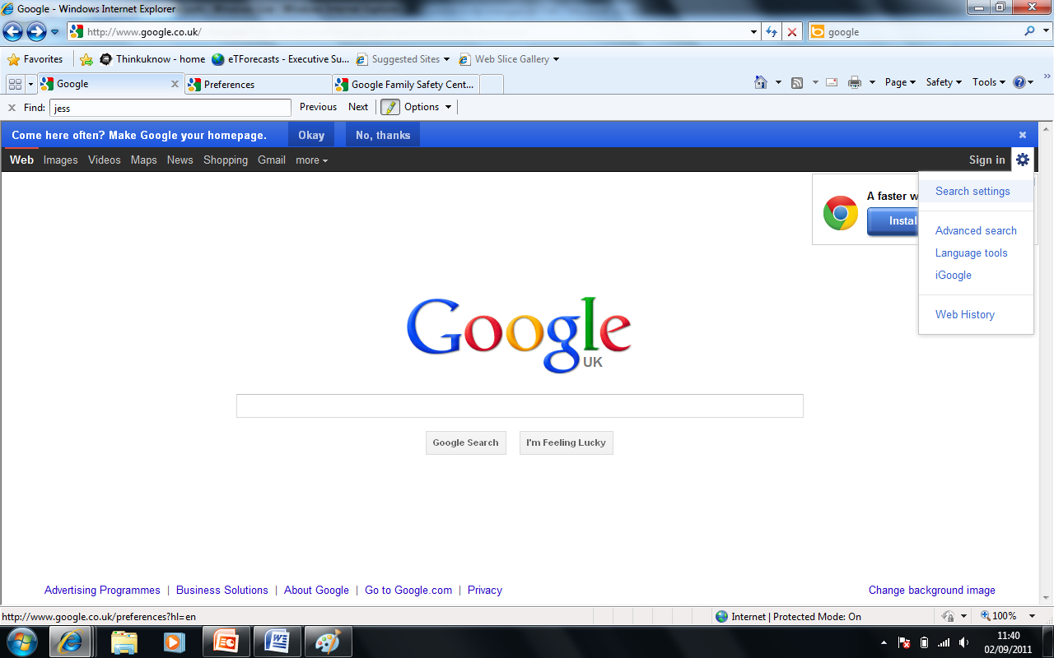
Scroll down the page and change the filtering options to suit your family’s needs. Make sure you lock the safe search; otherwise these settings can easily be changed without your knowledge.
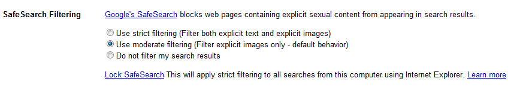
You can also set this on your child’s smart phone;
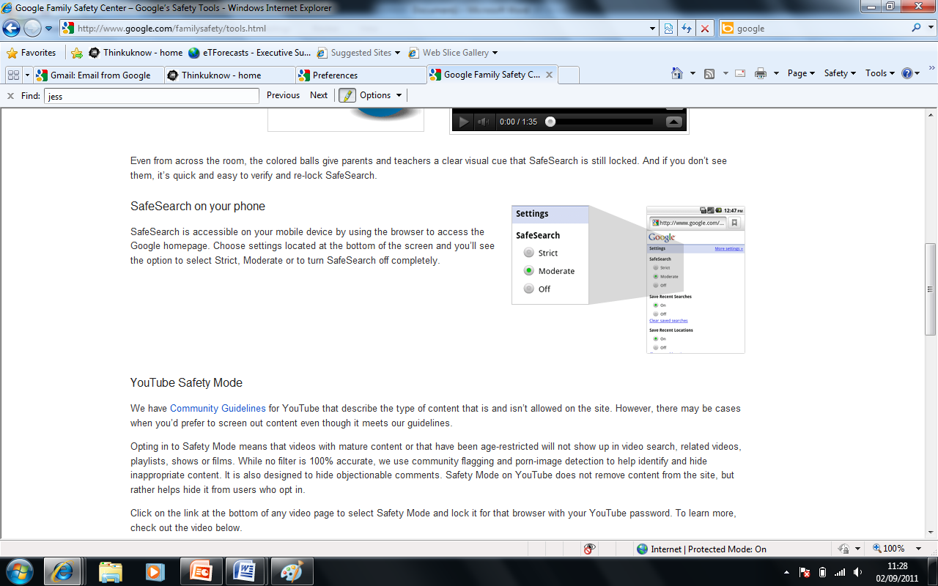
Please be aware that no filter is 100% accurate. CEOP advise that you talk to your child about the sites they use. Why don’t you discuss:
- Their favourite online sites
- What they enjoy most, the fun aspects of being online?
- What they think can go wrong?
- How would they react if things got out of control?

Let them know that you understand that situations happen online and that seeing ‘adult’ material can make them feel uncomfortable. Make sure they know that you are there to help.
Visit The Child Exploitation and Online Protection Centre (CEOP) parents’ information website for more information - www.thinkuknow.co.uk/parents
Look out for CEOP’s future parent and carers updates. Next addition – Christmas wish lists – Safety made easy.
Many social media sites have a minimum age for those wishing to join; however these are often ignored. Facebook, Instagram, Snapchat, WhatsApp and YouTube are all popular with children. In recent years there have been situations where children have posted inappropriate messages and/or videos in the heat of an argument. Sadly on occasions these have caused great hurt and the fallout has been felt both at home and in school. We teach the children that it is really important to think before you type! When children talk to their friends in the playground, their friends automatically pick up on the tone, facial expressions etc. and can determine what is actually meant. When a phrase is posted, meaning can often become unclear and arguments can develop.
If you require any further information, please contact the school and we will be happy to help.


Diary Dates

August

28th Whole school Mass – 10am

September

2nd Bishop Toal to visit the school

2nd Meet the Teacher: 3.10pm – 3.40pm

7th Parent Council AGM followed by PTA meeting – 7pm

8th School Photographer

22nd P.1 Welcome Mass – 10am

23rd God’s Loving Plan Meeting at 7pm in the school

25th/28th September Weekend

October Preview

5th Parent Council Meeting at 7pm

9th School closes at 3pm for October Break

19th School re-opens at 9am

26th Sacrament of Confirmation

30th Whole school Mass at 10am




Daniel Brannan Sebastien Bell Mila Hamilton Joe Lennon Aayat Ali

Jace McKellar Lewis Byrne Alfie McCracken Jay McGowan Harris Todd

Arran Henderson Zara Stan Hannah Wilkin

Amelia Gibson Riley Brown Alice Rose Polin Serge Murray



