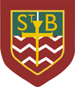**St. Barbara’s Primary School**

**October 2024**

Welcome to St. Barbara’s October Newsletter!

**Thank you!!!**

World’s Biggest Coffee Morning





Thank you so much for supporting this event in such large numbers this morning and for the huge numbers of donations.

**The grand total was £1118…amazing! Thank you so much.**

**School Photographer**

The photographer will visit the school on Tuesday 5th November.

**INSET Day**

A reminder that Monday 18th November is an INSET Day and children do not attend school.

School re-opens on Tuesday 19th November at 9am.

**Parent Council/PTA**

The next meeting of the Parent Council will take place on Monday 4th November at 7pm; the meeting of the PTA will follow.

**Parent Appointments**

Parent appointments will take place on Thursday 21st November 2024 from 3.10pm and into the evening. Details on how to book an appointment will be sent to you approximately a week before the event



School Leadership Opportunities

All of our children belong to one of four house groups which were named in collaboration with the whole school community several years ago: St. Andrew (Green), St. Bernadette (Red), St. Francis (Yellow) and St. Lucy (Blue).

The house groups give all children a voice – an opportunity to give opinions on a range of matters including school improvement and learning across the school.

The Houses are led by House Captains (traditionally from P.7) and by Vice-House Captains (traditionally from P.6). The Vice-House Captains become the House Captains once the holders pass to high school.

We recently held interview for the positions of Vice-House Captain and I am delighted to tell you the results below:

|  |  |  |
| --- | --- | --- |
|  | **House Captain(s)** | **Vice-House Captain** |
| **St. Andrew** | Cian Traquair | Darragh Hamilton |
| **St. Bernadette** | Mia Newton | Ailbhe McNamara |
| **St. Francis** | Miley Caldwell | Deri Duffy |
| **St. Lucy** | Lois Hagerty | Daniel Rice |



Next month we’ll update you on all of the other appointments across the school!

 **Halloween: Dress Up/Dress Down: Thursday 31st October**

On Thursday 31st October children can ‘dress-up/dress/down.’ If children choose to wear Halloween costumes they cannot bring props into school.

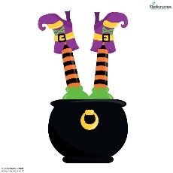I would also ask that **no** gory face paint (blood etc.)/Halloween masks/**clown costumes** are worn as some of the younger children find these very distressing.

If children choose to ‘dress down’ please remember that no football colours are allowed.

We are asking for a small donation for school funds on that day, please. Thank you.

Halloween Menu

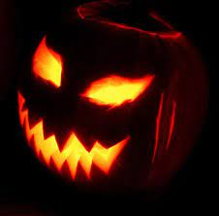

Halloween Menu

Thursday 31st October 2024

**Slimy Snake Broth**

**Chicken Noodle Soup**

**Witch’s Fingers**

**Hot Dog**

**Wizard’s Fingers**

**Vegan Hot Dog**

**Both options served with fries**

**Trick or Treat Sweet Warlock’s Brew**

**Home Baking Diluting Juice**

**Please note: Sandwiches and Baked Potatoes will NOT be available**

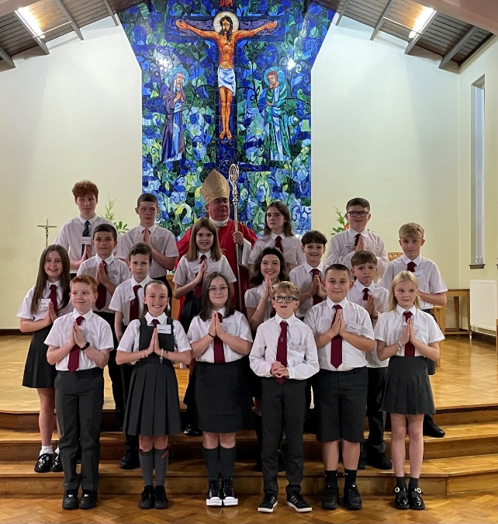

**Sacramental of Confirmation**

The Sacrament of Confirmation was conferred on the Primary 7 children yesterday evening Monday 28th October 2024 by Bishop Toal.

I would like to thank you, Bishop Toal, Fr. O’Brien and Miss Carrick for all of the hard work in preparation for the Sacrament; the children were a credit to you and to the school.

**‘Flu Immunisation**

The immunisation programme will take place on Friday 22nd November 2024**.**

**Allergy Awareness – especially at Halloween!**

Please let us know if your child has an allergy.

MC900215518[1]If your child has a food allergy, you **must** complete a specialist form in conjunction with your child’s dietician **before** your child can use the cafeteria service. Please contact the school for further information.

Please note: **St. Barbara’s is a NUT-FREE ZONE and a LATEX-REE ZONE.**

We have pupils with severe nut allergies. Please **do not** send nuts into school.

**Bus Travel/ After-School-Care**

Many parents of children who use the school bus will know that we take a bus register each day. If there is any change to your child’s normal arrangements, please contact the school office to let us know.

If there is any change to after-care arrangements, please ensure that you inform the service provider as well as the school. Thank you.

**Childsmile**

The Childsmile team will visit the school on Thursday 14th November for children in Primaries 1-4.

.

MC900356077[1]**Diary Dates**

**October**

Tuesday 29th Halloween Disco

Thursday 31st Halloween Dress up/Dress Down Day

**November**

Friday 1st Feast of All Saints – Mass at 10am

Monday 4th Parent Council/PTA – 7pm

Monday 4th Chryston High Transition Meeting (online)

Tuesday 5th Photographer

Thursday 14th Childsmile

Monday 18th INSET Day – children do not attend school

Wednesday 20th OLHS Transition Meeting (online)

Thursday 21st Parent Appointments

Friday 22nd Flu Immunization

Monday 25th Parent Council/PTA

Saturday 30th Christmas Coffee Morning

**Happy Birthday**



Lori Gallagher Adam Reid Winnie Walker

Marco McManus Reuben Reid Leonie Halligan Emily Herron

Aaron Ryan Eligh Sampaio Sofia Bryce Sophie Mulholland Gabriella Murray

Aiden Chen Aaron Bell Rebecca Cushley Alyssa Graham Mia Newton

Abbie Stevens