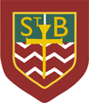**St. Barbara’s Primary School**

**September 2024**

Welcome to St. Barbara’s October Newsletter!

**September Holiday**

The school will close at 3pm on Thursday 26th September and will re-open on Tuesday 1st October at 9am. I hope that you all have a very enjoyable break.

World’s Biggest Coffee Morning





A very warm welcome to the annual coffee morning in support of the fantastic work done by the Macmillan team.

Please come along and support this event on **Thursday 26th September from 9.30am – 11.30am.**

We would be very grateful for donations of cakes etc. for this event. Please hand them into the school from Monday 23rd September – Wednesday 25th September.

Please include the ingredients if you are home-baking! Many thanks!

**Parish Baptism Course**

The annual Baptism course will take place each Tuesday from 3.10pm - 4.10pm for five weeks, beginning on Tuesday 22nd October 2024 in **St. Barbara's Church Hall.**

Once the course is complete, parents/carers should arrange a time with Fr. O'Brien for the Sacrament of Baptism.  
  
**Please note:**parents/carers are responsible for bringing/collecting the children.  
  
Please complete the form **before Thursday 12th September 2024** to book a place**,** thank you.

[**https://forms.office.com/e/3NKggFu3wU**](https://forms.office.com/e/3NKggFu3wU)

**HMIe Report**

The school was visited by HMIe in March 2024. The report was published last week and can be accessed via the following link:

<https://education.gov.scot/inspection-and-review/find-an-inspection-report/find-an-inspection-report/details?id=4462>

I would like to thank all parents/carers, the Parish community, our partners, all of our staff and of course the children who supported the process at that time.

**Maths Week Scotland**

****

Maths Week Scotland takes place week beginning 23rd September 2024.

The children will have lots of fun maths activities to explore both outside and inside that week.

We’ll keep you posted!

**Reporting to Parents**

Interim reports will be issued prior to the October break.

Parent Appointments will take place on **Thursday 21st November.** There will be an afternoon and an evening session. Further information in respect of booking an appointment will be issued nearer the time.

**Parent Council**

Many thanks to all those who expressed an interest in joining the Parent Council. The Council has been formed and the first meeting will take place on Monday 23rd September at 7pm in the school.

Any member of the Parent Forum (any parent/carer of a child in the school) is welcome to attend.

The PTA meeting will take at the conclusion of the Parent Council business.

**P.E.**

Thank you for sending the children to school wearing P.E. kits and trainers.

The new Parent Council will carry out a review of this over the coming year.

Please remember that no football colours, strappy tops, crop tops etc. are permitted, thank you.

**Breakfast Service**

The breakfast club is on in school each morning. Breakfast service opens at 8.15am with children going into the playground at 8.45am.

It should be emphasized that this is a breakfast club and NOT a wrap-around childcare facility. Should you require wrap-around care, there are a number of private providers in the local area.

[](https://www.google.co.uk/url?sa=i&rct=j&q=&esrc=s&source=images&cd=&ved=2ahUKEwj4xqjW-bTkAhUUbcAKHfQgAY8QjRx6BAgBEAQ&url=https%3A%2F%2Fwww.pinterest.com%2Fpin%2F432556739200074772%2F&psig=AOvVaw1umNDUiMeAmQ3LWRFU5kso&ust=1567610240870380)Please **do not drop your children off before the appointed time** as we cannot guarantee to have staff available. Children should be here and seated for **8.30am** at the latest in order for them to have time to enjoy breakfast in comfort.

**Annual Data Check/Annual Excursion Permission**

These have been issued. Please complete them and return them to school as quickly as possible. Many thanks to those who have already done so.

MC900434383[1]

**Emergency Contact Information**

* Please remember to inform the school if you change your mobile/house number
* Please remember to tell us about changes to emergency contacts for your child

Thank you!

**Allergy Awareness**

Please let us know if your child has an allergy.

MC900215518[1]If your child has a food allergy, you **must** complete a specialist form in conjunction with your child’s dietician **before** your child can use the cafeteria service. Please contact the school for further information.

Please note: **St. Barbara’s is a NUT-FREE ZONE.**

We have pupils with severe nut allergies. Please **do not** send nuts into school.

**Latex-Free Zone**

Please be aware that we have children with severe latex allergies.

**Bus Travel/ After-School-Care**

Many parents of children who use the school bus will know that we take a bus register each day. If there is any change to your child’s normal arrangements, please contact the school office to let us know.

If there is any change to after-care arrangements, please ensure that you inform the service provider as well as the school. Thank you.

**Bus Bay**

The Parent Council was instrumental in getting the bus bay created on Drumcavel Road. A significant number of children travel to/from school by bus each day – **please do not compromise their safety** by parking in the bus bay. Thank you.

**Health Promoting School**

Children are welcome to bring water bottles which can be filled during the course of the day to keep them hydrated. However fizzy drinks/energy drinks are not permitted. I ask for your continued support in this matter. Thank you.

**Sacramental Information**

The Sacrament of Confirmation will be conferred on the Primary 7 children on Monday 28th October 2024 at 7pm by Bishop Toal.

Please remember all of the children in your prayers.

**School Photographer**

The photographer will visit the school on **Tuesday 5th November.** The P.E. schedule will be amended that week to ensure that all children are wearing full school uniform.

**‘Flu Immunisation**

The immunisation programme will take place on Friday 22nd November 2024**.**

**October Holiday**

The school will close at 3pm on Friday 11th October for the October break; it will reopen on Monday 21st October at 9am.

**INSET Day**

The school will be closed to pupils on Monday 18th November for an INSET Day; it will reopen to pupils at 9am on Tuesday 19th November.

**Transition Reminder: OLHS**

The welcome Mass and orientation evening for children (and parents) moving to Our Lady’s High School in August 2025 will take place on Thursday 3rd October at 7pm in the high school. Children should wear full school uniform to this event.

**Animé**

It has come to our attention that some children are accessing animé online at home. You should be aware that there is an adult version of this; you might want to check what content your child is accessing.



**Halloween: Dress Up/Dress Down: Thursday 31st October**

On Thursday 31st October children can ‘dress-up/dress/down.’ If children choose to wear Halloween costumes they cannot bring props into school.

I would also ask that no gory face paint (blood etc.)/Halloween masks/**clown costumes** are worn as some of the younger children find these very distressing.

If children choose to ‘dress down’ please remember that no football colours are allowed.

We are asking for a small donation for school funds on that day, please. Thank you.

There will be a theme day in the cafeteria with menu details to follow.

--------------------------------------------------------------

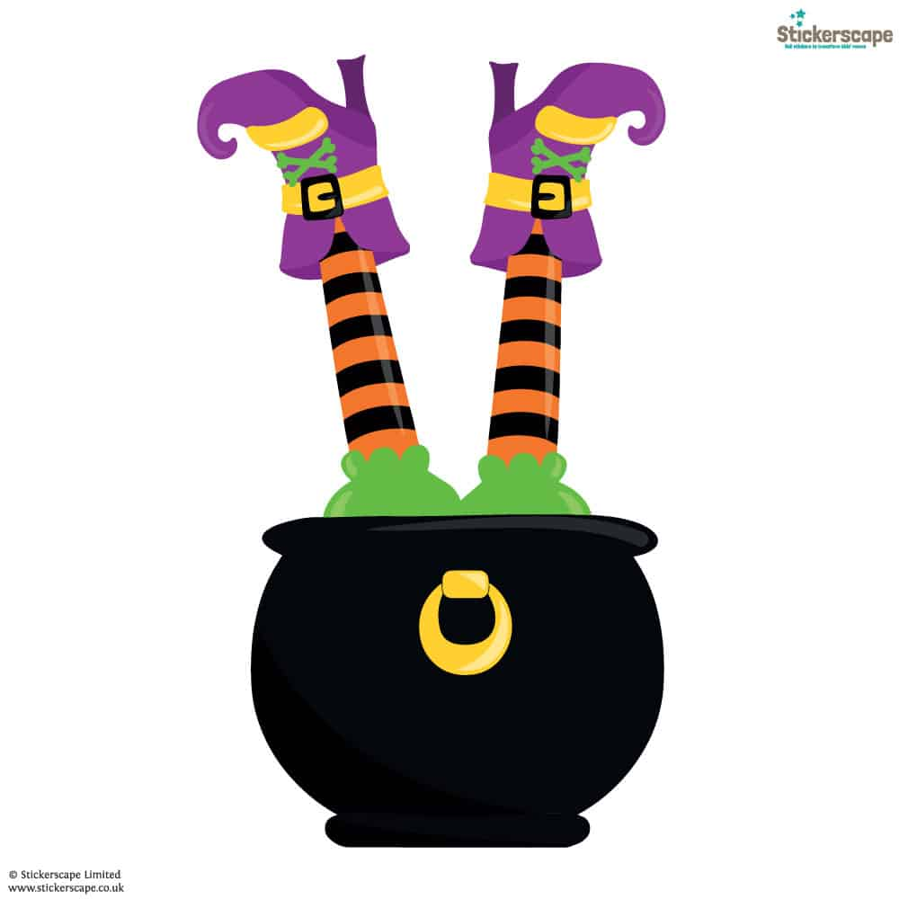**PTA Halloween Disco in the School Hall**

**Tuesday 29th October**

**6.30pm – 7.30pm Primary 1 – 3 children**

**7.45pm – 8.45pm Primary 4 – 7 children**

**More details to follow.**

MC900356077[1]**Diary Dates**

**September**

Monday 23rd 7pm Parent Council and PTA

Thursday 26th World’s Greatest Coffee Morning (9.30am – 11.30am)

Friday 27th/Monday 30th September weekend holiday

**October Preview**

Thursday 3rd P.7 children and families: OLHS Welcome Mass at 7pm

Friday 4th Whole school Mass at 10am

Friday 11th School closes at 3pm for the October break

Monday 21st School re-opens at 9am

Tuesday 22nd Parish Baptismal Course begins

Monday 28th Sacrament of Confirmation at 7pm

Tuesday 29th PTA Halloween Discos

Thursday 31st Dress up/dress down day

**November Preview**

Friday 1st Feast of All Saints: Mass at 10am

Tuesday 5th School Photographer

Monday 18th INSET Day – children do not attend school

Thursday 21st Parent Appointments

Friday 22nd Flu Immunization

C:\Users\Sheelah\AppData\Local\Microsoft\Windows\Temporary Internet Files\Content.IE5\B4YUHMQ5\MC900440414[1].wmf**Happy Birthday**

C:\Users\Sheelah\AppData\Local\Microsoft\Windows\Temporary Internet Files\Content.IE5\O3YLVVPW\MC900413580[1].wmf

Mya Clezy Liam Corey Addison Devine Niamh McGuire Lucas McKinlay

Nataniel Weremko Guy Kerr Connie Chen

Isabella Murray Zoe Dungavell Isabella Scullion

Saoirse-May Conway Tabitha Feeley Ava Keegan Amelia Doherty

Romano McManus Holly Boyle Luca Bryce Harris Devine breakfast_buddies_ii_by_psychopotato-d46wfc9[1]

Caden McKellar

