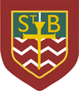**St. Barbara’s Primary School**

**October 2023**

Welcome to St. Barbara’s October Newsletter!

**October Holiday**

The school will close at 3pm on Friday 13th October and will re-open on Monday23rd October at 9am. I hope that you all have a very enjoyable break.

World’s Biggest Coffee Morning





Thank you so much for supporting this event in such large numbers this morning and for the huge numbers of donations.

The lucky winner of the 100 Square was Kathleen MacLeod in Primary 5! Congratulations to her!

**The total so far: £1300…amazing! Thank you so much.**

**Primary 6: Music Opportunity**

The children in Primary 6 have been given a fantastic opportunity to participate in an NL music pilot initiative. All of the children have been auditioned to play a variety of woodwind and brass instrument…made from plastic!

Each Wednesday morning, NL music tutors visit the school to teach the children in sections and then as a large ensemble.

Hopefully some of the children will be inspired to learn to play in the future.

We’re all hoping that the group will play for everyone later in the school year!



School Leadership Opportunities

All of our children belong to one of four house groups which were named in collaboration with the whole school community several years ago: St. Andrew (Green), St. Bernadette (Red), St. Francis (Yellow) and St. Lucy (Blue).

The house groups give all children a voice – an opportunity to give opinions on a range of matters including school improvement and, recently, the National Discussion on Education and learning across the school.

The Houses are led by House Captains (traditionally from P.7) and by Vice-House Captains (traditionally from P.6). The Vice-House Captains become the House Captains once the holders pass to high school.

We recently held interview for the positions of Vice-House Captain and I am delighted to tell you the results below:

|  |  |  |
| --- | --- | --- |
|  | **House Captain(s)** | **Vice-House Captain** |
| **St. Andrew** | Charlotte Ferry | Cian Traquair |
| **St. Bernadette** | Gracie Connell  Aiden McColligan | Mia Newton |
| **St. Francis** | Keir O’Connor | Miley Caldwell |
| **St. Lucy** | Ronan Bell | Lois Hagerty |





**Halloween: Dress Up/Dress Down: Tuesday 31st October**

On Tuesday 31st October children can ‘dress-up/dress/down.’ If children choose to wear Halloween costumes they cannot bring props into school.

I would also ask that no gory face paint (blood etc.)/Halloween masks/**clown costumes** are worn as some of the younger children find these very distressing.

If children choose to ‘dress down’ please remember that no football colours are allowed.

We are asking for a small donation for school funds on that day, please. Thank you.

There will be a theme day in the cafeteria with menu details to follow.

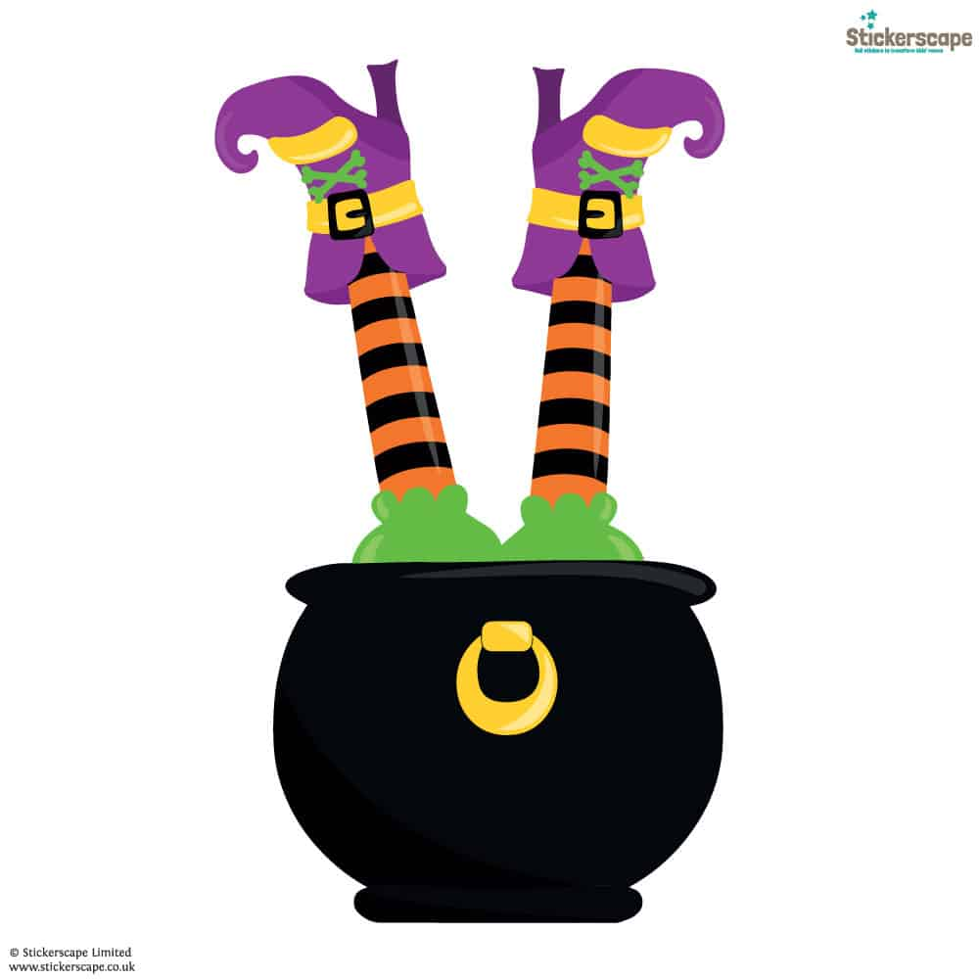**PTA Halloween Disco…**

**Thursday 26th October**

**6.30pm – 7.30pm Primary 1 – 3 children**

**7.45pm – 8.45pm Primary 4 – 7 children**

**More details will follow.**

**INSET Day**

A reminder that Monday 13th November is an INSET Day and children do not attend school.

School re-opens on Tuesday 14th November at 9am.

**Sacramental Information**

The Sacrament of Confirmation will be conferred on the Primary 7 children on Tuesday 24th October 2023 at 7pm by Bishop Toal.

Please remember all of the children in your prayers.

**‘Flu Immunisation**

The immunisation programme will take place on Wednesday 9th November 2022**.**

**Uniform**

Thank you very much for supporting our updated uniform policy. I would like to thank you for adhering so diligently to this policy. The children are resplendent in their uniforms complete with school shoes and jackets; they are a credit to you and to the school.

**Please remember that all branded footwear/clothing is NOT permitted. This policy is in line with the high school and it does extend to P.E. clothing. Thank you.**

**Breakfast Service**

The breakfast club is on in school each morning. Breakfast service opens at 8.15am with children going into the playground at 8.45am.

[](https://www.google.co.uk/url?sa=i&rct=j&q=&esrc=s&source=images&cd=&ved=2ahUKEwj4xqjW-bTkAhUUbcAKHfQgAY8QjRx6BAgBEAQ&url=https%3A%2F%2Fwww.pinterest.com%2Fpin%2F432556739200074772%2F&psig=AOvVaw1umNDUiMeAmQ3LWRFU5kso&ust=1567610240870380)Please **do not drop your children off before the appointed time** as we cannot guarantee to have staff available. Children should be here and seated for **8.30am** at the latest.

**Annual Data Check/Annual Excursion Permission**

These have been issued. Please complete them and return them to school as quickly as possible. Many thanks to those who have already done so.

MC900434383[1]

**Emergency Contact Information**

* Please remember to inform the school if you change your mobile/house number
* Please remember to tell us about changes to emergency contacts for your child

Thank you!

**Allergy Awareness**

Please let us know if your child has an allergy.

MC900215518[1]If your child has a food allergy, you **must** complete a specialist form in conjunction with your child’s dietician **before** your child can use the cafeteria service. Please contact the school for further information.

Please note: **St. Barbara’s is a NUT-FREE ZONE.**

We have pupils with severe nut allergies. Please **do not** send nuts into school.

**Bus Travel/ After-School-Care**

Many parents of children who use the school bus will know that we take a bus register each day. If there is any change to your child’s normal arrangements, please contact the school office to let us know.

If there is any change to after-care arrangements, please ensure that you inform the service provider as well as the school. Thank you.

**Bus Bay**

The Parent Council was instrumental in getting the bus bay created on Drumcavel Road. A significant number of children travel to/from school by bus each day – **please do not compromise their safety** by parking in the bus bay. Thank you.

**Health Promoting School**

Children are welcome to bring water bottles which can be filled during the course of the day to keep them hydrated. However fizzy drinks/energy drinks are not permitted. I ask for your continued support in this matter. Thank you.

MC900356077[1]**Diary Dates**

**October**

Friday 13th School closes at 3pm for the October break

Monday 23rd School re-opens at 9am

Tuesday 24th Sacrament of Confirmation

Thursday 26th Halloween Disco

Tuesday 31st Halloween Dress up/Dress Down Day

C:\Users\Sheelah\AppData\Local\Microsoft\Windows\Temporary Internet Files\Content.IE5\B4YUHMQ5\MC900440414[1].wmf**Happy Birthday**

C:\Users\Sheelah\AppData\Local\Microsoft\Windows\Temporary Internet Files\Content.IE5\O3YLVVPW\MC900413580[1].wmf

Guy Kerr Connie Chen

Isabella Murray Zoe Dungavell Isabella Scullion

Saoirse-May Conway Tabitha Feeley Ava Keegan

Romano McManus Holly Boyle Luca Bryce Harris Devine breakfast_buddies_ii_by_psychopotato-d46wfc9[1]

Lucy Gillooly Caden McKellar Luke McFall



Marco McManus Reuben Reid Leonie Halligan Emily Herron

Aaron Ryan Eligh Sampaio Sofia Bryce Sophie Mulholland Gabriella Murray

Aiden Chen Aaron Bell Rebecca Cushley Alyssa Graham Mia Newton

C:\Users\Sheelah\AppData\Local\Microsoft\Windows\Temporary Internet Files\Content.IE5\B4YUHMQ5\MC900440414[1].wmfAbbie Stevens