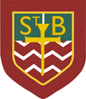
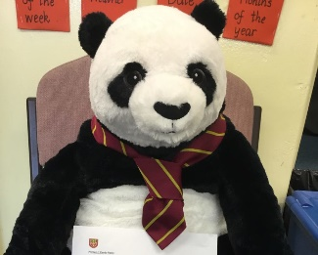
St. Barbara’s Primary School

Penny the Panda
Dear Parents/Carers and Children,
A very warm welcome to St. Barbara’s Primary School! We are looking forward to your child and your family joining our school community shortly.
The transition process from Early Years to Primary takes place over several months and will include visits to see the children in their Early Years setting.
There are two sessions in school for parents and children to attend. Both sessions will run from 9.30am – 10.30am with the children going to class for activities while parents/carers remain in the hall for salient information.
Tuesday 9th May 2023
This session will include curricular information and a visit from our uniform provider, Logoxpres.
You are very welcome to look at uniform items and sizes – however you are under no obligation to purchase uniform from our supplier – you can buy from any retailer of your choice.
Tuesday 16th May 2023
This session will include practical arrangements for the new term in August and a number of guest speakers who will tell you more about the school community and Parish.
You will have an opportunity to hear from the school cafeteria team and the children will have a packed lunch to take away afterwards.
St. Barbara’s Primary 6 Buddies will be on hand to meet with the children and to introduce themselves to you also.

In the meantime, please access the school website and follow us on Twitter @St_BarbarasPS to keep up-to-date.

You can also access a number of short videos on the St. Barbara’s YouTube channel; please search for ‘St. Barbara’s Teddy’ to follow the adventures of Penny the Panda!

If you have any questions, please contact us:
Telephone: 01236 794840 Email: enquiries-at-st-barbaras@northlan.org.uk

Kind Regards
St. Barbara’s

