Dear Parent,

GLOW/TEAMS

GLOW/TEAMS is a secure digital platform used by educational establishments across Scotland which facilitates communication between staff and children for educational purposes. Access to GLOW is restricted to teachers and children. Glow allows learners to work in a variety of ways, from collaborating with peers to working individually at their own pace. Glow services are free to all students with a Glow login and can be accessed at anytime, anywhere, and on any device. The platform allows children to access Microsoft Office including Word and PowerPoint to help with online tasks. Children can also email their teachers.
To access GLOW, please take the following steps:

- Google: Glow Login RM Unify
- Insert the username and password (issued to all children)

On the left hand-side, you will see a ‘Person Icon.’ This indicates the child’s home screen or Launch Pad.

NLC
App
Virtual
Class-room

The image shows a number of tiles or apps. The most important one is the Microsoft Teams app. Here the children can access homework tasks from the teacher and upload materials as required. Microsoft Teams will enable your child to participate on any online sessions – again as required.

Apps can be added to the Launch Pad as required (please see below for details on how to do this) and children should add the NL Virtual Classroom and the North Lanarkshire Council apps if they have not already been loaded.

Please Note: Some apps will NOT be available to children as they are restricted to staff.

Adding an App

To add an app, click on the right hand-side of the launch bar until ‘App Library’ appears.
Type the selected App name into the search bar and once it appears select:
‘Add to my Launch Pad.’
The App will now appear in the user’s launch pad.

Search bar

School Access

To access the School Website and a range of other useful apps, change the Person Icon to the School Icon on the left hand-side.
Again, some apps are restricted to staff – however there are many more to explore!

Access school website

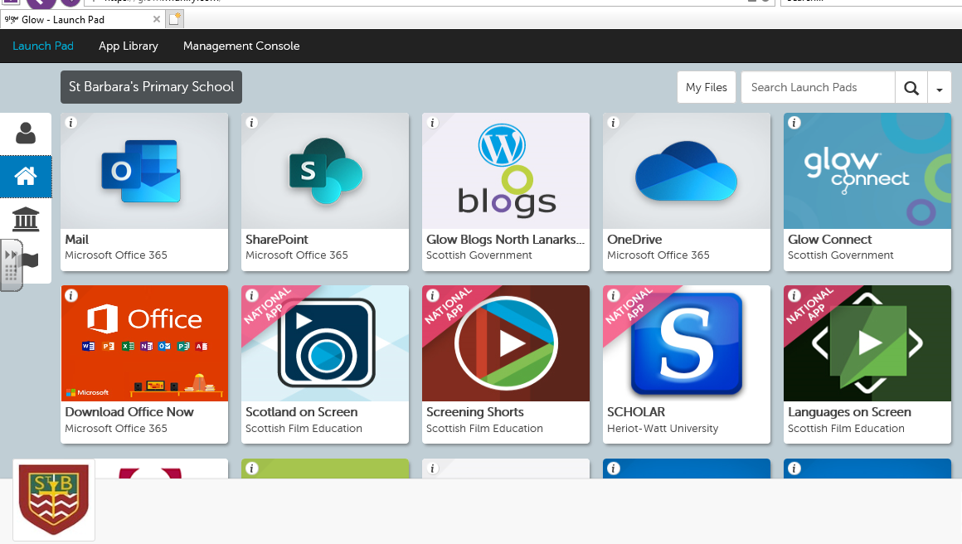

School

Email

M/soft
Office

The Virtual Classroom

Once logged into GLOW your child will be able to access the Virtual Classroom.
The Classroom has been created to support learners at home while they are isolating for a period of time or while they are awaiting test results on a short-term basis. It can also be used by staff to supplement on-going tasks in school as desired.

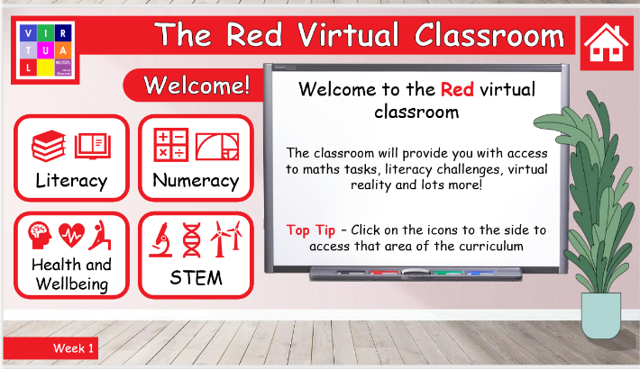
Once opened, your child will see a number of coloured tiles which roughly correspond to stages/levels. Once a colour is accessed, your child will have access to a range of Literacy, Numeracy, HWB and STEM (Science, Technology, Engineering and Maths) tasks to enjoy and to complete.
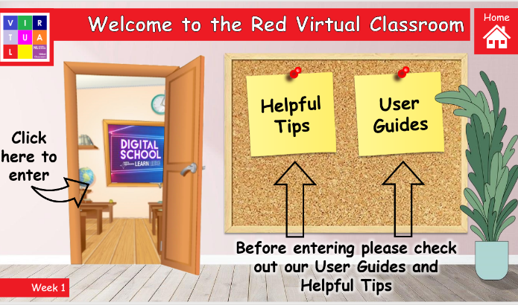
Below you will find the colours with approximate stages. For longer periods of isolation, the class teacher will indicate which colour(s) should be accessed.

Stage | Colour
Primary 1 | RED
Primary 2 | ORANGE
Primary 3 | YELLOW
Primary 4 | GREEN
Primary 5 | BLUE
Primary 6 | INDIGO
Primary 7 | VIOLET

Further information for parents can be found in the Parent Guide which has been attached as a SEPARATE document, thank you.

Please do not hesitate to contact the school if you experience any problems and we will be happy to help.

