**St. Barbara’s Primary School**

**August 2022**

Welcome to St. Barbara’s August Newsletter!



**Primary 1**

The Primary 1 children have settled very well in school and are enjoying meeting lots of new people! Thanks to the Primary 7 Buddies who have supported them so well so far!

**Uniform**

Thank you very much for supporting our uniform policy. I would like to thank you for adhering so diligently to this policy. The children are resplendent in their uniforms complete with school shoes and jackets; they are a credit to you and to the school.

**Primary 4-7 Pitch Reminder**

Children in Primaries 4-7 spend their intervals on the pitch. Please ensure that your child has an OLD pair of shoes to change into for intervals to keep their school shoes in pristine condition!

**Bus Travel/ After-School-Care**

Many parents of children who use the school bus will know that we take a bus register each day. If there is any change to your child’s normal arrangements, please contact the school office to let us know.

If there is any change to after-care arrangements, please ensure that you inform the service provider as well as the school. Thank you.

**Bus Bay**

The Parent Council was instrumental in getting the bus bay created on Drumcavel Road. A significant number of children travel to/from school by bus each day – **please do not compromise their safety by parking in the bus bay.** Thank you.

**Staff Car Park**

I would like to ask all parents/guardians to refrain from parking in the school car park and on the yellow lines on Elmira Road. I do realize that it can be very difficult to park in the vicinity of the school and I appreciate the great efforts made by many to park and stride.

Please **do not** park in the staff car park **at any point** during the day including prior to the start of the school day.

The car park is in use throughout the day, particularly for deliveries where lorries can be very large; consequently the car park can be very dangerous.

The car park is also used by those working in the annexe who also need access throughout the day.

The children are **not permitted** to cross the car park at any time, unless accompanied by a member of staff. Thank you.

**Sacramental Preparation**

**Confirmation**

Bishop Toal will confer the Sacrament of Confirmation on the Primary 7 children on Wednesday 26th October at 7pm in St. Barbara’s Church.

Each child will require a Sponsor. Ideally this should be one of your child’s Godparents; however it can be any ***practising Catholic*** over the age of sixteen – with the exception of parents.

More information will be sent to you in due course.

**Primary 7: Visit to Strathclyde Park**

The Primary 7 will enjoy a week-long series of outdoor activities in Strathclyde Park from 10th -14th October inclusive – led by NL Active Schools’ staff.

The cost of the visit is £108 which includes all activities, transport and lunch. Further details will be sent to you shortly.



**Parent Appointments**

Parent appointments will take place in the school on Thursday 6th October.

The first session will begin at approximately 3.15pm and the second at approximately 6.15pm. Further information including how to book your slots will be made available nearer the time.

**Breakfast Service**

[](https://www.google.co.uk/url?sa=i&rct=j&q=&esrc=s&source=images&cd=&ved=2ahUKEwj4xqjW-bTkAhUUbcAKHfQgAY8QjRx6BAgBEAQ&url=https%3A%2F%2Fwww.pinterest.com%2Fpin%2F432556739200074772%2F&psig=AOvVaw1umNDUiMeAmQ3LWRFU5kso&ust=1567610240870380)The breakfast club is on in school each morning. Breakfast service opens at 8.15am with children going into the playground at 8.45am. Please do not drop your children off before the appointed time as we cannot guarantee to have staff available. Children should be here and seated for **8.30am** at the latest.

**Allergy Awareness**

Please let us know if your child has an allergy.

MC900215518[1]If your child has a food allergy, you **must** complete a specialist form in conjunction with your child’s dietician **before** your child can use the cafeteria service. Please contact the school for further information.

Please note: **St. Barbara’s is a NUT-FREE ZONE.**

We have pupils with severe nut allergies. Please **do not** send nuts into school.

**GLOW/NL’s Virtual Classroom**

All children will be reminded of their GLOW login details or provided with new login information next week.

A guide to GLOW can be found in a separate attachement.

All children will have ONE homework task to complete on GLOW next week.

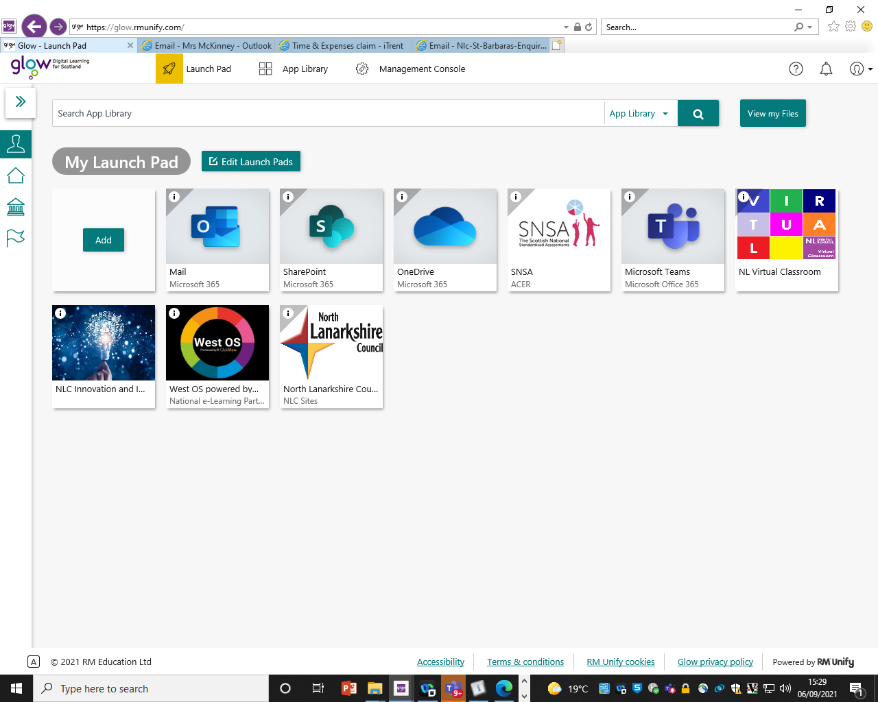



**Birthdays**

Birthdays are important occasions for all of our children and we have a special Birthday Wall in the school hall to celebrate with the children.

Treats cannot be brought into school to share with the class due to allergies.

**Birthday Invitations**

We all know how special and exciting birthdays are for all of our children. However there are two important points I would like to draw to your attention:

1. As a school we are NOT allowed to issue class lists due to data protection legislation. We will be happy to give you numbers of children in your child’s class to help your planning.
2. In recent years there were parties to which class groups of boys or girls or indeed practically whole classes were invited. However in one or two instances one child or two children were left out. This caused tremendous upset in school and beyond. Therefore I would ask you to consider this when planning for the special event.
3. Since the pandemic, parents have organized small gatherings/parties via social media rather than sending paper invitations in to school which are then passed onto other homes. I should be very grateful if you would continue this practice at present.
4. Birthday cakes: we are not permitted to accept birthday cakes/other treats for classes to celebrate birthdays in school.

MP900384807[1]

**Parent Council A.G.M. and PTA**

The Parent Council members are a point of contact for all members of the Parent Forum (any parent of legal guardian of a child in the school). They support the school in a wide variety of ways, including school improvement. They were instrumental in getting the bus bay installed on Drumcavel Road.

The Parent Council is organized/elected for a three-year period with the most recent election taking place last session. Each year we hold an A.G.M. and this year will be the first in which we can hold a face-to-face meeting since the pandemic.

The A.G.M. will take place on **Thursday 1st September at 7pm in the school** and any member of the Parent Forum is welcome to attend.

The Parent Council Constitution permits a maximum of eleven and a minimum of seven parent members; we currently have **two** vacancies on the Parent Council due to parents retiring as their children have moved to high school.

If you would like to join the Parent Council, please contact me to register your interest **on/before Wednesday 31st August.** If more than two parents are interested in joining, a formal election will be held.

The PTA is the fundraising arm of the school and the first meeting **will follow the Parent Council A.G.M. on Thursday 1st September.**

**P.E. Days**

Please see days for P.E. below.

|  |  |  |  |
| --- | --- | --- | --- |
| **Class** | **P.E. Days** | **Class** | **P.E. Days** |
| Primary 1 (both) | Tuesday & Thursday | Primary 4 | Wednesday & Friday |
| Primary 2 | Monday & Wednesday | Primary 5 | Tuesday & Thursday |
| Primary 2/3 | Wednesday & Friday | Primary 6 | Tuesday & Thursday |
| Primary 3/4 | Monday & Wednesday | Primary 7 | Wednesday & Friday |

**Please note:**

* **No football colours are permitted**
* **Jewellery should be removed**
* **Crop tops/strappy tops are not permitted**



**Mobile Phones/Electronic Devices/Consoles**

Many of our children have mobile phones to enable parents to make contact outwith school hours.

I would like to remind everyone that phones **must** be switched off upon entering the school grounds and may be turned on only once the children have left the school grounds.

If you need to contact your child during the school day, please phone the office and we will be happy to help.

In addition, some children have brought expensive phones and fitbits, smart watches etc. to school. Please note that we are **not insured** for these items and any loss/damage will be at the owner’s risk.

http://i1.cdnds.net/12/30/618x522/gaming_console_revision_gallery_5.jpgAdditionally, we **do not allow** the children to bring Nintendo Switch, ipads, ipods etc. to school as we are not insured should something happen to them.

**Internet Safety**

Throughout the year we maintain a focus on internet safety. We use material from the CEOP (Child Exploitation and Online Protection) website to support our work (details for parental access can be seen below).

Throughout the year the children will access the internet in school and at home to help with their work.

You will be aware the internet hosts many exciting opportunities for education. The online world is a wonderful place for young people to explore, with unprecedented opportunities for learning and creativity; however just like the real world there are risks and dangers they should be aware of and which we should all act to protect them from. As a school we encourage the use of technology as an important part of the children’s development but always want them to spend their time online safely. I am sure that you will support this aim.

Just a few simple steps by you can help keep them safe and help the children to know what to do if they feel uncomfortable about anything they encounter while on the internet.

If you do not wish your child to be able to access any inappropriate content online, please ensure that their computers, laptops and other devices with internet access are all fitted with parental controls.

You can find free downloadable versions online or you can contact your internet service provider (such as BT, Talk Talk, Sky) for more information.

As a **minimum**, please set parental controls on your search engines, youtube account and the mobile phone your child uses.

One of the most popular search engines in the world is Google. You can visit Google’s information safety centre for **simple** step by step guides - [www.google.com/familysafety/tools](http://www.google.com/familysafety/tools)

Below are a few options available to you; they truly are simple to set, promise.

Visit the Google home page – [www.google.co.uk](http://www.google.co.uk) and click on the ‘search setting’ tab in the top right hand corner.

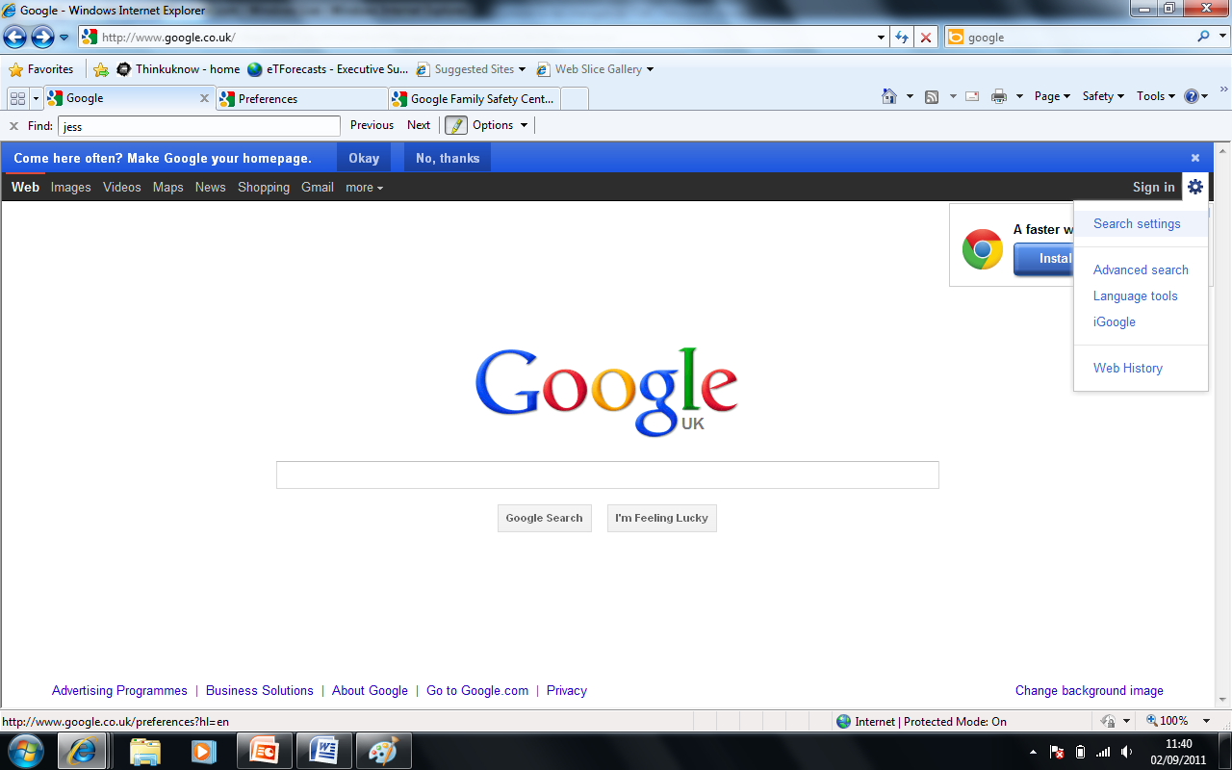

Scroll down the page and change the filtering options to suit your family’s needs. Make sure you lock the safe search; otherwise these settings can easily be changed without your knowledge.

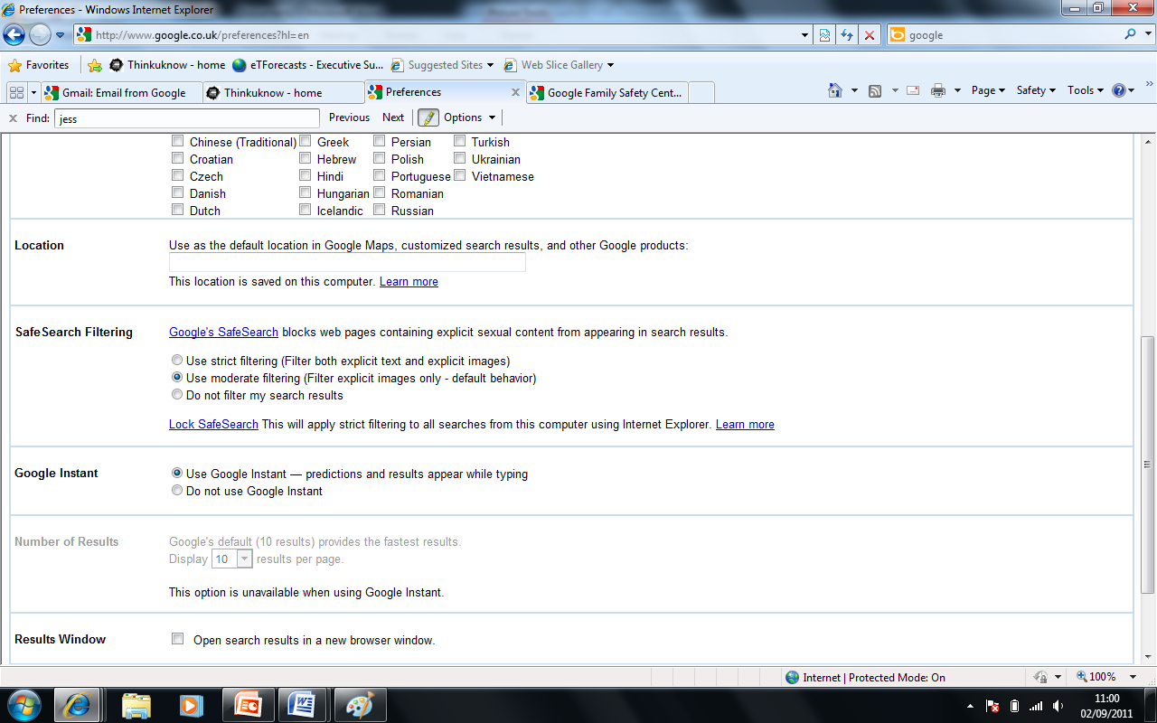

You can also set this on your child’s smart phone;

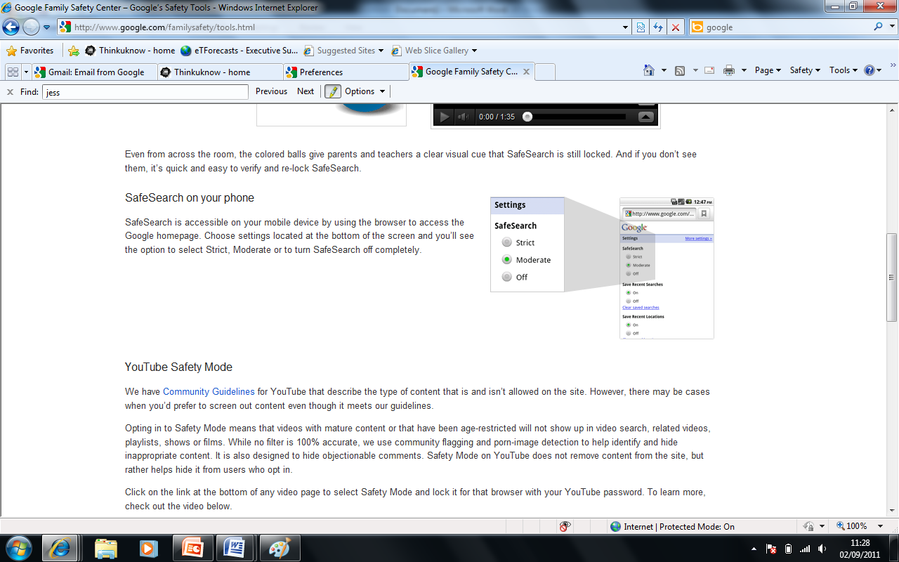

Please be aware that no filter is 100% accurate. CEOP advise that you talk to your child about the sites they use. Why don’t you discuss:

* Their favourite online sites
* What they enjoy most, the fun aspects of being online?
* What they think can go wrong?
* How would they react if things got out of control?

Let them know that you understand that situations happen online and that seeing ‘adult’ material can make them feel uncomfortable. Make sure they know that you are there to help.

Visit The Child Exploitation and Online Protection Centre (CEOP) parents’ information website for more information - [www.thinkuknow.co.uk/parents](http://www.thinkuknow.co.uk/parents)

Look out for CEOP’s future parent and carers updates. Next addition – Christmas wish lists – Safety made easy.

Many social media sites have a minimum age for those wishing to join; however these are often ignored. Facebook, Instagram, Snapchat, WhatsApp and YouTube are all popular with children. In recent years there have been situations where children have posted inappropriate messages and/or videos in the heat of an argument. Sadly on occasions these have caused great hurt and the fallout has been felt both at home and in school. We teach the children that it is really important to think before you type! When children talk to their friends in the playground, their friends automatically pick up on the tone, facial expressions etc. and can determine what is actually meant. When a phrase is posted, meaning can often become unclear and arguments can develop.

If you require any further information, please contact the school and we will be happy to help.

**School Crossing Patrol**

**The Council is still looking for a School Crossing Patroller for Station Road.**

**If you would be interested or know of anyone else who would enjoy this, please contact the organizer directly for more details:**

**Telephone: 07793 314257 or 07583129835**

**Email:** [**FacilitySupportRecruitment@northlan.gov.uk**](mailto:FacilitySupportRecruitment@northlan.gov.uk)

MC900356077[1]**Diary Dates**

**September Preview**

**1st Parent Council A.G.M. & PTA**

**2nd First Friday Mass**

Friday 23rd/Monday 26th September weekend

**October**

Friday 17th School closes at 3pm for the October break

Monday 21st School re-opens at 9am

C:\Users\Sheelah\AppData\Local\Microsoft\Windows\Temporary Internet Files\Content.IE5\B4YUHMQ5\MC900440414[1].wmf**Happy Birthday**C:\Users\Sheelah\AppData\Local\Microsoft\Windows\Temporary Internet Files\Content.IE5\O3YLVVPW\MC900413580[1].wmf

Andrew Gibb Amelia Gibson

Riley Brown Alice Rose PolinSerge Murray

Daanish Jamil Ailbhe McNamara

Amelie KeeganJenna MacLeod Sebastian Nowa

Olivia Ferrie Olivia McGinlay Freya Millar