 **St. Barbara’s Primary School**

**October 2021**

Welcome to St. Barbara’s October Newsletter!



C:\Users\Sheelah\AppData\Local\Microsoft\Windows\Temporary Internet Files\Content.IE5\B4YUHMQ5\MC900140905[1].wmf

**Halloween: Dress Up/Dress Down: Friday 29th October**

On Friday 29th October children can ‘dress-up/dress/down.’ If children choose to wear Halloween costumes they cannot bring props into school.

I would also ask that no gory face paint (blood etc.)/Halloween masks/**clown costumes** are worn as some of the younger children find these very distressing.

If children choose to ‘dress down’ please remember that no football colours are allowed.

We are asking for a small donation for school funds on that day, please. Thank you.

**INSET Day**

A reminder that Monday 15th November is an INSET Day and children do not attend school.

School re-opens on Tuesday 16th November at 9am.

**Sacramental Information**

The Sacrament of Confirmation will be conferred on the Primary 7 children on Wednesday 8th June 2022 at 7pm by Bishop Toal.

Further information will be sent to parents later in the session.

Dates for the other sacraments will be confirmed shortly.



**In celebration of Black History Month, we hope that you enjoy the following poem written by Mairead Shaw in Primary 7.**

**Harriet Tubman**

**Harriet Tubman is known for her bravery,**

**But the sad thing is she was born into slavery.**

**She was born in Maryland in 1820**

**When black lives did not matter and slaves were a-plenty.**

**She got beaten and whipped and hardly got fed;**

**Her clothes were just rags and she slept in a shed.**

**When Harriet got older, enough was enough**

**Her belief in God had made her so tough.**

**One night she ran all on her own;**

**For 100 miles she travelled alone.**

**She reached Philadelphia where she could live free**

**Because black people there could be what they wanted to be.**

**Harriet decided that others should be free**

**And went back to the danger to help others flee.**

**She rescued her family and many, many more.**

**She was an abolitionist to her very core.**

**But there’s more to this story that I want you to know;**

**Because Harriet helped the Underground Railroad grow.**

**That was a network that smuggled out slaves**

**Saving them all from their early graves.**

**Tubman didn’t stop in her quest to ban slavery.**

**She fought in the Civil War, again showing bravery.**

**Hundreds of slaves left their old lives behind**

**Hoping to meet more of Harriet’s kind.**

**The kind that stands up with courage and care**

**Knowing that black people were not treated fair.**

**Harriet died at age 93 and her story is one that really touched me.**

**She was a strong, black woman who was ahead of her time**

**I wish I had met her to read her this rhyme.**

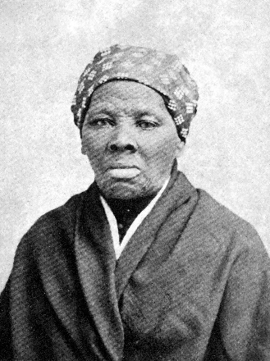

**COP26: Glasgow 2021**

‘Everything is connected in our world…we recognize the signs of divine harmony present in the natural world, for no creatures are self-sufficient; they exist only in dependence on each other, complementing one and other and in the service of one another…Let us commit ourselves to a future shaped by interdependence and co-responsibility.’

Pope Francis: 4th October 2021

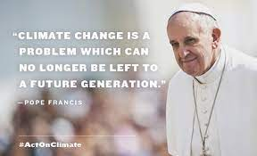

His Holiness urges world leaders and all of us to consider the harmful effects of our actions on our planet and to make an ‘urgently needed change of direction’ as required in order to preserve our planet for future generations.

At the forthcoming COP meetings, governments from across the globe will agree on **targets for the future**, with the aim of **reducing greenhouse gases**and **protecting the planet**. These decisions affect people all over the globe; they encourage us all to work together to become **greener**and more **sustainable**.

With COP26 beginning in Glasgow next week, the children will be working on several projects in the coming month when they will be reflecting on climate change and of the impact of this on our planet now and in years and centuries to come.

We will also be reflecting on what we as a school community can do to reduce our carbon footprint and do our part to preserve the planet for future generations.

We will launch COP26 with a special Assembly next week – more information to come!



**Parent Council**

I am delighted to tell you that we have now formed a new Parent Council for a three-year duration. Thank you to all of the parents who volunteered to be part of this. Their details are as follows:

|  |  |
| --- | --- |
| Name | Role |
| Mrs Bernice McNamara | Parent Member |
| Mrs Katrina Patterson | Secretary |
| Mrs Clementina Nnoli | Parent Member |
| Mrs Houten Feeley | Parent Member |
| Mrs Marie Clare Dungavell | Parent Member |
| Mrs Pamela Connell | Vice-Chair |
| Mrs Donna Marie Rodden | Chair |
| Mrs Marcella Campbell | Parent Member |
| Ms Yvonne McGachey | Parent Member |
| Mrs Joann Duffy | Secretary |
| Mrs Theresa Wilkin | Parent Member |
| Mrs Louise Todd | Parent Member |

The next meeting of the Parent Council will take place on Wednesday 3rd November at 6.45pm. A link will be sent out next week to enable you to join.

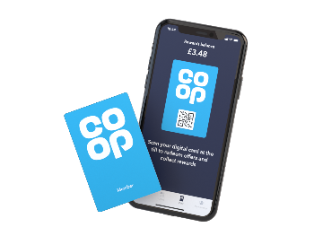

**Parent Council: Funding Success!**

At the end of last session, the Parent Council applied for funding from the

Co-op in order to create a community garden. I’m delighted to say that their bid

has been successful and St. Barbara’s has been included in the scheme.

In order to make the most of this we are asking **everyone** who shops at the Co-op in Muirhead or Moodiesburn to sign up for a membership card which costs £1.

Remember to scan your card each time you shop and select St. Barbara’s PTA as your chosen charity and the Co-op will do the rest!

Many thanks to Mrs Houten-Feeley who made the application on behalf of the school!

**Pupil Voice**

**School House System**

**St. Bernadette (red)**

**St. Andrew (green)**

**St. Lucy (blue)**

**St. Francis (yellow)**

There are four houses in St. Barbara’s and the children compete for points for their houses on a regular basis.

We are currently seeking four House Captains (P.7) and four Vice-House Captains (P.6).

Application forms have been sent to the relevant classes with a closing date of Tuesday 2nd November. Thereafter the applicants will have an opportunity to speak to the whole school community including a representative panel of P.4-7 children who will elect the Captains/Vice-House Captains on behalf of the school.

**Pupil Council**

|  |  |  |
| --- | --- | --- |
| **Name** | **Class** | **Position** |
| Hollie McNamara | P.7 |  |
| Imogen Di Nardo | P.7 |  |
| Rachael Cushley | P.7 |  |
| Olivia McGinlay | P.6 | Pupil Member |
| Freya Millar | P.6 | Pupil Member |

Above you will find the current membership of the Pupil Council. Each year children in the Primary 7 cohort assume leadership responsibilities: Chair, Vice-Chair and Secretary. These positions have yet to be decided and you will be informed once they have been agreed.

We have vacancies for members in Primaries Four and Five. Application forms have been sent to the relevant classes and the procedure for electing representatives will be the same as it is for House/Vice-House Captains.

In Session 2019/2020 (pre-pandemic) several members of the Pupil Council visited their counterparts in our family group schools. They looked specifically at Health and Wellbeing within the, ‘How Good is OUR School,’ document. We hope to continue with this albeit virtually this session.

**Eco Leaders: COP26 and beyond…**

We need to appoint Eco Leaders within the school as our previous leaders have now moved to high school. They will work with classes and with the Parent Council to ascertain how we can be more eco-friendly and reduce our carbon footprint. Application forms will be sent to children in P.5, P.6 and P.7

[](https://www.google.co.uk/url?sa=i&rct=j&q=&esrc=s&source=images&cd=&ved=2ahUKEwirnruq5f_kAhVQTBoKHcRJAT8QjRx6BAgBEAQ&url=https%3A%2F%2Flea-pri.herts.sch.uk%2Fchildren%2Feco-team%2F&psig=AOvVaw0MuyCSVyHuH1azBCnHzZhg&ust=1570181841285483)

**[](https://pbs.twimg.com/profile_images/942536130288869376/TtKXo7mH_400x400.jpg)Missio Ambassadors**

Missio is the charity linked to all Catholic primary schools in Scotland. Our Mission Ambassadors have now moved on to high school and we will appoint some more. This group will work on the theme of ‘Serving the Common Good’ within the current School Improvement Plan.

Application forms have been sent to relevant classes.

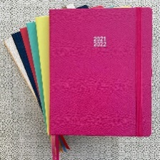**Diary Dates**

**Friday 29th October Dress-up/Dress down Day for Halloween**

**Monday 15th November INSET Day – children do not attend school**

C:\Users\Sheelah\AppData\Local\Microsoft\Windows\Temporary Internet Files\Content.IE5\O3YLVVPW\MC900413580[1].wmf

**Happy Birthday**

Aaron Ryan Eligh Sampaio Sofia Bryce Sophie Mulholland

Aaron Bell Rebecca Cushley Alyssa Graham Mia Newton

C:\Users\Sheelah\AppData\Local\Microsoft\Windows\Temporary Internet Files\Content.IE5\B4YUHMQ5\MC900440414[1].wmfMatei Bucur Maya Ballantyne Cole McKellar

Liam McKenna

**Happy Halloween**

