# 

Kirklands HQ

Fallside Road

Bothwell

G71 8BB

Telephone: 01698 858176

11th December 2020

Dear parent/carer/staff member,

As you may know, the Scottish Government has just announced that the self-isolation period for **close contacts of positive cases of COVID infection and international arrivals** has been changed **from 14 days to 10 days**, effective from Monday December 14.

Someone who had previously been instructed to self-isolate for 14 days will, from Monday, be able to stop self-isolating if 10 days has elapsed from the date their period of self-isolation began.

If you or your child has been identified as a close contact of a positive case and has an isolation end date after the 13th of December, then your isolation date has now changed. Please refer to the table below for your new isolation date and contact your school or nursery if you require any further clarification.

|  |  |  |
| --- | --- | --- |
| **Existing Isolation End Date** | **New Isolation End Date** | **New Return Date to School/Nursery** |
| 14.12.20 | Midnight on 13.12.20 | 14.12.20 |
| 15.12.20 | Midnight on 13.12.20 | 14.12.20 |
| 16.12.20 | Midnight on 13.12.20 | 14.12.20 |
| 17.12.20 | Midnight on 13.12.20 | 14.12.20 |
| 18.12.20 | 14.12.20 | 15.12.20 |
| 19.12.20 | 15.12.20 | 16.12.20 |
| 20.12.20 | 16.12.20 | 17.12.20 |
| 21.12.20 | 17.12.20 | 18.12.20 |
| 22.12.20 | 18.12.20 | 21.12.20 |
| 23.12.20 | 19.12.20 | 21.12.20 |

People who test positive should continue to self-isolate for 10 days from the onset of symptoms or 10 days from a positive test if asymptomatic.

Kind regards

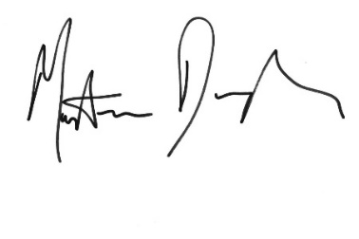

Dr Martin Donaghy

Consultant in Public Health Medicine

NHS Lanarkshire