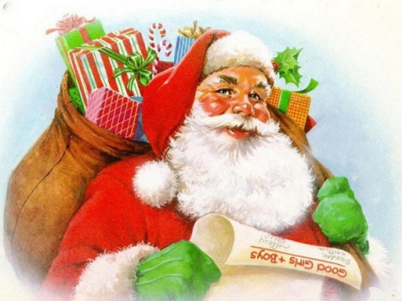
Christmas Numeracy
Word Problems

WALT: to be able to solve word problems

- Santa had 15 gifts in his sack. 6 of these gifts were for girls, how many were for boys?

- Sarah bought 7 gifts for her family. She has wrapped 3 of them. How many more does she need to wrap?

- Tony bought 20 tree decorations. He put ten on the front of the tree. How many did he put on the back of the tree?

- Amy had £20 to buy two gifts. She spent £11 on one gift. How much money did she spend on the other gift?

- Today is the 5th of December. How many more days until Christmas?

- Sarah bought 4 tree ornaments. They each cost the same amount of money and she spent £4 altogether. How much did each ornament cost?

- Santa can deliver 12 gifts in one hour. How many gifts can he deliver in 2 hours?

- Tony had 16 gifts under his tree. He opened 7 of them. How many more does he have to open?

- Amy was given 10 gifts for Christmas. She opened half of them. How many did she have left to open?

- Santa can carry 11 gifts. Rudolph can carry double this. How many can Rudolph carry?

