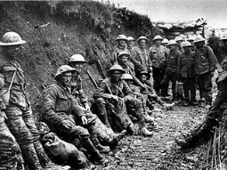
Primary 6 WW1 Personal Research

In class we are enjoying exploring the fascinating theme of WW1. You are challenged to research one area of particular interest to you in order to create a personal project to share with the class. You might choose one of the following areas:
Alliances of WW1
Recruitment
A Significant Battle of WW1 ( First Battle of the Marne. ...
Gallipoli. ... Jutland, Verdun. ... Somme. ... )
The Role of Animals in WW1
WW1 Weapons
Battleships of WW1
Aircraft of WW1
Leaders of WW1
Heroes of WW1
The Role of Women in WW1
WW1 Propaganda
Children’s Experiences of WW1
Trench Warfare
The Home front
Stories from WW1
Remembrance
Memorials and Monuments
To begin with you should find a variety of suitable online sources of information to read or watch. Take a note of every sources that you use and include a reference list with your work. You should gather important information in note form. You should then organise your information logically in order to present it in your own words. You can present your research in any manner that you wish e.g. poster, mind map, Power Point, written report. It can be handwritten or typed. In order to make your project more interesting try to include images or labelled diagrams.
If you do not have access to a printer you can email your work to gw17mcmullenkenedi@glow.sch.uk to be printed in school.
You should be ready to share your research week beginning 7th December. You will be allocated time in the coming weeks to complete your research as part of your weekly homework.

Good Luck! Miss McMullen

