November Homework Grid
HWB and RME
Skills for learning, life and work!  Help an adult to prepare a snack or a meal. Tick off the following when you do them:  - Washing ingredients  - Peeling  - Cutting  - Juicing  - Grating  Remember to wash your hands before you begin! | The Holy Souls  In November we remember all those members of our family and friends who have died.  With an adult, write the names of those you would like us all to pray for during November on a heart-shape and upload a picture.
Create a 3 minute dance or Zumba routine. Practise it so that you know it by heart and, with permission from an adult upload a video which we can use in school! Choose some exciting music! | Learn the special prayer for those who have died:  Eternal rest grant unto them, O Lord and let perpetual light shine upon them,  May they rest in peace, Amen.  May their souls and the souls of all the faithful departed rest in peace. Amen.
Safe, Healthy, Achieving, Nurtured, Active, Respected, Responsible, Included

These are the SHANARRI Indicators and they measure YOUR health and Wellbeing. The first is all about keeping yourself Healthy (eating and exercising) and Achieving (working hard and doing your best)at home and at school

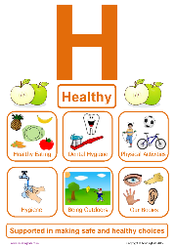
Can you design a character to represent either? We would like to have someone or something everyone would recognize in school.
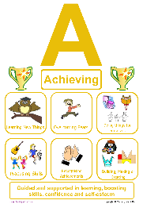
There will be a class winner and one overall winner.
Please upload your picture. The closing date for this
competition is Wednesday 25th November. Good luck!

Homework: Additional Choices

How to Draw Fireworks  Watch the video using the link below and have a go!  https://www.youtube.com/watch?v=O0zmxW81slU | Stop! Look! Listen!  The nights are getting darker and darker and it can be difficult for drivers to see children on the streets.  Your task is to design a road safety poster to remind children how to cross the road safely OR to remind drivers to slow down near homes and schools.  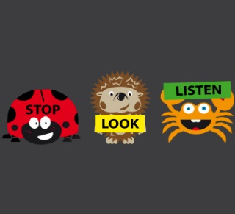 | Symmetry and Line Drawing  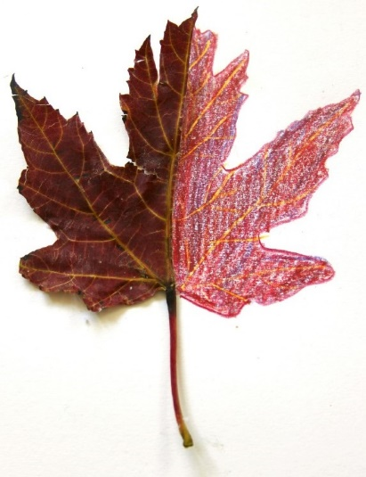  Maths and Art  Choose an Autumn leaf. With help, cut it carefully in half. Now make it symmetrical, taking care to match your lines, the shape and the colours.
Art all Around!  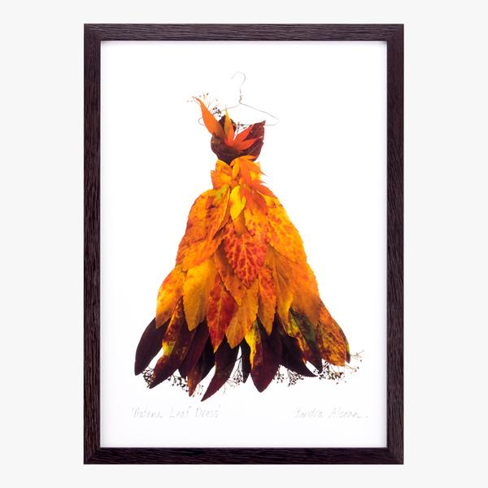  Take inspiration from the falling leaves and create something special!  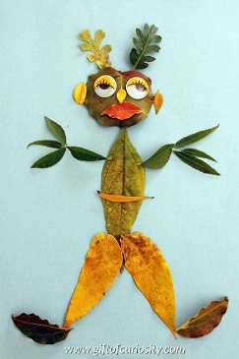 | Step 1  Go on an Autumn walk with your family and collect fallen leaves which you can use to complete some of these tasks.
 | Secure your leaves to some paper. Paint around them very carefully to reveal the shapes. Can you name the trees from which the leaves came? | Make your Initial Room Decoration  Cut out your initial from an old cereal box, decorate with leaves, add a ribbon and attach it to your bedroom door!  