Red Group

Homework WB ^{9th} Nov

To keep us all safe, we have decided that all completed work should be kept at home (until further notice). Reading should be completed every night.

Thank you for all your support.

Mon | Literacy  This week we are consolidating all of the phonemes from stage 1.  Make a table in your jotter and try to list at least three words that have each of the below phonemes.  sh (shop) ch (chop) th (bath) ng (sing) wh (when) ph (phone)  ee (see) oo (zoo) ck (back) air (air) oi (boil) oa (float)  Maths  Copy and complete in your jotter.  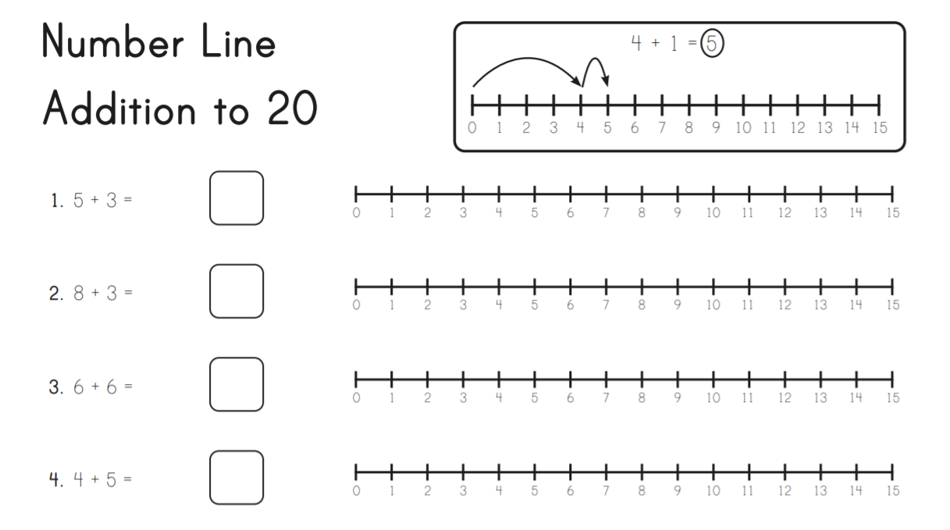
Tues | Literacy  Common Words: This week we are revising all the common words from stage 1.  a down it or  all first just our  am for like out  an from little play  and get look said  are go made see  as going make she  at got me so  be had much that  before has my the  big have new then  but he not this  by her now to  came here of us  can him off was  come his old we  could if on went  dad in one with  do into only you  did is I your  no  Choose a selection of words you still find tricky to spell and practice writing them in your jotter or use one of the fun spelling activities below –  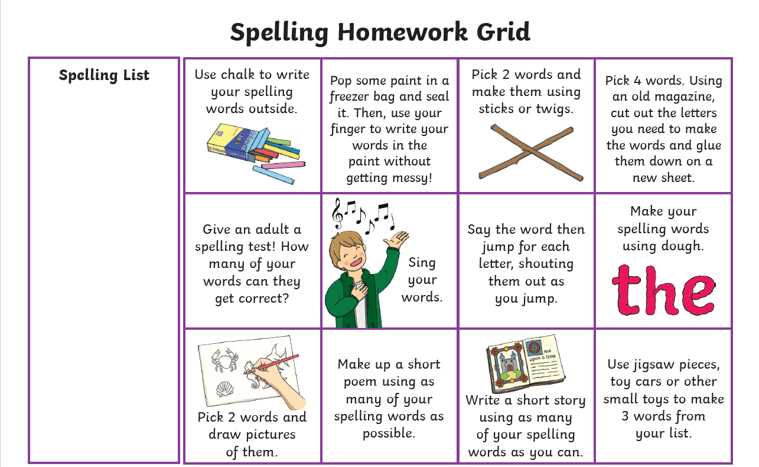  Maths  Try playing the game below. Borrow some dice from your favourite board game and use anything you can as the counters! Coins or little toys could work.  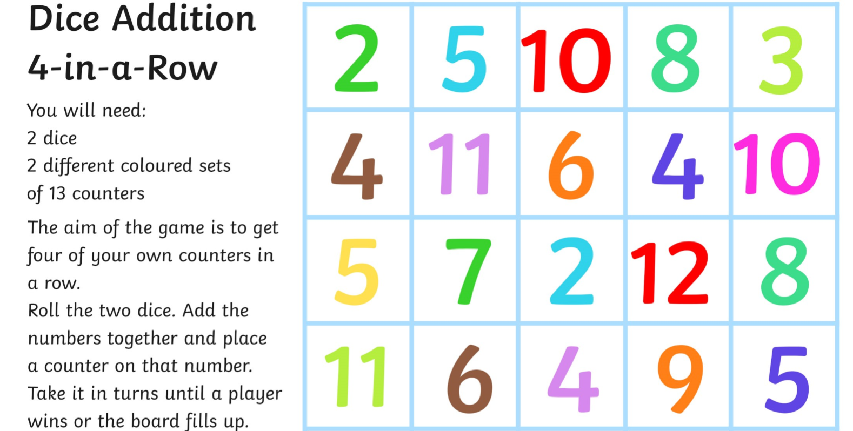
Wed | Literacy  Choose a selection of words from this week and write them on a page in your jotter or on post-it notes (including common words)  Ask someone at home to shout out one of your words. SPLAT the word they shouted out.  Maths  Please complete the Sumdog challenge set for you. 😊

Children do not need to spend any more than 20 minutes each night on homework. If you do want to spend more time with your child below are some additional ideas, you can do to help support their learning or send me an email and I will be happy to provide different activities.

Reading  Discussion questions:  Who was the Author and illustrator of the book?  What does the Author do? What does the illustrator do?  Who were the main characters of the book?  Discuss the beginning, middle and end of the book.  Discuss your favourite part of the book and why? | Phonics/Common Words  Go on a sound hunt around your house looking for objects that have the phoneme(s) you are revising.  Write a super sentence for each of your common words/phoneme words- making sure to include core targets. | Maths  Out loud, count forward in:  - 2s from 0-20  - 5s from 0-50  - 10s from 0-100  - 100s from 0-900  - 5s from 25-55  - 10s from 20-80  - 100s from 200-800  Now use the same numbers but count backwards.  Count to 100 by 1’s- forwards and backwards.

