Red Group

Homework WB 2nd Nov

To keep us all safe, we have decided that all completed work should be kept at home (until further notice).

Reading should be completed every night.

Thank you for all your support.

Mon | Literacy  Phoneme ‘oa’-  Listen to this week’s phoneme video: https://www.youtube.com/watch?v=M8nGaspuWAQ  Write a list of as many words you can with the ‘oa’ phoneme. (eg bot, float, coat..)  Choose three of your words and write a sentence. Remember capital letters and full stops.  Maths  Play ‘Robot Addition’ on Topmarks- https://www.topmarks.co.uk/addition/robot-addition
Tues | Literacy  Common Words: him, all, come  Practise writing your common words by choosing one of the fun spelling tasks below:  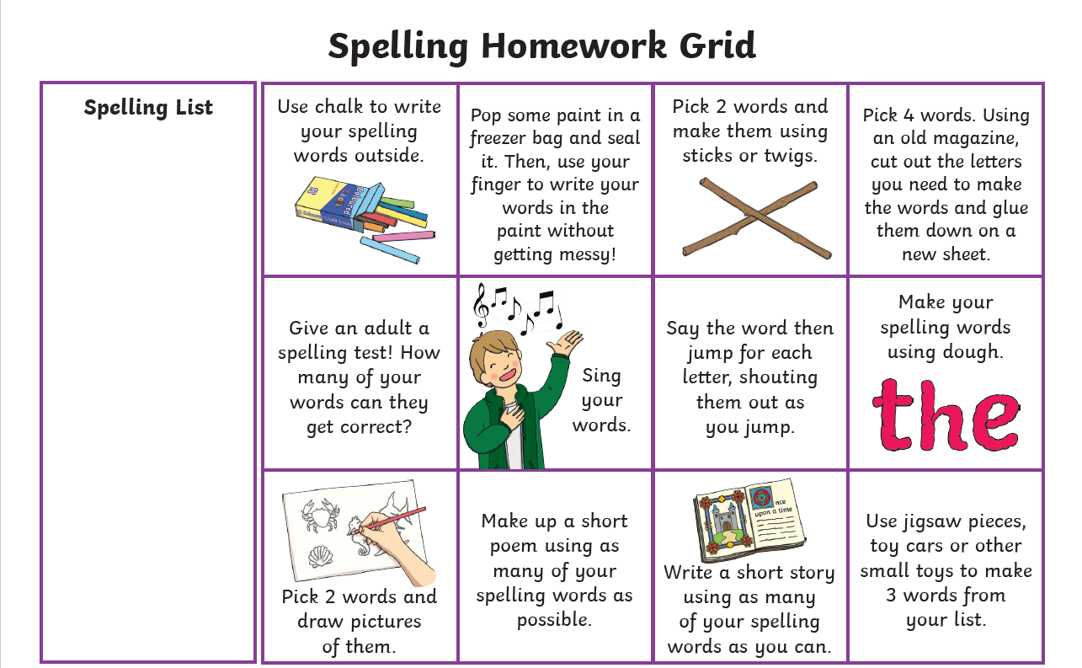  Maths  Try playing the game below. Borrow some dice from your favourite board game and use anything you can as the counters! Coins or little toys could work.  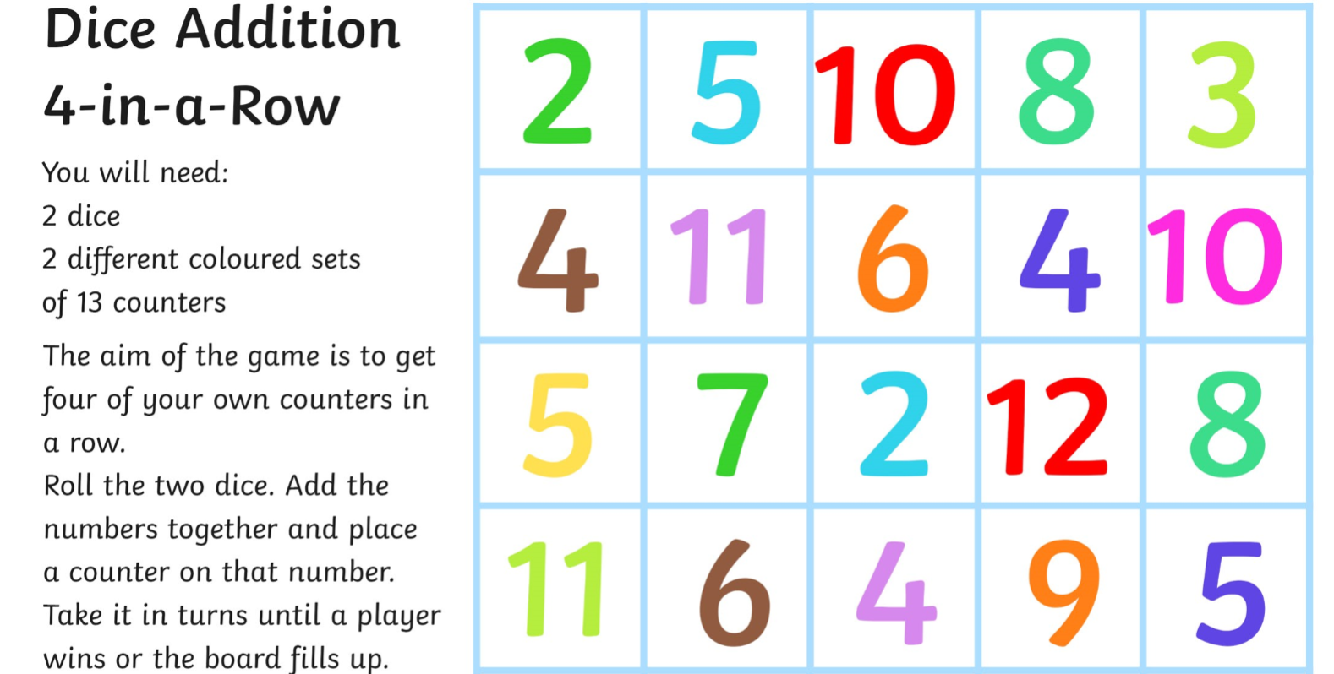
Wed | Literacy  Write all of your words for this week on a page in your jotter or on post-it notes (including common words)  Ask someone at home to shout out one of your words. SPLAT the word they shouted out.  Maths  Please complete the Sumdog challenge set for you. 😊

Children do not need to spend any more than 20 minutes each night on homework. If you do want to spend more time with your child below are some additional ideas, you can do to help support their learning.

Reading  Discussion questions:  Who was the Author and illustrator of the book?  What does the Author do? What does the illustrator do?  Who were the main characters of the book?  Discuss the beginning, middle and end of the book.  Discuss your favourite part of the book and why? | Phonics/Common Words  Go on a sound hunt around your house looking for objects that have the phoneme(s) you are revising.  Write a super sentence for each of your common words/phoneme words- making sure to include core targets. | Maths  Out loud, count forward in:  - 2s from 0-20  - 5s from 0-50  - 10s from 0-100  - 100s from 0-900  - 5s from 25-55  - 10s from 20-80  - 100s from 200-800  Now use the same numbers but count backwards.  Count to 100 by 1’s- forwards and backwards.

