Green Group

Homework WB 2nd Nov

To keep us all safe, we have decided that all completed work should be kept at home (until further notice).
Reading should be completed every night.

Thank you for all your support.

Mon | Literacy  Sound – ‘-at’  Make a table in your jotter and write down the ‘ap’ words below three times.  Cat, mat, bat, sat, rat, hat.  Choose three words and write a sentence. Remember to use capital letters and full stops.  Maths  Play ‘Robot Addition’ on Topmarks- https://www.topmarks.co.uk/addition/robot-addition
Tues | Literacy  Common Words – We are consolidating these common words this week- am, me, my, did, as, he, can, we, into  Choose one of the fun activities below to practise your common words -  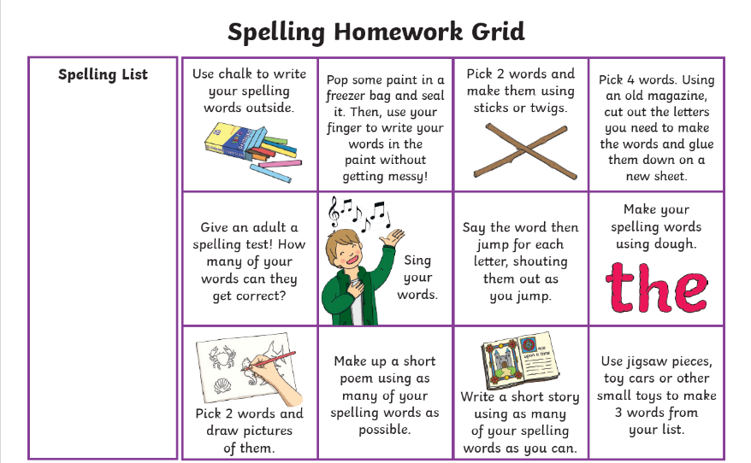  Maths  Try playing the game below. Borrow some dice from your favourite board game and use anything you can as the counters! Coins or little toys could work.  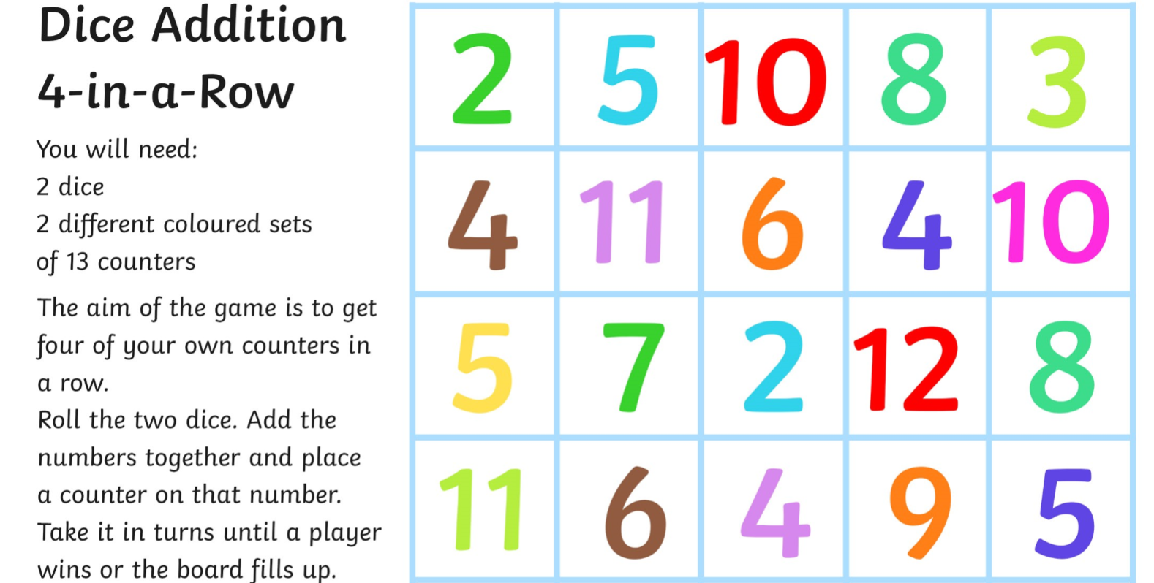
Wed | Literacy  Write all of your words for this week on a page in your jotter or on post-it notes (including common words)  Ask someone at home to shout out one of your words. SPLAT the word they shouted out.  Maths  Please complete the Sumdog challenge set for you. 😊

