Blue Group

Homework WB 2nd Nov

To keep us all safe, we have decided that all completed worksheets should be kept at home (until further notice).

Reading should be completed every night.

Thank you for all your support.

Monday | Literacy  We are revising all of these letter sounds this week- r, m, d, e, c, k  Listen to the Jolly Phonics song for each letter sound. Sing each song whilst doing the action. Practise saying each sound correctly https://www.youtube.com/watch?v=jvAYUvQUrGo  Complete Initial Sounds worksheet.  Maths  Complete Bonfire Night Addition worksheet.
Tuesday | Literacy  We are consolidating these common words this week- am, me, my, did, as, he, can, we, into  - Use your word tin to practise all of your common words. When you look at each word, read the word and then spell it out loud.  - Choose a task of your choice from the menu below, to help you practise all of these common words. Have fun!  - Ask an adult to give you a spelling test. How many of your words can you write correctly?  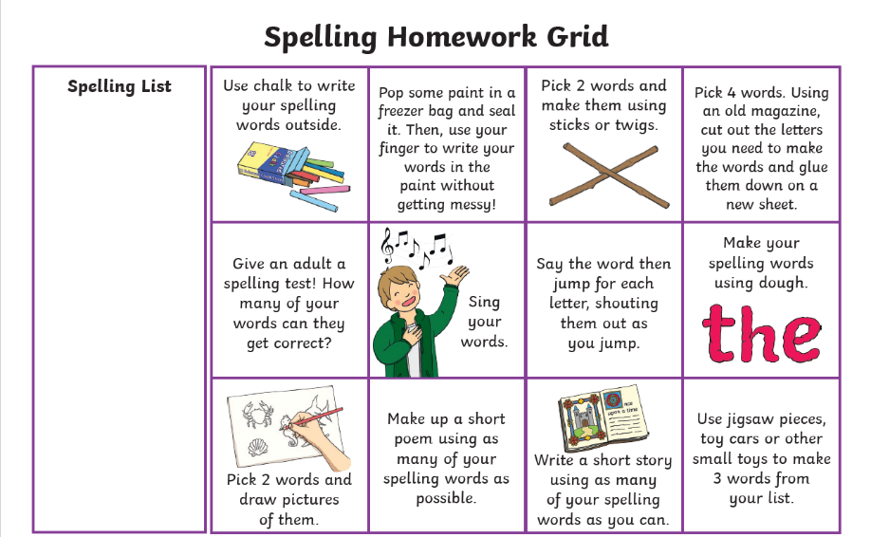  Maths  Practise adding to 10 by playing the Robot Addition game.  https://www.topmarks.co.uk/addition/robot-addition
Wednesday | Literacy  CVC words  This term we will be continuing with our initial sounds and working on blending CVC words (consonant-vowel-consonant).  The children have been using their magnetic boards and letters in class to blend the sounds we have learned so far to make words.  They have been using the Five Finger Strategy:  - SAY– Ask your child, ‘Can you say the word ________?’  - MAKE/BREAK– Continue, ‘Can you make the word _______ with your letters?’  -‘Do you know what letter comes first?’  – Your child will choose the appropriate letters and make the word  - BLEND– Ask your child to SOUND OUT the letters by running their finger below  the letters and your child should then BLEND the sounds together to make the word.  - READ– Ask your child to read the word.  - WRITE– Ask your child to WRITE the word.  Using the CVC worksheet provided, ask your child to cut out all of the letters on the worksheet and use these letters to make each CVC word.  Words– sat, tap, pin, tin, pan, den, red, can, mat, pen  Maths  Log onto Sumdog and complete this week’s challenge. Good luck!

