[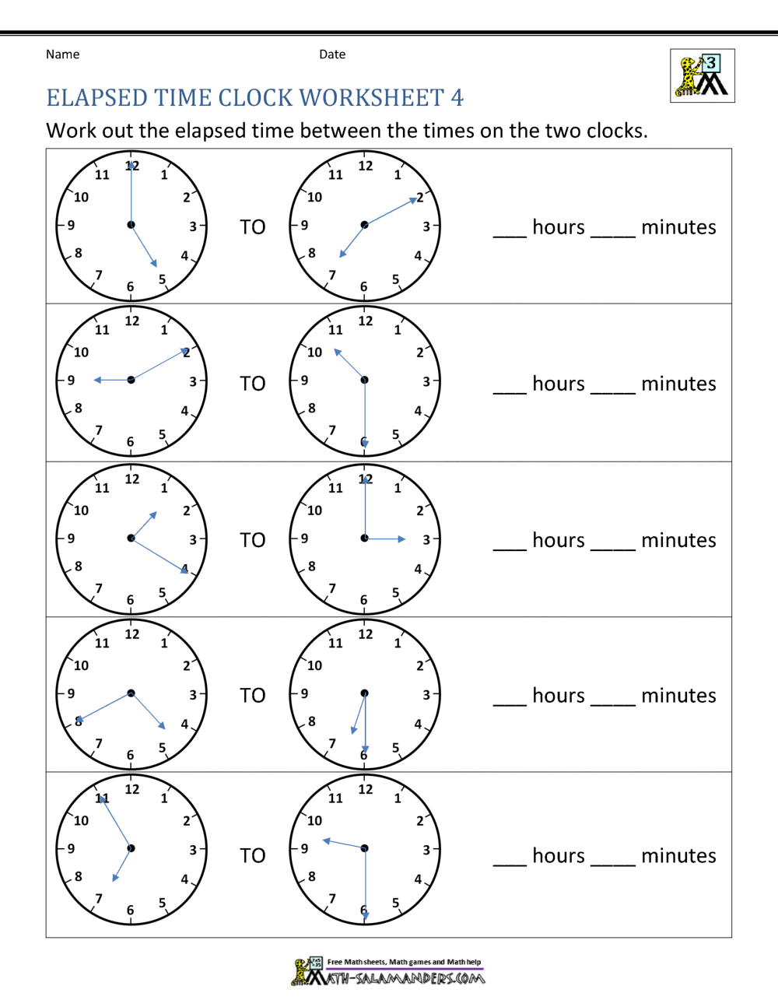](https://www.google.co.uk/url?sa=i&url=https%3A%2F%2Fwww.math-salamanders.com%2Felapsed-time-worksheet.html&psig=AOvVaw0UZF_XchPPHMWSaMGGm2j9&ust=1603794137524000&source=images&cd=vfe&ved=0CAIQjRxqFwoTCKjqpfKE0uwCFQAAAAAdAAAAABBM)