[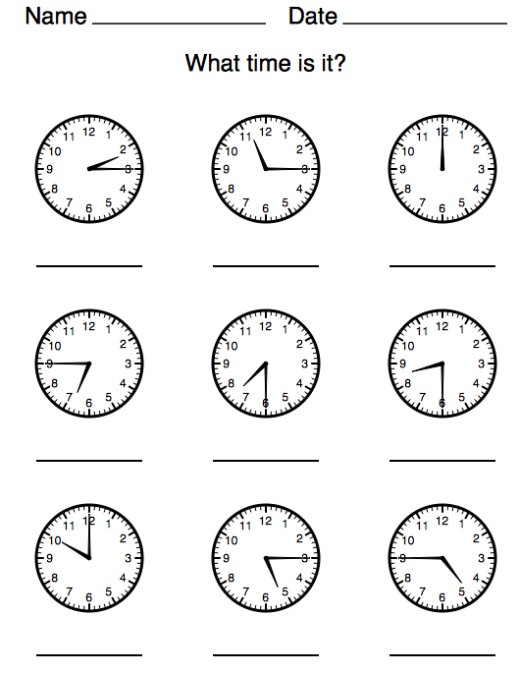](https://www.google.co.uk/url?sa=i&url=https%3A%2F%2Fwww.teachingcave.com%2Fnumeracy%2Fks1%2Ftime%2F&psig=AOvVaw0WJVbbazb8PGpsCPVH6oXJ&ust=1603794474747000&source=images&cd=vfe&ved=0CAIQjRxqFwoTCOCmgZOG0uwCFQAAAAAdAAAAABAO)