Red Group

Homework WB 26th October

To keep us all safe, we have decided that all completed work should be kept at home (until further notice).

Reading should be completed every night.

Thank you for all your support.

Monday | Literacy  - Read the story of ‘oy’ below.  - Highlight or underline any words that have this phoneme.  - Write the words in a list in your jotter.  The story of ‘oy’  Ben was a boy who enjoyed playing with his toys. He had a model of a royal coach with a little king inside it. He also had a cowboy sitting on a brown and white horse.  “Why can’t you be more like Ben.” Mum would say to Belle. “He is such a joy. He doesn’t annoy anyone.”  “You don’t say that when he comes home with his muddy football boots,” laughed Belle. Mum laughed too  Maths  Practise counting from 0-100 by 1’s forwards and backwards.  Here are some videos you can sing along to:  https://www.youtube.com/watch?v=0TgLtF3PMOc  https://www.youtube.com/watch?v=8jMmZaFvRpE  Ordering numbers- can you place these numbers in order from smallest to biggest.  (Remember we have to look at our tens and ones to help us when ordering)  82 35 10 3 77 _ _ _ _ _  41 20 15 65 54 _ _ _ _ _  25 23 20 21 24 _ _ _ _ _
Tuesday | Literacy  Common Words: our, down, off  Practise writing your common words by choosing one of the fun spelling tasks below:  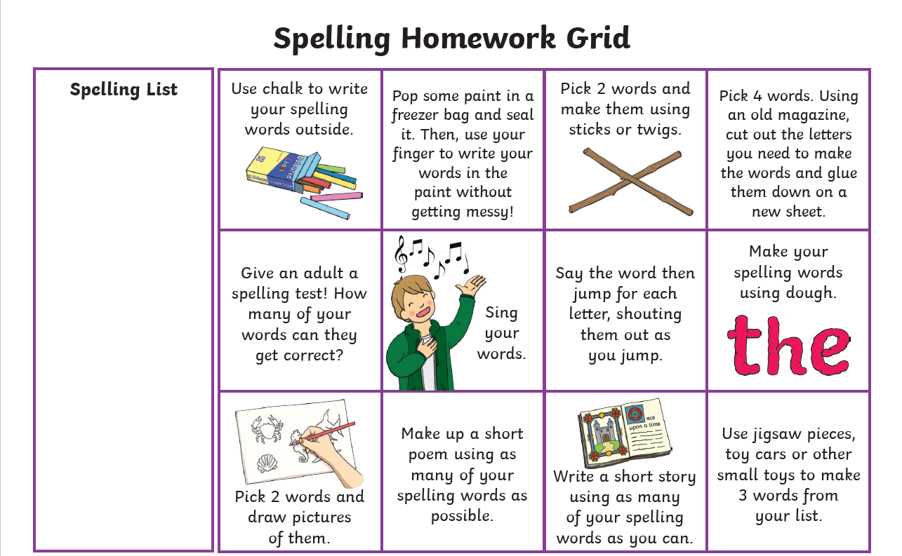  Maths  Number bonds to 10  Practise your recall of number bonds to 10.  Have look at BBC Bitesize website for a reminder of what these are. There is a helpful video and game you can play.  https://www.bbc.co.uk/bitesize/articles/zh8m6v4
Wednesday | Literacy  Choose three words that have the ‘oy’ phoneme and your three common words and write a sentence for each one in your jotter. Remember capital letters, finger spaces ad full stops!  Maths  Please complete the sumdog challenge set for you. 😊

Children do not need to spend any more than 20 minutes each night on homework. If you do want to spend more time with your child below are some additional ideas, you can do to help support their learning.

Reading  Discussion questions:  Who was the Author and illustrator of the book?  What does the Author do? What does the illustrator do?  Who were the main characters of the book?  Discuss the beginning, middle and end of the book.  Discuss your favourite part of the book and why? | Phonics/Common Words  Go on a sound hunt around your house looking for objects that have the phoneme(s) you are revising.  Write a super sentence for each of your common words/phoneme words- making sure to include core targets. | Maths  Out loud, count forward in:  - 2s from 0-20  - 5s from 0-50  - 10s from 0-100  - 100s from 0-900  - 5s from 25-55  - 10s from 20-80  - 100s from 200-800  Now use the same numbers but count backwards.  Count to 100 by 1’s- forwards and backwards.

