Green Group

Homework WB 26th October

To keep us all safe, we have decided that all completed work should be kept at home (until further notice).
Reading should be completed every night.

Thank you for all your support.

Monday | Literacy  Sound – ‘-ap’  Make a table in your jotter and write down the ‘ap’ words below three times.  Cap, map, lap, nap, rap, sap, tap  Maths  Practise counting from 0-100 by 1’s forwards and backwards.  Here are some videos you can sing along to:  https://www.youtube.com/watch?v=0TgLtF3PMOc  https://www.youtube.com/watch?v=8jMmZaFvRpE  Ordering numbers- can you place these numbers in order from smallest to biggest.  (Remember we have to look at our tens and ones to help us when ordering)  82 35 10 3 77 _ _ _ _ _  41 20 15 65 54 _ _ _ _ _  25 23 20 21 24 _ _ _ _ _
Tuesday | Literacy  Common Words – can, we into  Choose one of the fun activities below to practise your common words -  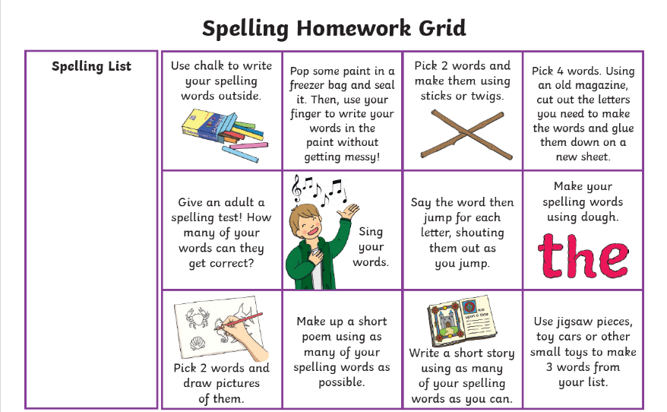  Maths  Number bonds to 10  Practise your recall of number bonds to 10.  Have look at BBC Bitesize website for a reminder of what these are. There is a helpful video and game you can play.  https://www.bbc.co.uk/bitesize/articles/zh8m6v4
Wednesday | Literacy  Choose three words that have the ‘-ap’ sound and your three common words and write a sentence for each one in your jotter. Remember capital letters, finger spaces ad full stops!  Maths  Please complete the sumdog challenge set for you. 😊

