Blue Group

Homework WB 26th October

To keep us all safe, we have decided that all completed worksheets should be kept at home (until further notice).

Reading should be completed every night.

Thank you for all your support.

Monday | Literacy  - Practise saying the ‘c’ sound. Listen to the ‘’c” Jolly Phonics song. Sing the song whilst doing the action.  https://www.youtube.com/watch?v=jvAYUvQUrGo  - Go on a sound hunt around your house looking for objects that begin with the sound ‘c’. Can you think of any other words that begin with ‘p’?  - Complete letter ‘c’ formation worksheet.  Maths  - Complete worksheet
Tuesday | Literacy  Common Words: can, we, into  1.Use your word tin to practise your common words. When you look at each word, read the word and then spell it out loud.  2.Practise writing your common words by choosing one of the fun spelling tasks below:  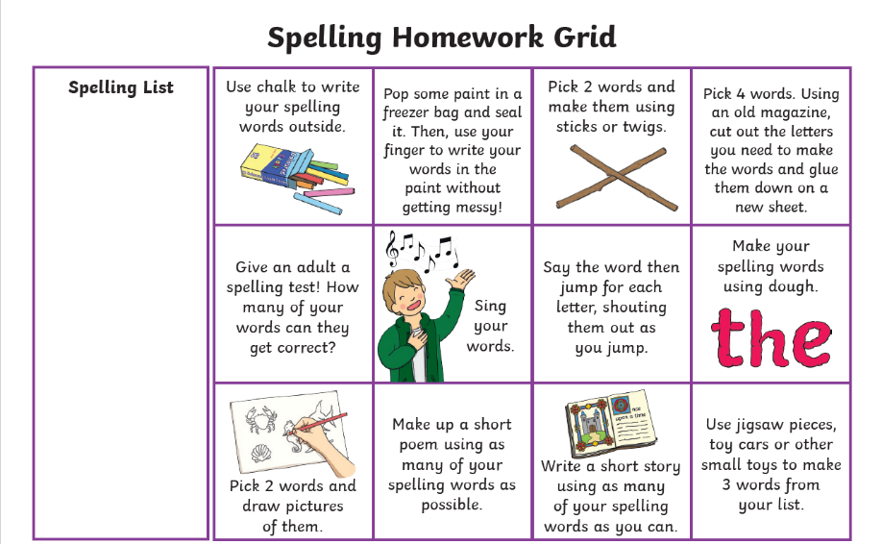  Maths  Practise counting & matching with the game below.  https://www.themathsfactor.com/games/try/?gameid=46&prefix=ZONE&config=IPG_CM_Y1_CA_001,%20support&title=Count%20the%20Yeti%201%20to%2010
Wednesday | Literacy  - Practise saying the ‘k’ sound. Listen to the ‘’k” Jolly Phonics song. Sing the song whilst doing the action.  https://www.youtube.com/watch?v=jvAYUvQUrGo  - Go on a sound hunt around your house looking for objects that begin with the sound ‘k’. Can you think of any other words that begin with ‘p’?  - Complete letter ‘k’ formation worksheet.  Maths  Complete the sumdog challenge set for you. 😊

