Time Tasks Primary 6
Task 1: Read the following worksheet carefully, make a copy of the tables in your jotter and complete.

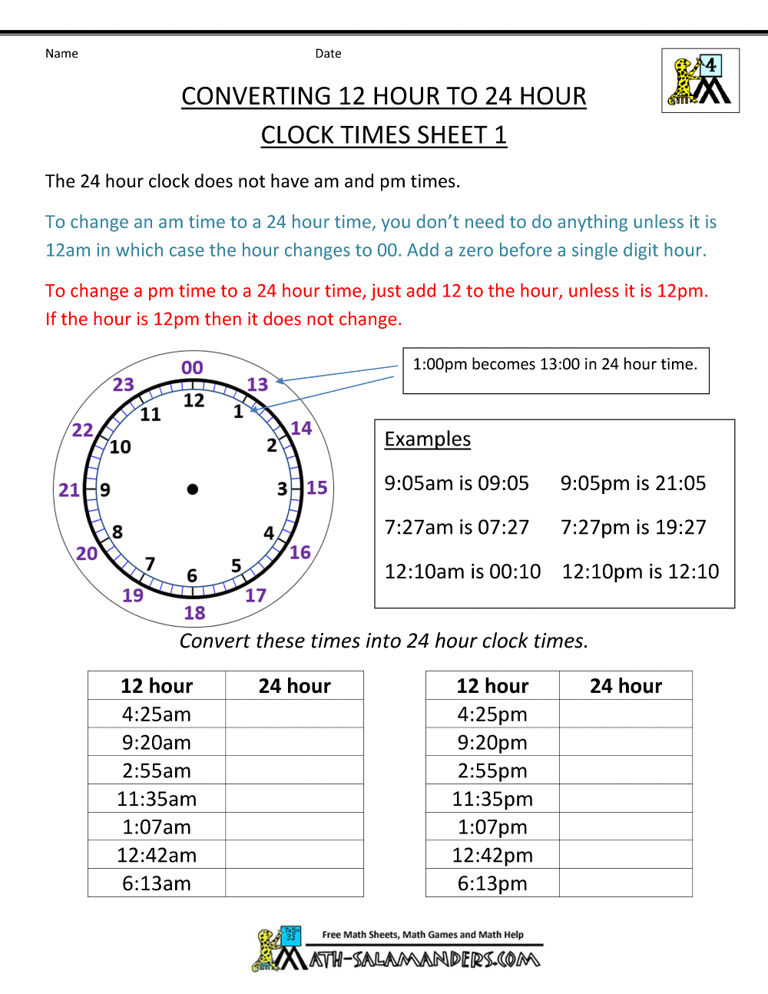

Task 2
Please cut and paste the following link to complete a 12/24 hour time quiz:
https://www.educationquizzes.com/11-plus/maths/time-easy/
How well did you do?

