

I watched Harry Potter and The Goblet of Fire. This is the first time I have seen it. Over the past few weeks I have been watching all of the films in order. This one has been my favourite so far. I really enjoyed it and I cannot wait to watch the next one.

I made a sandwich for my lunch and had it with a cup of tea. Next I emailed some pupils with feedback about their work. I am so proud of how hard they have all been working.

**1:10pm**



I planned some lessons for Primary 6 to complete tomorrow. I will upload these on to Teams later. I miss being able to teach the children face to face.

I made some breakfast. I had toast with boiled egg and it was super tasty. After I finished eating I cleared away my dishes. Next I went into my garden and to do a little exercise. I am really glad I can still get some fresh air.

**10:30am**

I logged in to Microsoft Teams and sent a message to some of the Primary 6 pupils. Next I answered my emails and helped the children that could not log on to Teams. I am enjoying using Teams as it allows me to help the children with their home learning.

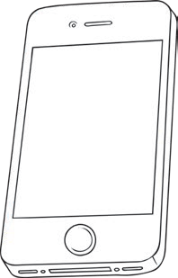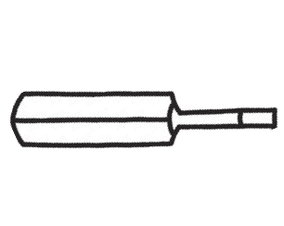

**My Home Learning 2020 Diary**

**Date**  6th October 2020

[**visit twinkl.com**](https://www.twinkl.co.uk/resources/class-management/school-closure-home-learning-classroom-management-key-stage-1-year-1-year-2/life-positive-mental-health-and-wellbeing-resource-packs-school-closure-home-learning-classroom-management-key-stage-1-year-1-year-2)

**B**

**C**

**A**

**Something I hope will happen tomorrow:**

I hope tomorrow is a sunny day so I can sit in my garden.

**Something I miss about school:**

I miss being able to read Wonder with Primary 6.

**Something creative I did today:**

I tried out a new recipe when I was cooking my dinner.

**My exercise tracker:**

Draw a picture to show what exercise you have done today. Here are some ideas.

**The weather today was:**

The weather was cold but dry.

**The best thing I watched on T.V:**

I loved Harry Potter and the Goblet of Fire.

**Something I did not enjoy:**

I did not enjoy tidying up after I made my dinner.

**9:00am**

**12:15pm**

**5:45pm**

**Something I enjoyed today:**

I enjoyed chatting to Primary 6 on Teams.