Primary 2

Homework WB 5th October 2020

To keep us all safe, we have decided that all completed work should be kept at home (until further notice). Please return reading book on Thursday with empty clear folder.

Thank you for all your support.

Monday | Literacy  Phoneme ‘ai’- https://www.youtube.com/watch?v=JDzpV3jFefs  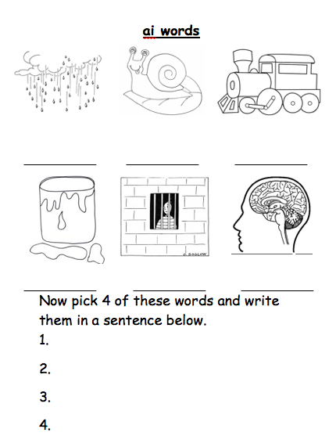  Complete phoneme ‘ai’ worksheet- paper copy inside clear folder.  Reading Book- Try to read with fluency and expression.
Tuesday | Literacy  Common Words: said, big, could  (cut out your new common words and add to your word tin)  1.Use your word tin to practise your common words. When you look at each word, read the word and then spell it out loud.  2.Practise writing your common words by choosing one of the fun spelling tasks below:  - Pasta Words– Arrange pasta or cereal to make your words. Glue onto a piece of paper or take a picture.  - Chalk- Write your common words outside on the ground using chalk.  - Foamy Words– Spray a small amount of shaving foam and spread it out. Practise writing your words in the foam.  - Rainbow Words- write your words out in rainbow colours x 3.  - Pyramid Words- add a letter each time until you complete the word x 3.  Reading book- Try to read with fluency and expression.
Wednesday | Maths- Sumdog Challenge  Complete the Sumdog challenge that has been set.  Reading book- Try to read with fluency and expression.

Children do not need to spend any more than 20 minutes each night on homework. If you do want to spend more time with your child below are some additional ideas, you can do to help support their learning.

Reading  Discussion questions:  Who was the Author and illustrator of the book?  What does the Author do? What does the illustrator do?  Who were the main characters of the book?  Discuss the beginning, middle and end of the book.  Discuss your favourite part of the book and why? | Phonics/Common Words  Go on a sound hunt around your house looking for objects that have the phoneme(s) you are revising.  Write a super sentence for each of your common words/phoneme words- making sure to include core targets. | Maths  Out loud, count forward in:  - 2s from 0-20  - 5s from 0-50  - 10s from 0-100  - 100s from 0-900  - 5s from 25-55  - 10s from 20-80  - 100s from 200-800  Now use the same numbers but count backwards.  Count to 100 by 1’s- forwards and backwards.

