October STEM Homework Challenges

Don’t forget to read the Halloween STEM Information Pages below to help you to complete the challenges!
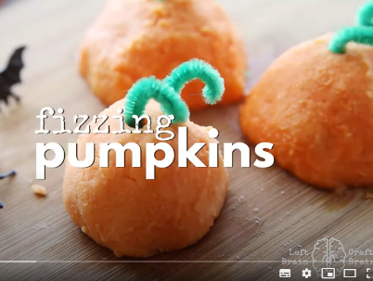  Fizzing Pumpkin Challenge | 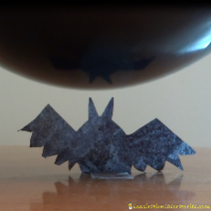  Static Electricity Challenge  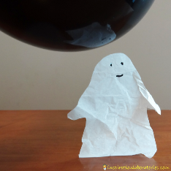  Ghosts and Bats | Foaming Pumpkins  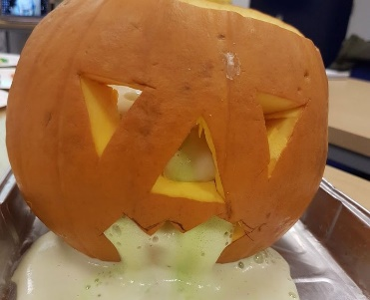 | 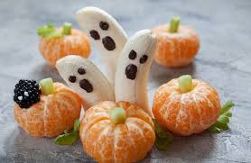  Fruity Halloween Treats
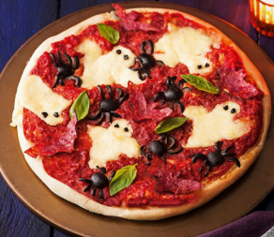  Haunted House Pizza | Halloween Puffy Ghost  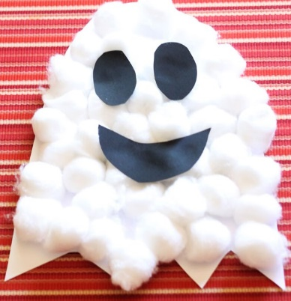 | 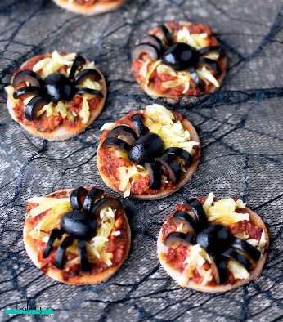  Vegan/Gluten-Free Pizza Bites | Make a string Witch’s Broomstick!  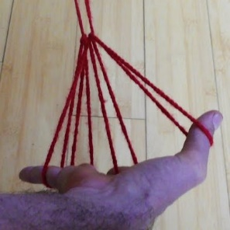  All you need is wool.  Copy the link below:  https://youtu.be/FO6a4FmVuAA

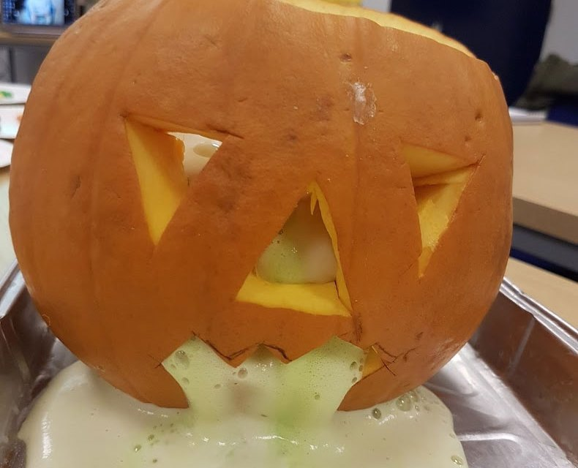

Foaming Pumpkins

You will need:
- Pumpkin
- Baking powder or Bicarbonate of Soda
- Vinegar
- Washing up Liquid
- Green food colouring
- Small container – a foil dish will do.
- Newspaper or an old cloth to protect the table. A foil tray would also work.

Instructions

- Cut the top off the pumpkin. Remove the insides of the pumpkin and carve a face.
- In the foil dish – add a few teaspoons of Baking powder, the food colouring and a few drops of washing up liquid.
- Place the dish inside the pumpkin
- When ready – pour some vinegar into the dish through the top of the pumpkin and see what happens!

The vinegar reacts with the baking powder to produce carbon dioxide gas. This forms bubbles. The washing up liquid makes it froth up really well!

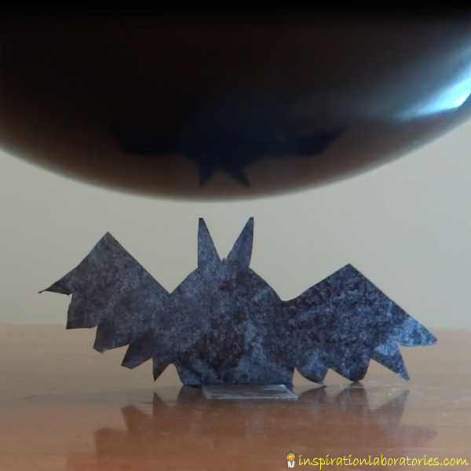
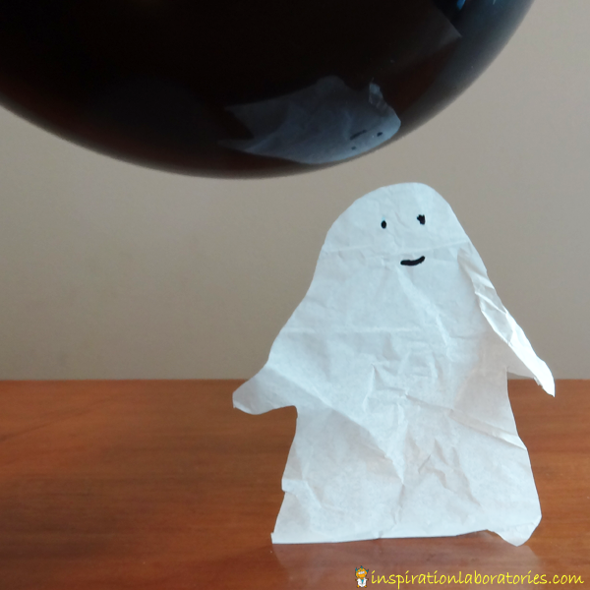

Static Electricity Dancing Ghosts and Bats

We going to experiment with static electricity to make Halloween shapes out of the tissue paper.
We’ll use static electricity to move the shapes around.
Here’s what you need:
- balloon
- tissue paper
- markers
- scissors
- tape
- jumper or your hair

Cut out your Halloween shapes from the tissue paper. We chose a ghost and a bat. After cutting out the bat, I coloured the white tissue paper with a black marker and waited for it to dry.
Tape the bottom of your ghost, bat, or other Halloween shapes to the table.

Rub the balloon on a sweater or a head of hair to gather some extra electrons.
Move the balloon over your Halloween shapes. The balloon is attracted to the tissue paper. The tissue paper will rise up. As you move the balloon around, the tissue paper will move as well.

If you don’t tape down your tissue paper, your Halloween shapes will most likely just get stuck to the balloon.

Halloween Bone Bridge
Can YOU build a Bone Bridge?
Will it take the weight of 1 toy car; 2 toy cars; a coin?
You will need:
- Cotton Buds
- Lolly Sticks
- Clothes Pegs
- Pipe Cleaners
- Scissors
- Items to place on your bridge

Now you can get started! Think about your design: are you designing your bridge for
- Strength – what WEIGHT can your Bone Bride support?
- Capacity - how WIDE do you dare make it so that it remains standing?
- Length – how LONG can you make it so that it remains standing?

Or do you DARE to try to achieve all three???
Haunted Pizza Recipe from…
Mozzarella ghosts and olive and salami bats make this homemade treat a real scream!
An easy way to raise spirits during the Halloween season. You will need help from an adult for this challenge!

Ingredients
- 200ml passata
- 1 tbsp olive oil
- 1 x 145g pack pizza base mix
- 4 salami slices, cut into bat shapes
- 7 pitted black olives, halved
- 125g ball mozzarella, torn into pieces
The perfect easy bake for a scary Halloween treat, this easy homemade pizza recipe is topped with gooey mozzarella ghosts, salami bats and black olive spiders. Simply double (or even triple) the quantities if you have a large gang of trick-or-treaters to feed.

- Preheat the oven to gas 7, 220°C, fan 200°C. Put the passata and olive oil in a pan and bring to the boil. Reduce the heat and simmer for 5 mins, or until thickened.
- Empty the pizza base mix into a bowl and stir in 100ml warm water. Mix to a soft dough, then tip out onto a lightly floured surface and knead for 5 mins, or until smooth. Roll out the dough to roughly 24cm in diameter. Transfer to a large, greased baking sheet and turn up the edge of the base for a crust. Leave to stand in a warm place for 10 mins.
- Meanwhile, thinly slice 8 olive halves lengthways into 4 to make 32 legs for the spider (each spider has eight). Dice two more olive halves to make eyes for the mozzarella ghosts.
- Spread the passata over the base, allowing a 1cm border. Top with the salami and arrange the torn mozzarella in ghost shapes (with room to spread). Position the remaining olives, cut-side down, and arrange 4 spidery legs on either side.
- Cook the pizza for 15-18 mins, until bubbling and golden. Remove from the oven and leave to cool for 1 min, before adding the reserved olive eyes to each melted mozzarella ghost. Serve immediately and enjoy !

Halloween Fizzy Pumpkin Treasure Rock

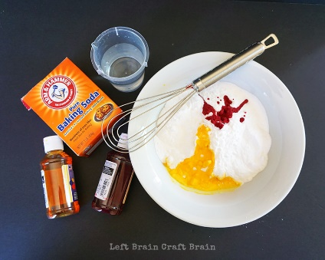
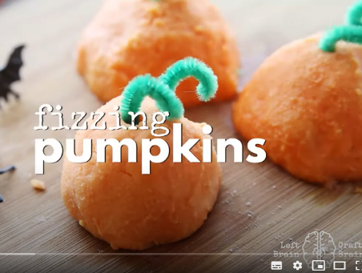
You will need:
- 2 cups baking soda
- Food colouring
- 2/3 cups water
- Halloween trinkets or toys like spiders or body parts
- Green pipe cleaners
- Vinegar
- Liquid soap and a deep tray
Video Link: https://www.youtube.com/watch?v=KPrTO5kTpL0

Method
- Make your baking soda mixture by adding 1 teaspoon yellow colouring and 1/2 teaspoon red liquid colouring to two cups of baking soda. (Or use orange colour if you’ve got it on hand.)
- Mix well with a whisk until the colour is fairly well distributed. Then add water a bit at a time until the mixture can be moulded. Don’t worry if you don’t add all of the water.
- Take one of your trinkets and about half a cup of the baking soda mixture. Hide the trinket inside the mixture and form into a pumpkin like ball. Place on a cookie sheet covered in parchment or foil and set aside. Repeat with remaining trinkets.
- Cut your pipe cleaner into 4 pieces and twist each into a vine-like curl. Insert one end into the top of the treasure rock.
- The pumpkins will be dry in about 24 hours and ready to use!
- Squirt some liquid soap onto the bottom of the tray and then place the pumpkins in it.
- Squeeze the vinegar on top and watch what happens!

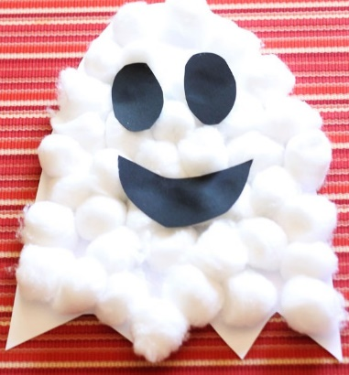
Halloween Puffy Ghost

You will need:
- White card
- Pencil
- Scissors
- Cotton Wool
- Glue
- Black paper/card or a Black pen
- String/Wool – to hang your decoration (optional)

Instructions
- Copy these shapes onto your white card and cut them out carefully
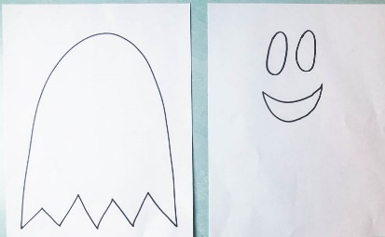
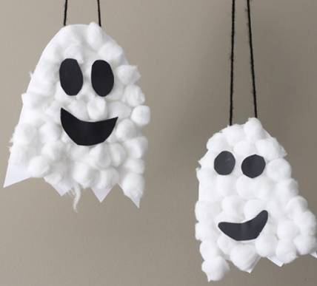

- Make your ghost using cotton wool and glue.
- Add the eyes and mouth and finally some wool or string to hang it up! Spooky!!!

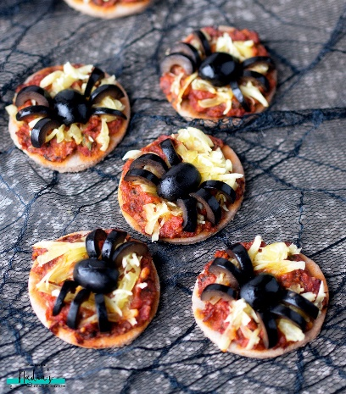
Vegan/Gluten-Free Pizza Bites
Yummy! (You will need an adult to help!)
For the base
- 1/2 cup (80g) buckwheat flour
- 1/4 cup (25g) ground almonds
- 1/2 tsp baking powder
- 1/4 tsp salt
- 1 tbsp coconut oil, melted
- 3-4 tbsp water
For the topping
- Homemade sun-dried tomato pesto
- Vegan cheese, shredded
- Black olives
Instructions
- In a bowl, mix together the first 4 base ingredients, then pour in the coconut oil and 3 tbsp water.
- Mix until you have a dough that holds well together. If the dough is still dry, add more water as needed, 1/2 tbsp at a time.
- Sprinkled some buckwheat flour on a clean surface and roll out your dough.
- Use a round cookie cutter to create your mini pizza bases.
- Place on a baking sheet covered with parchment paper
- Spread some sun-dried tomato and top with shredded vegan cheese.
- Bake for 10 minutes.
To make the spiders
- Cut each olive in half then divide one of the halves into 4 (to create legs)
- Place one half in the middle of the pizza and then arrange 3 of the small slices on each side so each spider has 6 legs. Enjoy!
Halloween Fruity Treats

This idea is so easy you don’t need a recipe!
Turn a healthy snack into a fun Halloween-themed one by getting creative.
- Turn your clementines into pumpkins and use some celery for the stems
- Use the celery leaves to look like ivy
- Make ghostly bananas by adding melted chocolate/dairy-free chocolate

