October Home Learning Grid: Health and Wellbeing and RME
HWB
RME
Play a game of ‘Active Simon Says’ with someone at home. You could try:  - Simon says jump on one foot 10 times  - Simon says do 20 ‘step-ups’ on the lowest stair  - Simon says do 5 star jumps  - Simon says run as fast as you can for 20 seconds  Remember NOT to do it if Simon doesn’t say it! | 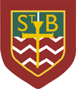  St. Barbara is the Patron Saint of our school.  Can you find out 5 things about her and her life?  St. Barbara is the Patron Saint of_____  Her Feast Day is _________________  Upload your answers, please.
Make/draw an Emotions Rainbow.  Can you think of a word to describe how each colour makes you feel? Why? | October is the Month of the Holy Rosary.  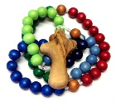  Try to say a decade of the Rosary with your family each evening.
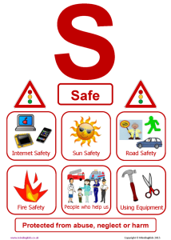
Safe, Healthy, Achieving, Nurtured, Active, Respected, Responsible, Included

These are the SHANARRI Indicators and they measure YOUR health and Wellbeing. The first is all about keeping yourself safe – at home, at school, when playing and online.

Can you design a Superhero to represent Safe? We would like to have a Superhero everyone would recognize in school.

There will be a class winner and one overall winner. Please upload your picture. The closing date for this competition is Wednesday 28th October. Good luck!

