Red Group

Homework WB 28th September 2020

To keep us all safe, we have decided that all completed work should be kept at home (until further notice).

Thank you for all your support.

Tuesday | Literacy  Phoneme ‘oo’ - https://www.youtube.com/watch?v=ONgqoexO8gY  Look at the pictures below, what ‘oo’ words can see?  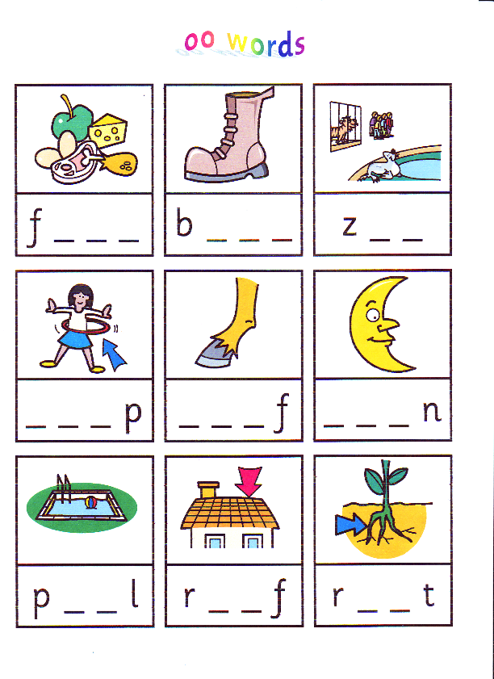  Can you sound out each ‘oo’ word to fill in the missing letters.  Reading Book- Try to read with fluency and expression.  Maths  Count along with Jack Hartmann- https://www.youtube.com/watch?v=1dkPouLWCyc  Practise writing your numbers 0-100 in your jotter.  Challenge- can you colour all the odd numbers in blue and all the even numbers in red.
Wednesday | Literacy  Common Words: play, no, look  Practise writing your common words by choosing one of the fun spelling tasks below:  - Pasta Words– Arrange pasta or cereal to make your words. Glue onto a piece of paper or take a picture.  - Chalk- Write your common words outside on the ground using chalk.  - Foamy Words– Spray a small amount of shaving foam and spread it out. Practise writing your words in the foam.  - Rainbow Words- write your words out in rainbow colours.  Reading book- Try to read with fluency and expression.  Maths  Sumdog- log on and complete the Sumdog challenge set for you!

If you do want to spend more time with your child below are some additional ideas, you can do to help support their learning.

Reading  Discussion questions:  Who was the Author and illustrator of the book?  What does the Author do? What does the illustrator do?  Who were the main characters of the book?  Discuss the beginning, middle and end of the book.  Discuss your favourite part of the book and why? | Phonics/Common Words  Go on a sound hunt around your house looking for objects that have the phoneme(s) you are revising.  Write a super sentence for each of your common words/phoneme words- making sure to include core targets. | Maths  Out loud, count forward in:  - 2s from 0-20  - 5s from 0-50  - 10s from 0-100  - 100s from 0-900  - 5s from 25-55  - 10s from 20-80  - 100s from 200-800  Now use the same numbers but count backwards.  Count to 100 by 1’s- forwards and backwards.

