Primary 2 homework WB 31st August 2020

Mon-Thurs- hand back on Thursday.

Literacy

Phonics

Phoneme ‘sh’, ‘th’ and ‘ch’

Go on a word hunt and see if you can find sh, th and ch words.

Write down and draw what you find on your word hunt into your homework jotter.

Useful videos

Jolly Phonics-Initial Sounds https://www.youtube.com/watch?v=euxN7LGOoLc

Phoneme SH- https://www.youtube.com/watch?v=HfMtsRVZWfE

Phoneme TH- https://www.youtube.com/watch?v=o3INXFPrfJM

Phoneme CH- https://www.youtube.com/watch?v=FWg2uzAuSe4

Common Words

This week’s common words are:

old do going

(cut these common words out and put them inside your word tin)

Can you read these words out to someone at home?

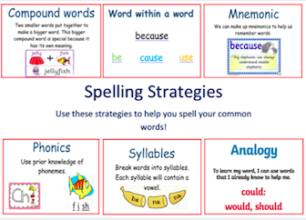

Remember to think about what strategy will help you spell and read these words.

Select a fun spelling task to practise this week’s new common words.

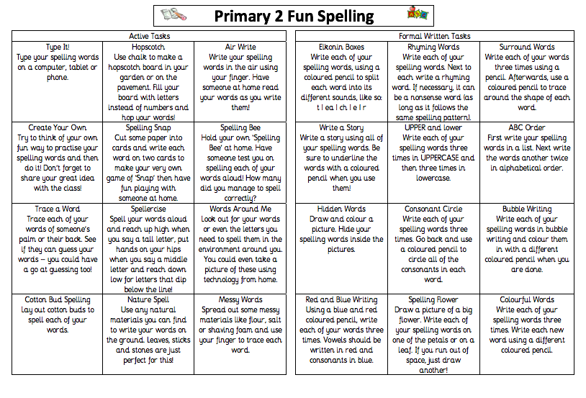

Reading

Read aloud your new reading book to someone at home every night. Remember to use expression.

Discussion questions:

Discuss the beginning, middle and end of the book.
Discuss your favourite part of the book and why?
Who were the main characters of the book?
Who was the Author and illustrator of the book?
What does the Author do? What does the illustrator do?

Numeracy

Mental Maths

Out loud, count forward in:
- 2s from 0-20
- 5s from 0-50
- 10s from 0-100
- 100s from 0-900
- 5s from 25-55
- 10s from 20-80
- 100s from 200-800
Now use the same numbers but count backwards.

Count to 100 by 1’s- forwards and backwards.

Useful videos to help with oral counting:

Count to 100 by 1’s- https://www.youtube.com/watch?v=0TgLtF3PMOc

Count backwards from 100 by 1’s- https://www.youtube.com/watch?v=8jMmZaFvRpE

Count by 2’s= https://www.youtube.com/watch?v=GvTcpfSnOMQ

Count by 5’s- https://www.youtube.com/watch?v=EemjeA2Djjw

Count by 10’s- https://www.youtube.com/watch?v=Ftati8iGQcs

Count by 100’s- https://www.youtube.com/watch?v=5v-aDFOmTBc

Sumdog-

Your child has been given their Sumdog login details. You will find this inside their jotter in their homework folders.

This week I would like you to complete the Sumdog diagnostic test. This will come on as soon as you login to Sumdog. Try to complete this task on your own without parents helps as this will show your teacher the areas in which you need support and it will help to set appropriately challenging tasks each week for individual pupils.

