Who is The Pope?
Today you will be learning about The Pope. Have a look at the PowerPoint below.
(powerpoint)
Every pope has three main jobs:
• He teaches us by writing and preaching about Jesus.
• He governs, or leads, us with the power handed down to him from St. Peter.
• He sanctifies us, or helps make us holy, through prayer and the sacraments.

Although the pope has just three primary jobs, he has many names, or titles. Fill in the missing vowels to find just five of his many titles. (use the powerpoint to help you.)

To show that the pope is the spiritual father of all Catholics, he is called the
H____LY F____TH____R.

To show that he is the head of a very special diocese, he is called the
B____SH____P ____F R____M____.

To show that he represents Jesus on earth, he is called the
V____C____R ____F J____S____S CHR____ST.

To show that he is the head of the Church, he is called the
S___PR____M___ P____NT____FF.

To show that he is carrying out Jesus’ command to help others, he is called the
S____RV____NT ____F TH____ S____RV____NTS ____F

Here is a picture for you to colour in.  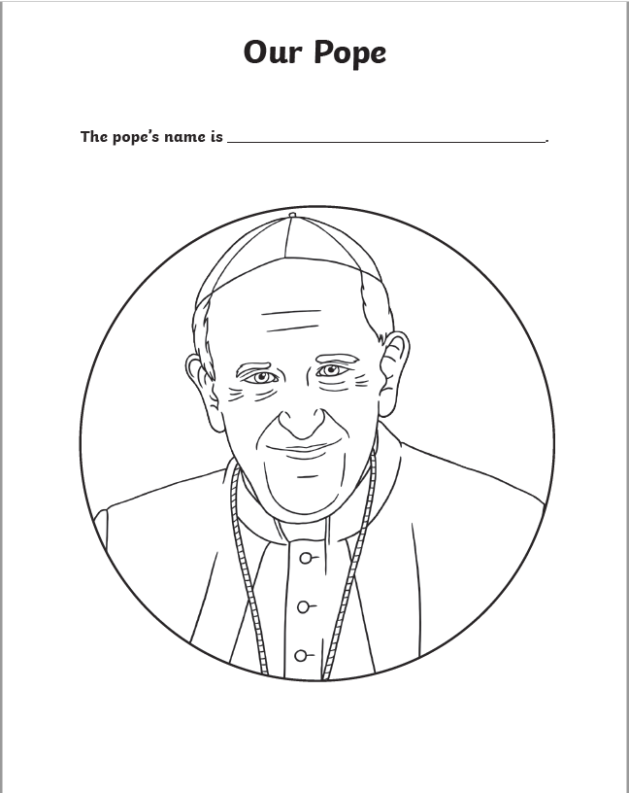 | Extension Activity  You are going to research our current Pope. You must include the following:  - The Pope’s real name and reason for their chosen name as Pope.  - Their date and place of birth  - When they began their papacy  - 5 interesting facts about them

